Serological evidence of Q fever in domestic ruminants in Latvia
Žanete Šteingolde, MVM, Institute of Food Safety, Animal Health and Environment “BIOR”, Latvia
Ilga Vīksna, MVM, Institute of Food Safety, Animal Health and Environment “BIOR”, Latvia
Ieva Rodze, MVM, Institute of Food Safety, Animal Health and Environment “BIOR”, Latvia
Lelde Grantiņa-Ieviņa, Dr.biol., Institute of Food Safety, Animal Health and Environment “BIOR”, Latvia

Abstract (300 word limit)
Statement of the Problem: Q fever is a zoonotic disease, caused by intracellular bacteria Coxiella burnetii (C.burnetii). Q fever is distributed almost worldwide. Main reservoir animals are ruminants and ticks, but many other species can be infected. Humans usually get infected by inhaling with C.burnetii contaminated aerosols or dusts. C.burnetii is shed in the environment via birth products, milk, feces, urine and vaginal mucus of the ruminants. The objective of this study was to determine the ruminant herds in Latvia, which show serological evidence of C.burnetii infection. Materials and Methods: In total 302 sera samples of ruminants (279 cattle, 17 sheep, 6 goats) were investigated on C.burnetii antibodies presence by commercial ID Screen Q Fever Indirect ELISA (ID.Vet, France). Out of these, tests of C.burnetii phase specific antibodies by commercial ELISA kits – VetLine Coxiella Phase 1 (indicates disease’s chronic phase) and VetLine Coxiella Phase 2 (indicates disease’s acute phase) (NovaTec, Germany) were performed on 91 sample (80 cattle, 10 sheep and 1 goat) from 56 farms in 30 regions in Latvia. 82 samples (n=91) were from aborted animals, which is a typical clinical manifestation of C.burnetii in ruminants. Results: Serological evidence of Q fever infection was detected in 21,9% (65 cattle, 1 sheep) of investigated samples (n=302) by ID.Vet ELISA kit. C.burnetii phase 1 antibodies were detected in 7,7% (6 cattle, 1 sheep) and C.burnetii phase 2 antibodies were determined in 5,5% (4 cattle, 1 sheep) of 91 investigated samples. C.burnetii antibodies more often were observed in ruminants that aborted in third trimester of gestation (53,8%). Conclusion & Significance: Findings show the positive serological evidence of C.burnetii in domestic ruminant population in Latvia. Antibodies against phase 1 antigen were observed slightly more often, indicating disease’s chronic phase. Study will be continued by investigating more samples by C.burnetii phase specific antibodies.

Image
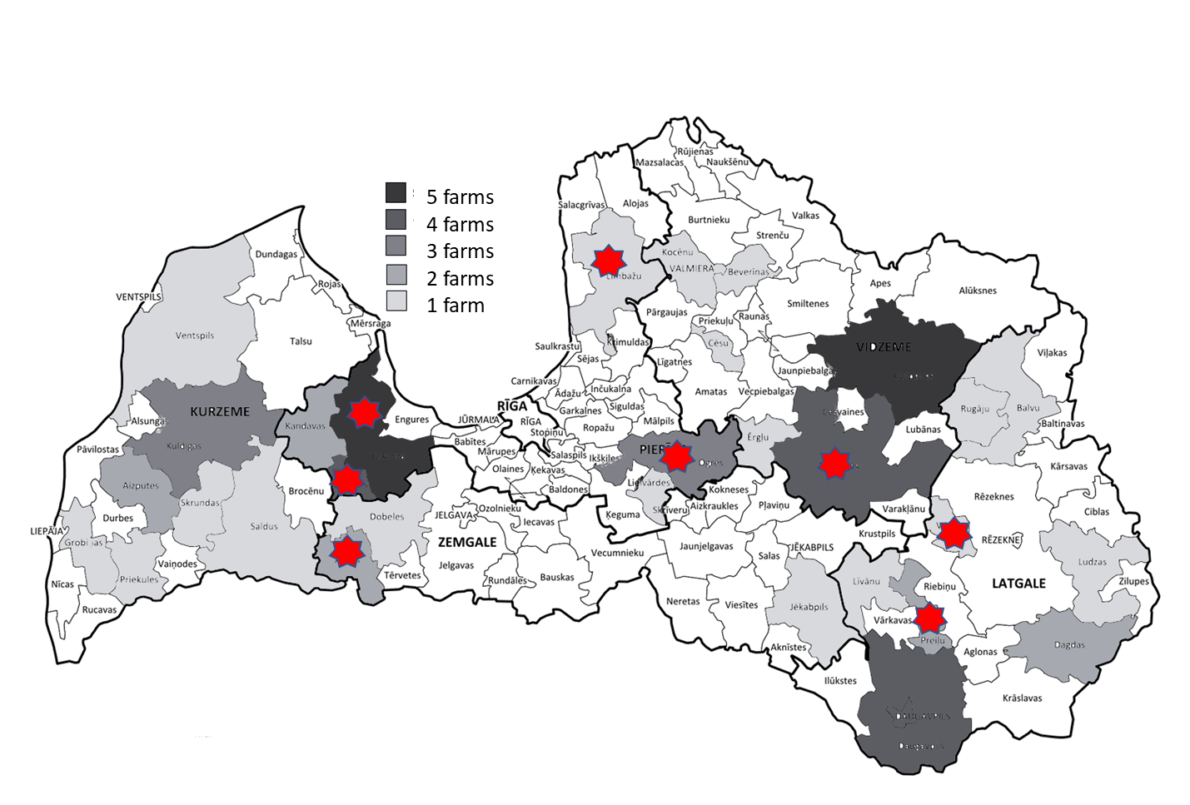
Figure 1: 30 regions in which 56 farms were investigated for C.burnetii phase specific antibodies. Districts in which seropositive farm/farms were observed, are marked with red star

Recent Publications (minimum 5)
- Klemmer J, Njeru J, Emam A, El-Sayed A, Moawad AA, Henning K, et al. (2018) Q fever in Egypt: Epidemiological survey of Coxiella burnetii specific antibodies in cattle, buffaloes, sheep, goats and camels. PLoS ONE 13(2): e0192188.
- Boroduske A, Trofimova J, Kibilds J, Papule U, Sergejeva M, Rodze I, Grantina-Ievina L (2017) Coxiella burnetii (Q fever) infection in dairy cattle and associated risk factors in Latvia. Epidemiology and Infection, 145 (10): 2011-2019.
- Barberio A, Badan M, Busa A, Ceglie L, Capello K, Comin A, & Natale A (2014) Association between serological response and shedding of Coxiella burnetii in milk in dairy cattle. Large Animal Review, 20(1): 3–8.
- Lucchese L, Capello K, Barberio A, Zuliani F, Stegeman A, Ceglie L, Natale A (2015). IFAT and ELISA phase I/phase II as tools for the identification of Q fever chronic milk shedders in cattle. Veterinary Microbiology, 179 (1–2): 102-108.
- Shannon JG and Heinzen RA (2009) Adaptive immunity to the obligate intracellular pathogen Coxiella burnetii. Immunologic research, 43(1-3): 138-148.

Biography (150 word limit)
Žanete Šteingolde works in Animal Disease Diagnostic Laboratory and has her experience in performing and interpreting serological investigations for seven years. She is PhD candidate and works on her dissertation about listeriosis in domestic ruminants. She has participated in research project about Bluetongue and Schmallenberg virus potential risk factors in Latvia, and conducts a national research project about Hepatitis E presence in domestic pigs and wild boars and their meat products in Latvia.
Email: zanete.steingolde@bior.lv
Notes/Comments:

