EGG FERTILITY RESPONSE OF TURKEY HENS TO FREQUENCY OF INSEMINATION AND SEMEN DILUTION

Emmanuel Olubisi Ewuola, RAS, PhD, Department of Animal Science, University of Ibadan, Nigeria
Karamat Adejumoke Adebisi, RAS, PhD, Department of Animal Science, University of Ibadan, Nigeria

Abstract
Statement of problem: Insemination frequency and semen dilution are critical factors that can influence egg fertility in Poultry. However, interval at which turkey hen should be inseminated and suitable diluents for tom semen for optimum fertility in indigenous turkeys have not been reported. Hence, effects of different intervals of insemination and potential of normal and dextrose saline as semen diluents for artificial insemination in indigenous turkeys in Nigeria was investigated. Methodology & Theoretical Orientation: Seventy-two white-feathered indigenous turkey hens (8-10months, 3.46±0.33kg) were divided into three groups and each hen inseminated with 0.02mL of undiluted semen (harvested from 10 proven toms, 10 months old, 8.06±0.76kg) containing approximately 90x10⁶ motile sperm cells/ml weekly (W1), fortnightly (W2) and at three weeks (W3) intervals. Fertility and hatchability were determined. Another semen was harvested, pooled and divided into four portions: Undiluted Semen (US), others were diluted at 1:1 with Modified Ringers Solution (MRS), Normal Saline (NS) or 1% Dextrose Saline (DS). Spermatozoa motility was measured hourly at ambient temperature (27.75±0.25 ̊C) till it drops below 50%. Treatments with different diluents above were inseminated into sixty hens for 12 weeks to assess fertility and hatchability. Findings: Fertility in W1 (84.5±2.5%) and W2 (84.8±1.3%) were significantly higher than W3 (77.4±2.2%), while hatchability was similar. Spermatozoa motility at three hours was higher in MRS (83.3±1.7%) and DS (83.3±1.7%) than US (66.7±3.3%) and NS (63.3±1.7%). Fertility was similar among the diluents. Conclusion & Significance: Fortnight insemination interval improved fertility and hatchability in indigenous turkeys. Normal and dextrose saline are suitable semen diluents for on-farm artificial insemination in turkeys.

Biography


Image
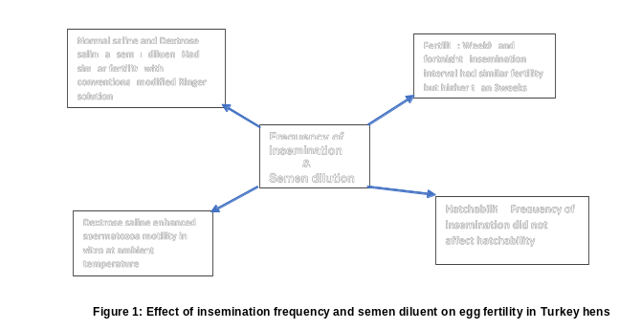

Recent Publications
- Bakst, M. R. 1988. Turkey hen age fertility and egg production after artificial insemination with multiple oviduct eversions during the pre – laying period. J Reprod Fertil.; 83: 873-887.

- Brillard, J.P. and Bakst, M.R. 1990. Quantification of Spermatozoa in the sperm-storage tubules of turkey hens and the relation to sperm numbers in the periviteline layer of eggs. Biology of Reproduction 43: 271-275.

- Bramwell, R.K. 2002. Fertility and Embryonic Mortality in Breeders. Avian Advice 4(2) :1-4

- Liu, G. Q., Zhu, J.J., Wang, Z.Y., Jiang, X.P. and Dafalla, M.M. 2008. Analysis of sperm storage ability using duration of fertility in hens. British Poultry Sc. 49 (6): 770-775.
- Sasanami, T., Matsuzaki, M. and Hiyama, G. 2013. Sperm storage in the female reproductive tract in birds. J. Reprod. Dev. 59 (4): 334-338.

Dr Ewuola completed his Ph.D from University of Ibadan, Nigeria. He is a Senior Lecturer in the Department of Animal Science with bias for Animal Reproductive Physiology and artificial Insemination. He is versatile in artificial insemination for rabbits, layers and broiler breeders, Turkey, Geese and small ruminants He has published more than 50 papers in reputed journals, He is currently Editor-in-Chief for Journal of Tropical Animal Production investigations and has been serving as a reviewer for many journals.
Email: eoewuola@gmail.com

