Repair of segmental radial defect with autologous bone marrow aspirate and hydroxyapatite in rabbit radius: A clinical and radiographic evaluation
Ahmed Y KALBAZA, Sc.D., BATNA 1 University, ALGERIA Karim AMARA, PhD, IBN KHALDOUN University, ALGERIA
Mokhtar BENCHOHRA, Sc.D., IBN KHALDOUN University, ALGERIA
Houari HEMIDA, Sc.D., IBN KHALDOUN University, ALGERIA

Abstract (300 word limit)
Finding an ideal bone substitute to treat large bone defects, delayed union and nonunion remain a challenge for orthopedic surgeons and researchers. Several studies have been conducted on bone regeneration; each has its own advantages and disadvantages. The aim of this study was to evaluate the effect of a combination of hydroxyapatite (HA) powder with autologous bone marrow (BM) aspirate on the repair of segmental radial defect in a rabbit model.
A total of 36 male and adult New Zealand rabbit with a mean weight of 2.25 kg were used in this study. Approximately, 5 mm defect was created in the mid-shaft of the radius to be filled with HA powder in the control group “HA” (n=18) and with a combination of HA powder and autologous BM aspirate in the test group “HA+BM” (n=18).
Animals were observed daily for healing by inspection of the surgical site, and six rabbits of each group were sacrificed at 30, 60, and 90 post-operative days to perform a radiographic evaluation of defect site.
Obtained results revealed a better and more rapid bone regeneration in the test group: Since the defect was rapidly and completely filled with mature bone tissue after 90 days.
Based on these findings, we could infer that adding a BM aspirate to HA is responsible of a better regeneration process leading to a complete filling of the defect.

Image
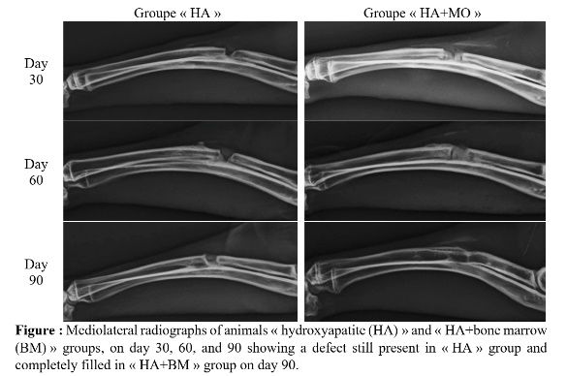
Recent Publications (minimum 5)
- Mokhtar BENCHOHRA, Karim AMARA, Hebib AGGAD, Aboud BOULKABOUL, Ahmed Yassine KALBAZA and Houari HEMIDA (2015) Effect of body weight on milking capacity and weight changes in Rembi ewe. Livestock Research for Rural Development, 27 (3).
- Mokhtar BENCHOHRA, Ahmed Yassine KALBAZA and Karim AMARA (2015) Vaginal and Rectal Prolapse (Type II) in Montbeliarde Dairy Cow-Case Report. Global Veterinaria 14 (1), 56-58.
- Ahmed Yassine KALBAZA, Mokhtar BENCHOHRA, Houari HEMIDA, Karim AMARA and Mohamed MELIZI (2017) Repair of segmental radial defect with autologous bone marrow aspirate and hydroxyapatite in rabbit radius: A clinical and radiographic evaluation. Veterinary World, 10 (7), 752-757.
- Houari HEMIDA, Mokhtar BENCHOHRA, Ahmed Yassine KALBAZA and Karim AMARA (2018) Vaginal Fibrosarcoma in an Algerian Crossbreed Cow Case Report. Pakistan Veterinary Journal, 38 (1), 119-120.
- Houari HEMIDA, Mokhtar BENCHOHRA, Karim AMARA and Ahmed Yassine KALBAZA (2018) Assessment of two abdominal mass closure methods using fishing line in rabbit model: clinical and pathological study. Comparative Clinical Pathology, (27) 1, 821-827.

Biography (150 word limit)
Ahmed Yassine KALBAZA graduated from the Institute of Veterinary Sciences of IBN KHALDOUN University, ALGERIA in 2011. He pursued his studies to obtain the Magister degree in small animal surgery in 2014. He started working then as assistant professor at BATNA 1 University in which he obtained a Scientific Doctorate in small animal surgery in 2018.
Email: docahmedyacine@gmail.com

Notes/Comments:

