Covid 19 Vaccine Acceptance and Hesitancy in Low-and-middle-income Countries
Fayomi Segun Alex, MRPP, Hi-Fin Care, Nigeria

Abstract (300 word limit)
Widespread acceptance of COVID-19 vaccines is crucial for achieving sufficient immunization coverage to end the global pandemic, yet few studies have investigated COVID-19 vaccination attitudes in lower-income countries, where large-scale vaccination is just beginning. We analyze COVID-19 vaccine acceptance across 15 survey samples covering 10 low- and middle-income countries (LMICs) in Asia, Africa and South America, Russia (an upper-middle-income country) and the United States, including a total of 44,260 individuals. We find considerably higher willingness to take a COVID-19 vaccine in our LMIC samples (mean 80.3%; median 78%; range 30.1 percentage points) compared with the United States (mean 64.6%) and Russia (mean 30.4%). Vaccine acceptance in LMICs is primarily explained by an interest in personal protection against COVID-19, while concern about side effects is the most common reason for hesitancy. Health workers are the most trusted sources of guidance about COVID-19 vaccines. Evidence from this sample of LMICs suggests that prioritizing vaccine distribution to the Global South should yield high returns in advancing global immunization coverage. Vaccination campaigns should focus on translating the high levels of stated acceptance into actual uptake. Messages highlighting vaccine efficacy and safety, delivered by healthcare workers, could be effective for addressing any remaining hesitancy in the analyzed LMICs.
Further studies on vaccines hesitancy in 2021 showed contracting findings as willingness to take a COVID-19 vaccine were observed considerably lower in the LMICs where trust and communication of the protective benefits of the vaccines are central factors responsible for the new trend observed.

Image
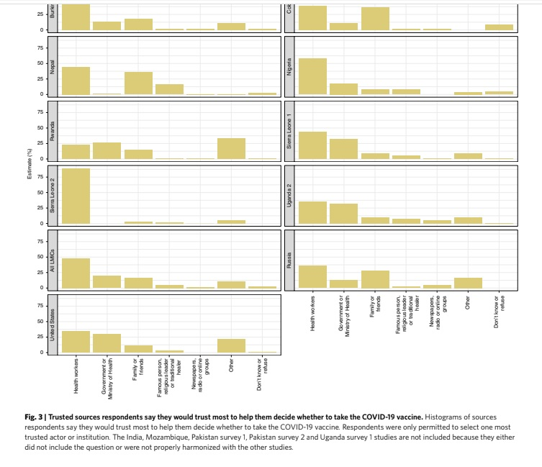
Recent Publications (minimum 5)
- Draft landscape and tracker of COVID-19 candidate vaccines (World Health Organization, 2021); https://www.who.int/publications/m/item/draft-landscape-of-covid-19-candidate-vaccines
- COVID-19 Vaccine Tracker (McGill COVID19 Vaccine Tracker Team, 2021); https://covid19.trackvaccines.org/vaccines/
- Wouters, O. J. et al. Challenges in ensuring global access to COVID-19 vaccines: production, afordability, allocation and deployment. Lancet 397, 1023–1034 (2021).
- de Figueiredo, A., Simas, C., Karafllakis, E., Paterson, P. & Larson, H. J. Mapping global trends in vaccine confdence and investigating barriers to vaccine uptake: a large-scale retrospective temporal modelling study. Lancet 396, 898–908 (2020).
- Global attitudes: COVID-19 vaccines (Ipsos World Economic Forum, 2021); https://www.ipsos.com/en-ro/global-attitudes-covid-19-vaccine-january-2021

 Biography (150 word limit)
Fayomi Segun Alex had his Master degree in Research and Public Policy from the University of Lagos and has contributed to several academic studies in Africa across different sectors. His recent interest has been centered on health policy development in Nigeria, where one of his recent research addresses the National health insurance and the informal workers in Lagos and has huge influence in co-founding Hi-Fin Care that is an organization working to address the healthcare gap in Africa using technology. His most recent engagement was leading an ethnography study with ReD Associates in Nigeria to assess and understand vaccines hesitancy in the World.
Email: segunfayomialex@gmail.com

Notes/Comments: Fayomi Segun contributed to the planning, designs and data collection of the paper cited above with formal acknowledgement found at https://doi.org/10.1038/s41591-021-01454-y.

