Development of the attitudes and intention scale toward vaccination in pregnancy: COVID-19 version (AIVP: COVID-19)
Serpil Özdemir RN PhD¹, Arzu Aybek Kalkanlı RN PhD¹, Gulten Guvenc RN PhD, Professor¹, Kazım Emre Karaşahin MD., Professor², Mahsa Tamaddon RN PhD¹
¹ Gulhane Faculty of Nursing, University of Health Sciences Turkey,
²,Gulhane Education and Research Hospital, University of Health Sciences Turkey.

Abstract
Statement of the Problem: Pregnant women are more likely to develop a more severe course of COVID-19 infection than their non-pregnant peers. It is reported that the most effective method of protection against COVID-19 is immunization. Evidence continues to build showing that COVID-19 vaccination during pregnancy is safe and effective. In the literature, there is no standard measurement tool that measures the attitudes and intentions toward vaccination against infectious diseases in pregnant women. The aim of this study is to develop an attitude and intention scale towards COVID-19 vaccine during pregnancy.
Methodology & Theoretical Orientation: This study designed as methodological study. The data were collected between February and June 202 in the obstetrics and gynecology outpatient clinic of a training and research hospital serving in the tertiary level, where approximately 30 thousand pregnant women receive service annually. The sample of the study consisted of 519 pregnant women who received prenatal care from the hospital at the time of the study and met the inclusion criteria of the study. According to the sample size classification of scale development studies reported in the literature, the criterion of having at least 500 participants was taken as a basis for a “very good” sample size. Considering possible data losses, 550 pregnant women were invited to the study. Inclusion criteria for the research were 1) volunteering to participate in the research, 2) filling out the study forms completely, 3) not having visual or hearing impairment, 4) not having a risky disease/disorder in terms of maternal and fetal health, 5) not having any contraindications for vaccination, 6) not having trouble in written and oral communication in Turkish. Ethical approval was obtained from the ethics committee of the University. All participants included in this study agreed to participate voluntarily after researchers informed them about the aim of the study.
The data were collected using a socio-demographic information form and the “Attitude and intention scale towards vaccination during pregnancy: COVID-19 version” The scale included 29 items obtained as a result of a series of systematic studies aimed at determining the attitudes and intentions of pregnant women towards vaccination. The application took place face to face with a mask while maintaining social distance in an environment where the privacy of pregnant women is ensured. While creating the scale items, the scale development steps, which are frequently preferred in the literature, were followed. These steps were: 1) Definition of basic concepts, 2) Preliminary evaluation of experts, 3) Submission of the item pool to expert opinion and Content Validity, 4) Pilot application and surface validity, 5) Application of the scale 6) Re-test, 7) Validity analysis, 8) Reliability Analysis, 9) Interpretation of results.
Findings: The mean age of the participants was 28.50±5.40 (min.:18, max.:45), and the mean week of gestation was 23.60±10.63 (min.:4, max.:41). Of the participants 48.4% (n=251) stated that they were

vaccinated during pregnancy. The Scope Validity Index of the scale was 0.96. In item-total item correlation; five items were removed from the scale according to the correlation coefficients. In the factor analysis, the 4-factor structure of the 24-item scale, which had an Eigenvalue above 1 and explained 58.05% of the total variance, was discovered. The fit indices of these four factor confirmatory factor analysis were found to be at acceptable values, and the 4-factor structure was confirmed. It was determined that there were statistically significant positive correlations between scale total score and subscale scores, varying between 0.878 and 0.585 (p < 0.05). The Cronbach α value of the scale was calculated as 0.90 and the McDonalds' (ω) α value was calculated as 0.91. The ICC value between scale total score and retest total score was calculated as 0.823 (F = 5.728; p = 0.001).
Conclusion & Significance: “The attitude and intention scale towards vaccination during pregnancy: COVID-19 version” is a valid and reliable measurement tool in Turkish culture. COVID-19 vaccine acceptance and its predictors among pregnant women vary globally. Attitude and intention toward vaccination should be evaluated in different countries in order to attain the largest impact.
Image: CFA of AIVP:COVID-19
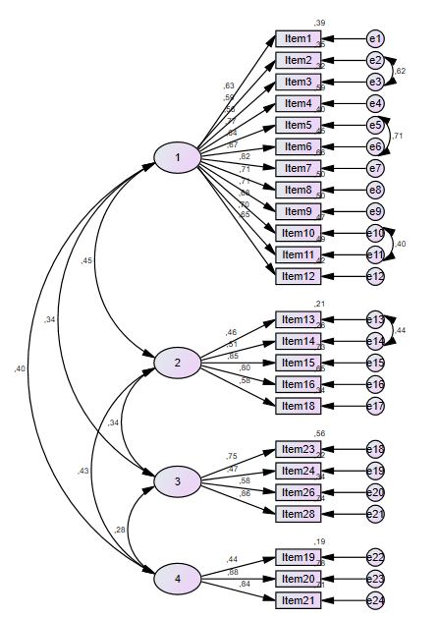

Recent Publications
- Baxter R, Bartlett J, Fireman B, Lewis E, Klein NP (2017) Effectiveness of Vaccination During Pregnancy to Prevent Infant Pertussis. Pediatrics. 139(5): e20164091.
- Chamberlain AT, Lavery JV, White A, Omer SB (2017) Ethics of maternal vaccination. Science. 27;358(6362):452-453.
- Simionescu AA, Streinu-Cercel A, Popescu FD, Stanescu AMA, Vieru M, Danciu BM, Miron VD, Săndulescu O. J Pers Med. (2021) 13;11(11):1196
- Mohan S, Reagu S, Lindow S, Alabdulla M. (2021) COVID-19 vaccine hesitancy in perinatal women: a cross sectional survey. J Perinat Med. 28;49(6):678-685.
- Januszek SM, Faryniak-Zuzak A, Barnaś E, Łoziński T, Góra T, Siwiec N, Szczerba P, Januszek R, Kluz T (2021) The Approach of Pregnant Women to Vaccination Based on a COVID-19 Systematic Review. Medicina (Kaunas). Sep 17;57(9):977.

Biography
Dr. Gulten Guvenc received her Ph.D. from Gulhane Military Medical Academy in 2008. She studied as a visiting scholar at Texas Woman's University from August 2010 through August 2011 in Houston,the USA. She is currently Professor at Obstetrics and Gynecology Nursing Department in Gulhane Faculty of Nursing, University of Health Sciences Turkey. Her research interests include early detection and prevention of gynecological cancers, breast cancer, attitudes towards vaccination, women’s health and nursing education. Most of her research involves in developing and validating research instrument, assessing health beliefs that influence health behaviors, and evidence-based nursing interventions. She has peer-reviewed publications in reputed journals and has been serving as reviewer.
Email: guvencgulden@yahoo.com

Notes/Comments:

