Title: Importance of the participation of the community pharmacist in the vaccination of influenza and pneumonia in Covid 19 time in Argentine

CAPONI IB¹.
¹Argentine Pharmacist Confederation Cofa, Chamber of Pharmacist of Buenos Aires

Keywords: Vaccination, Pharmacist, Covid, Influenza, Pneumoniae

I. Abstract Body
The present study shows the importance of vaccination in pharmacies in Argentine. In my country, vaccination has been carried out in pharmaceutical offices since 1958, Argentine pharmacists have a strong legislation that supports us and it is one of the activities that general population most recognizes as accessible, safe and effective to be carried out in pharmacies. One of the vaccination campaigns that is carried out in Argentine pharmacies corresponds to that of the social security for pensioners and retirees that has been carried out since 2009 in pharmacies and each year more people attend these establishments to be vaccinated.
In particular this year due to the Covid19 pandemic and to respect the guidelines of preventive and compulsory social isolation that was decreed in our country on March 20, the vaccination campaign was modified.
In this study, I relate and list the different precautionary measure that were taken into account for the proper conduct of this campaign, protection and care as well as make a brief comparison with what happened in previous years. I was able to compare the total doses administrated this year to last year ones in the whole country.
Argentine Pharmaceutical Confederation, Cofa, provided me with invaluable information, and that was why this work was possible to be carried out. I consider this study can be taken into account as an experience for the development of strategies for future campaigns and facing different situations.

II. Image:

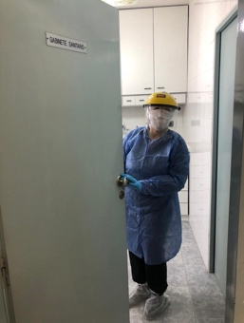

IV. Reference:
- Argentine Pharmacist Confederation CoFA.
- Internacional Pharmacist Federation FIP
- Argentine Health Ministry

V. Biography:
Irma Caponi is the owner and director of an independent community pharmacy in Buenos Aires, Argentina since 1998. Irma is the past president of the local branch of the Chamber of Pharmacist of Buenos Aires, which is part of the Argentinian Pharmaceutical Confederation (CoFA). She is a Pharmaceutical legal adviser and holds a Master Degree in Integral Pharmaceutical Care from the University of Barcelona, Spain.

VI. Presenting author details


Full Name: Irma Beatriz Caponi
Contact number: +5491167049105
Twitter account:@BettinaCaponi
Linked In account:
Session name/ number:
Category: (Oral presentation/ Poster presentation)
Passport Number:

