Abstract

Development of vaccine against Helicobacter pylori using Bioinformatics approaches:
Abid Qureshi¹, Vaqar Gani Tantray¹, Omar Javed Shah², M Ashraf Ghanie³
¹Department of Biomedical Informatics Centre, SKIMS, Srinagar, J&K, India,
¹Department of Biomedical Informatics Centre, SKIMS, Srinagar, J&K, India,
²Department of Surgical Gastroentrology, SKIMS, Srinagar, J&K, India.
²Department of Endocrinology, SKIMS, Srinagar, J&K, India.

Keywords: Helicobacter pylori, Vaccine, Bioinformatics
Abstract Body (up to 250 words)
Helicobacter pylori (H. pylori) are a widespread kind of bacteria which flourish in the digestive tract and have a propensity to damage the stomach lining. The microbe infects around 60% of the adults globally. H. pylori infections are responsible for most of stomach and small intestine ulcers. Using Bioinformatics approaches, we have identified certain proteins that contain the virulence factors, resistance factors and essentiality factor for this pathogen. Computational tools and servers were used for the identification of MHC class I, II and B cell epitopes. All selected epitopes were further shortlisted computationally to know their immunogenicity, antigenicity, allergenicity, conservancy and toxicity potentials. Designed vaccine construct was docked against multiple HLA targets employing virtual modeling. Therefore the designated vaccine constructs may be developed to control the infection caused by H. pylori.

- Image:
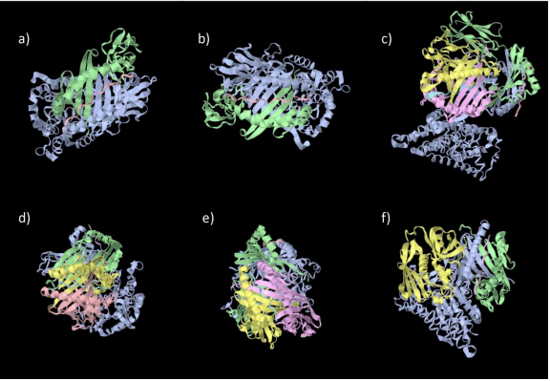

- Reference:
- Zamani, M., et al., Systematic review with meta-analysis: the worldwide prevalence of Helicobacter pylori infection. Aliment Pharmacol Ther, 2018. 47(7): p. 868-876.
2. Diaconu, S., et al., Helicobacter pylori infection: old and new. J Med Life, 2017. 10(2): p. 112-117.
3. Burucoa, C. and A. Axon, Epidemiology of Helicobacter pylori infection. Helicobacter, 2017. 22 Suppl 1.
4. Hooi, J.K.Y., et al., Global Prevalence of Helicobacter pylori Infection: Systematic Review and Meta-Analysis. Gastroenterology, 2017. 153(2): p. 420-429.
5. Sutton, P. and J.M. Boag, Status of vaccine research and development for Helicobacter pylori. Vaccine, 2018.
6. Sutton, P. and C. Doidge, Helicobacter pylori vaccines spiral into the new millennium. Dig Liver Dis, 2003. 35(10): p. 675-87.
7. Malfertheiner, P., et al., Safety and immunogenicity of an intramuscular Helicobacter pylori vaccine in noninfected volunteers: a phase I study. Gastroenterology, 2008. 135(3): p. 787-95.
8. Li, X., et al., Oral immunization with recombinant Lactococcus lactis delivering a multi-epitope antigen CTB-UE attenuates Helicobacter pylori infection in mice. Pathog Dis, 2014. 72(1): p. 78-86.
- Biography:
Mr. Vaqar Tantray has completed his M.Tech in Biomedical Informatics at the age of 30 years from SRM University, Tamil Nadu , India He is the Scientist-C at Biomedical Informatics Centre at SKIMS, Sringar, J&K, India , a Tertiary care Medical Institute. He has published more than 10 papers in reputed journals.

.
- Presenting author details


Full Name: Vaqar Gani Tantray
Contact number: +91 9622519292
Twitter account: @waqsaf
Linked In account:
Session name/ number:
Category: (Poster presentation)
Passport Number: J7892917

