Abstract

Understanding the Evolution of Broadly Neutralizing Antibodies (bNAbs) Targeting the N332 Glycan Site on HIV-1 gp120

Copley P, Doores K, Graham C, Huettner I,
School of Immunology and Microbial Sciences (King’s College London), Guy’s Hospital, London, UK

Keywords: HIV-1, Broadly Neutralizing Antibodies, FACS, N332 glycan, Superinfection, Protein, Expression, Purification

Abstract:
HIV-1 env-targeting broadly neutralizing antibodies (bNAbs), developed in 10-30% of HIV infected patients¹, are protective against a broad range of SHIV strains in macaque challenge studies². Ideally, a potential HIV vaccine would elicit these bNAbs to provide broad protection in humans. The challenge of this vaccine strategy is designing immunogens that are capable of eliciting a broadly neutralizing response quickly when these bNAbs take years to develop through affinity maturation. Therefore research efforts to understand the co-evolution between escaped viral HIV-1 strains and affinity maturation (which drive bNAb development) are important in informing vaccine design.
The Doores’ Lab are studying the longitudinal development of bNAbs in donor SJU of the SPARTAC trial³. SJU’s N332 glycan-targeting bNAb response was ‘boosted’ following superinfection with 133_s9C virus (Image 1). If Antigen-specific B cell sorting via FACS could isolate SJU bNAbs from before and after superinfection, then it would provide insight into the development of this ‘breadth boost’³.
This study investigated whether recombinant gp120 proteins would make ideal FACS probes and whether gp120 proteins could be expressed from the env genes of 2 viral strains (1_s5H and 133s9c) isolated from SJU plasma samples.
Neutralization assays on env pseudo-typed viruses confirmed that expressed WT and N332A (site-directed mutagenesis) gp120 proteins would make ideal candidates for FACS probes.
The gp120 parts of the env genes were assembled into expression vectors and transfected into HEK 293T cells. Quality-control testing by ELISA, Western Blot and SDS-PAGE confirmed that WT and N332A probes could be expressed on a small-scale.

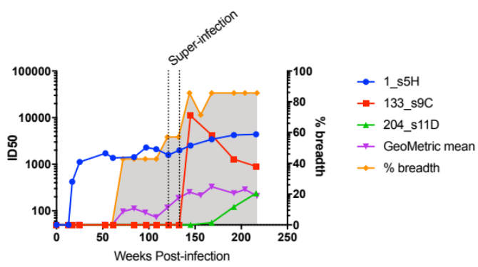
Image 1:
References:
- Doria-Rose, NA, Klein RM, Manion MM et al, 2009. Frequency and Phenotype of Human Immunodeficiency Virus Envelope-Specific B Cells from Patients with Broadly Cross-Neutralizing Antibodies. Journal of Virology 83(1):188–99.
- Nishimura Y, Martin MA, 2017. Of Mice, Macaques and Men: Broadly Neutralizing Antibody Immunotherapy for HIV-1; August 2017 Cell 22(2): 207-216
- Brady, M., S. Fidler, A. Oxenius, R. Phillips, and J. Weber. 2015. Short Course Antiretroviral Therapy in Primary HIV-1 Infection. Clinical Science 368:207–17.
Biography:
Patrick Copley is a 5th year medical student at the University of Sheffield, UK. Patrick undertook an intercalated Bachelor of Sciences degree in Infectious Diseases and Immunobiology at King’s College London in 2019, graduating with first class honors. During his degree, he undertook a project with the Doores’ Lab at Guy’s Hospital, London. Patrick has great enthusiasm for infectious diseases and vaccinology – an area he hopes to specialize in upon qualifying as a Doctor of Medicine in 2021.

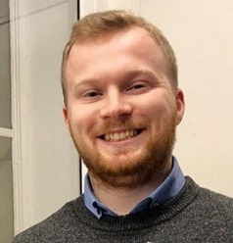
Presenting author details
Full Name: Patrick Tobias Copley
Contact number: +44 7445 275752
Twitter account: @Pabz3142
Linked In account: https://www.linkedin.com/in/patrick-copley-2b54341a6/
Session name/ number: HIV and AIDS Vaccine
Category: Poster presentation
Passport Number: 523874228

