Immunization of goat with recombinant B2L and Kisspeptin-54 DNA vaccine inhibits fertility via disrupting the hypothalamic-pituitary- testicular axis
Teketay Wassie, PhD fellow, Huazhong Agricultural University, Ethiopia

Abstract (300 word limit)
Statement of the Problem: Kisspeptin, encoded by the KISS1 gene with its cognate receptor GPR-54 is recognized as an upstream orchestrator in the hypothalamic-pituitary-gonadal (HPG) axis. Despite kisspeptin role as a gatekeeper of gonadotropin-releasing hormone (GnRH) secretion is well known, the effect of kisspeptin immunization on HPG axis in goat is not yet studied. The purpose of this study was to investigate the effect of recombinant orf virus envelope protein (B2L) and kisspeptin-54 DNA vaccine on HPG axis. Methodology: A total of 15 male white Yichang goats were equally and randomly assigned in to one of the following three groups: PBK-asd immunized, PVAX-asd treated (control) and surgically castrated. Bucks assigned in the PBK-asd and control group were intramuscularly immunized with 1mg/dose of PBK-asd DNA vaccine and PVAX-asd plasmid, respectively. Finding: Administration of recombinant B2L and Kisspeptin-54 DNA vaccine is shown to produce significant antibody responses to kisspeptin and decreased serum levels of luteinizing hormone (LH) and testosterone levels as compared to control group (p<0.05). The current recombinant vaccine caused testicular atrophy in vaccine treated animals and prevented spermatogenesis. In contrast, the surgical castrated group showed significantly higher serum FSH and LH levels as compared to control group (p< 0.05). Furthermore, our data showed that PBK-asd immunization altered HPG axis via reducing hypothalamic androgen receptor (AR), G protein-coupled receptor (GPR54), gonadotropin-releasing hormone (GnRH); pituitary GnRH receptor, follicle stimulating hormone beta (FSHb), luteinizing hormone beta (LHb), and testicular FSH and LH receptors. In contrast, surgical castration significantly increased mRNA expression of all reproductive genes detected in HP axis except AR (p< 0.05). Conclusion & Significance: It is concluded that PBK-asd immunization inhibits fertility via perturbing the genes and receptors expression, and hormones production in the HPG axis. This research provide insight for the use of kisspeptin vaccine in the modulation of fertility.
Image

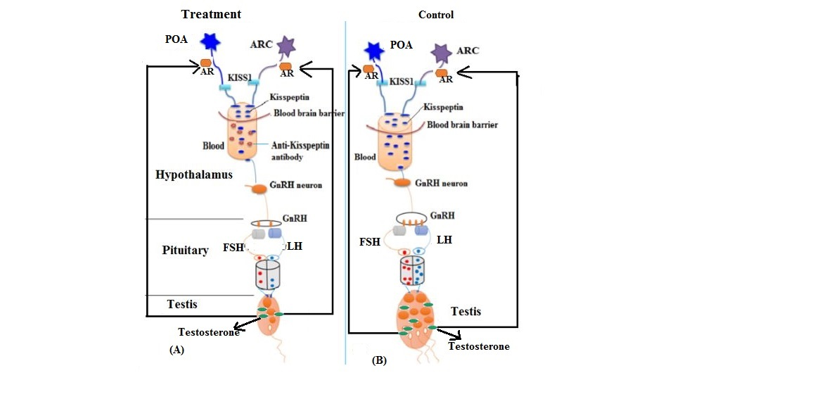
(a). Anti-kisspeptin antibody produced due to immunization against kisspeptin-54 counteracts the kisspeptin in the blood then less kisspeptin goes down to activate GnRH neuron. Because of that the GnRH productions inhibited and then the concentrations of GnRH circulate in the blood to initiate the synthesis of FSH and LH at the pituitary become decline. Thereby, less FSH and LH have produced and they are unable to initiate and support high testosterone and sperm production. Consequently, sexual behavior reduced and testis size becomes smaller, eventually the rams become infertile.(b). The kisspeptin produced in the hypothalamus of control group knocks the GnRH neuron, so that high concentration of GnRH has produced. This GnRH stimulates and initiates the production of FSH and LH. Thereby, high concentrations of FSH and LH hormones have secreted and that support and initiate spermatogenesis, leads to high sperm production. As a result, the rams maintain their libido behavior, testis size and keep fertile. AVPV, Anteroventral periventricular nucleus; ARC, arcuate nucleus; AR, androgen receptor; GnRH, Gonadotropin-releasing hormone; FSH, Follicle stimulating hormone;LH, luteinizing hormone.
Recent Publications (minimum 5)
- Teketay Wassie, Zeng Fanmei, Xunping Jiang, Guiqiong Liu, Shishay Girmay, Zhang Min, Liu Chenhui, Dong Dong Bo. ecombinant B2L and Kisspeptin-54 DNA Vaccine Induces Immunity Against Orf Virus and Inhibits Spermatogenesis In Rats. Scientific reports, 9:16262. https://doi.org/10.1038/s41598-019-52744-y.
- Teketay Wassie, Guiqiong Liu, Xunping Jiang, Birhanu Tesema, Yanguo Han, Jiayu Zhao, Shishay Girmay, Hafiz Ishfaq Ahmad.2019. Immunization against Kisspeptin-54 perturb hypothalamic-pituitary-testicular signaling pathway in ram lambs.Theriogenology.125:193–202. https://doi.org/10.1016/j.theriogenology.2018.10.029
- Birhanu Tesema, Jia-yu Zhao, Xun-ping Jiang, Gui-qiong Liu, Yan-guo Han, Teketay Wassie. Kisspeptin recombinant oral vaccine: A master gene vaccine inhibiting the reproductive physiology and behavior of ram lambs, Vaccine, 2017. https://doi.org/10.1016/j.vaccine.2017.09.001.
- Hafiz Ishfaq Ahmad, Guiqiong Liu, Xunping Jiang, Shishay Girmay Edallew, Teketay Wassie, Birhanu Tesema, Yu Yun, Liu Pan, Chenhui Liu, Yuqing Chong, Zhao Jia Yu, Han Jilong. 2017. Maximum-likelihood approaches reveal signatures of positive selection in BMP15 and GDF9 genes modulating ovarian function in mammalian female fertility. Ecology and Evolution.7 (21):8895-8902. DOI: 10.1002/ece3.3336
- Girmay Shishay, Guiqiong Liu, Xunping Jiang, Yun Yu, Wassie Teketay, Dandan Du, Huang Jing and Chenghui Liu. Variation in the Promoter Region of the MC4R Gene Elucidates the Association of Body Measurement Traits in Hu Sheep. International journal of molecular science. 2019, 20, 240. https://www.mdpi.com/1422-0067/20/2/240


Biography (150 word limit)
Teketay Wassie is a PhD at Huazhong Agricultural University, China. He has served more than 4 years as a University teacher at Assosa University, Ethiopia. He has over 10 publications published in international journals.
Email: teketaywassie@yahoo.com/ teketay@webmail.hzau.edu.cn

Notes/Comments:

