Abstract Template

Title: Development of an iCELLis Nano Bioreactor Platform for High-Yield Viral Vector Production

Eric M. Vela¹, Sheldon Doxilly¹, April Green¹, Isabel Scholz¹
¹Process Development, Ology Bioservices, Alachua, Florida

Keywords: Vesicular Stomatitis virus (VSV), iCELLis Nano, Viral vector vaccines, bioreactors

- Abstract Body (up to 250 words)
The increasing importance of viral vaccine manufacturing has driven the need for high cell density processes that allow for higher production levels of viral vectors in efficient and scalable processes. The present investigation evaluated recombinant Vesicular Stomatitis virus (rVSV) viral vector production in the Pall iCELLis Nano bioreactor. Vero cell growth within the fixed bedding system was monitored using a biomass sensor that measures conductivity and capacitance. Infection was performed upon optimal cell growth as measured by the biomass sensor. Viral vector harvest was triggered by the biomass readings, which occurred two days post-infection. All iCELLis runs within the campaign yielded an increase of 1 to 2.5 logs of virus production per mL when compared to virus production from standard flat-stock methods. This correlated to an overall increase of 4 logs of virus per batch. In terms of dosages, utilization of the iCELLis Nano resulted in an increase in the number of doses per campaign, when compared to standard flat-stock methods, which ultimately led to a reduction in the cost per dose. In summary, use of the iCELLis bioreactor platform allows for a cost-efficient and scalable process for viral vaccine production.

- Image:

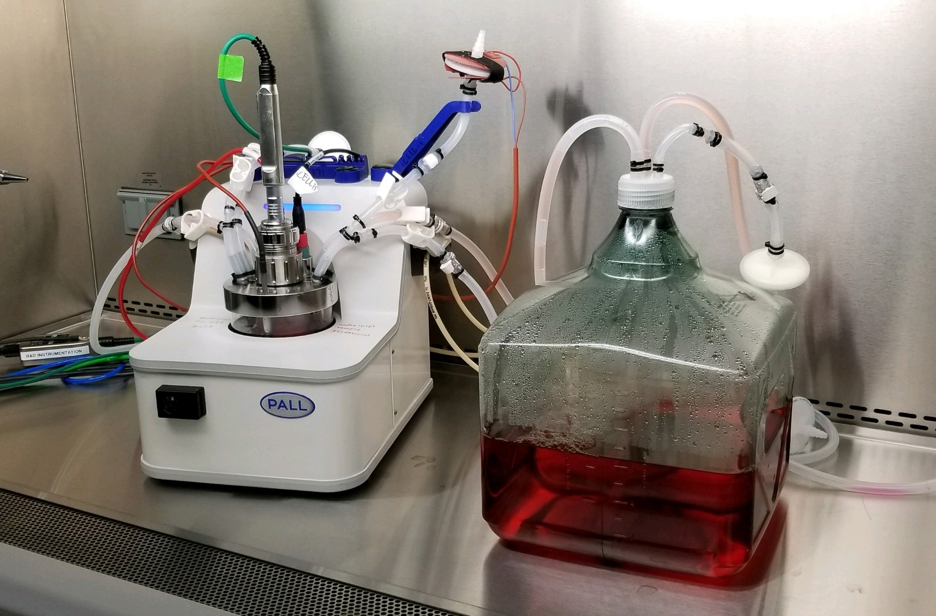

- References:
- Pall Life Sciences, 2015. Application Note. Bringing Fast Process Development to Adherent Cell Culture Processes: Demonstration of Linear Scalability from 1.6 to 200 m² in Single-Use Fixed Bed Bioreactor.
- Biography:
Eric Vela completed his PhD in the field of Virology and Gene Therapy from The University of Texas Graduate School of Biomedical Sciences at Houston. He then completed his Postdoctoral Studies at The University of Texas Medical Branch in Galveston in the field of Viral Pathology. He is currently the Associate Director for Process Development at Ology Bioservices, a premier Contract Development and Manufacturing Organization (CDMO). He has published more than 25 peer reviewed publications in reputed journals, in addition to several book chapters.
- Presenting author details


Full Name: Eric Vela
Contact number: 386-418-8998
Linked In account: https://www.linkedin.com/in/ericvela
Session name/ number: Vaccines Research & Development
Category:

