Characterization of recombinant vaccine constructed by individually cloning of HIV1 C gag, env and polRT genes using Semliki forest Virus Vector
A. H. Bandivdekar
National Inst for Research in Reproductive Health J M Street, Parel, Mumbai 400 012 INDIA
Key Words : Recombinant Vaccine, Vectors, Immune responses, Virus, Cloning

I Abstract
The development of a safe, immunogenic, globally effective and affordable vaccine may be useful in control of HIV/AIDS. The recombinant vaccines developed by cloning of HIV genes using different vectors have not been found to be effective due to poor or moderate immunogenicity and/or safety. Semliki Forest Virus (SFV), an alpha virus does not have pre-existing immunity, has cytoplasmic but not nuclear expression of heterologous proteins and non-pathogenic in humans. Therefore HIV1 Indian subtype C gag, env and polRT genes were individually cloned using SFV vector to develop recombinant SFV2gen replicon RNA constructs and subsequently constructed recombinant SFV2gen viral like replicon particles (VRP) designated as rSFV2gen/gag VRP, rSFV2gen/env VRP, and rSFV2gen/polRT VRP by co-electroporation with Helper RNA.In vitro studies demonstrated high levels of expression of respective HIV1 proteins and their localization in cytosol and not nucleus from all three recombinant constructs following infection of BHK-21 cells. The recombinant RNA constructs and VRPs individually and in combination of three constructs elicited significantly high cell mediated immune responses as detected by INF gamma and IL2 Assay and humoral immune responses in mice. VRPs have been found to be more immunogenic as compared to RNA constructs. Studies demonstrated that all three recombinant SFV2gen based vaccine constructs of Indian subtype C gag, env and polRT genes were highly immunogenic in the mice model and therefore promising preventive and theraputic candidate vaccine and therefore may be effective in control and management of HIV/AIDS.

II Image
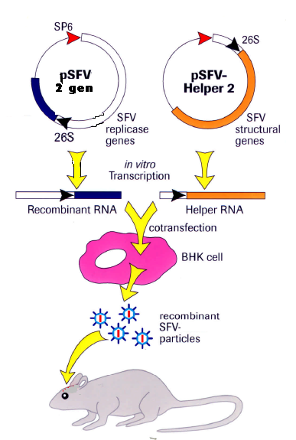

III References
1.Seema P. Ajbani, Shilpa M. Velhal, R. B. Kadam, V. V. Patel, A H.Bandivdekar (2015) Immunogenicity of Semliki Forest virus based self-amplifying RNAexpressing Indian HIV-1C genes in mice. International Journal of Biological Macromolecules 81 : 794–802.
2.S K Jadhav , Shilpa M.Velhal, Alaka Deshpande and A H Bandivdekar (2013) Association of Human Mannose Receptor in Sexual Transmission of Human Immunodeficiency Virus in Serodiscordant Couples. AIDS Research and Human Retroviruses 29 : 158, 2013.
3.S K Jadhav , S M.Velhal, A Deshpande, A Maitra, S Chinnaraj and A H. Bandivdekar (2011) Characterization of Human Immunodeficiency Virus [HIV1C] Variants in Peripheral Blood Mononuclear Cells and Spermatozoa J. Med. Virol. 83:760–767.
4.S. E. Fanibunda, S. M. Velhal, V. P. Raghavan and A. H. Bandivdekar (2008) CD4 Independent Binding of HIV gp120 to Mannose Receptor on Human Spermatozoa. J Acquired Immune Deficiency Syndromes (JAIDS). 48(4):389-397.

IV Biography
Dr Atmaram Bandivdekar completed his Ph D Degree from Mumbai University. He was Post-Doctoral and subsequently Carrier fellow at Population Council, New York. He was also the visiting scientist at UC Davis Primate Center. He has major research contributions at National Institute for Research in Reproductive Health in the field of Reproductive Health and understanding mechanism of sexual transmission and pathogenesis of HIV. He has developed recombinant vaccine which elicited significant cell mediated and humeral immune responses against HIV. Also developed formulation for prevention of sexual transmission of HIV which prevents HIV binding to hMR and CXCR4 and CCR5 coreceptors. He has also developed non surgical method of fertility regulation using synthetic peptide of sperm specific antigen. He has published more than 80 papers in peer reviewed journals and also the book and two conference proceedings. He also has six National and International awards for his scientific contributions

V Presenting author details

Full Name: Dr Atmaram H Bandivdekar
Contact number: 9869027186
Twitter account:
Linked In account:
Session name/ number: Hepatitis and HIV/AIDS
Vaccine
Category: (Oral presentation/ Poster presentation)
Oral Presentation
Passport Number: P9391769

