Role of antibodies in HIV vaccine: the lessons learned from HIV controlers
Christiane Moog, 1109, INSERM, France

Abstract (300 word limit)
It is now admitted that neutralizing antibodies (Abs) play a critical role in HIV protection. However, the HIV vaccine trial RV144 demonstrated that additional functional Abs may protect from HIV infection. The characteristic of these Abs was not yet defined. We took advantage of a French cohort of HIV controller to characterize the Abs response induced in this subgroup of individuals. Indeed, HIV control was associated with a specific HLA B*57 allele, inducing an unusually efficient cytotoxic CD8 response liable to their control. The role of the Ab response in HIV control was however not yet established. In HIV controller, we found a very specific Ab profile and a particular Fc gamma receptor genotype. HIV specific of IgG1 and 2 isotype was lower but HIV specific IgG3 subtype was higher in HIV controller compared to chronic individual. HIV specific B cell was preserved certainly because of their limited circulating viruses. Moreover, HIV neutralizing activity was detected, especially against transmitted founder viruses. Interestingly, in the subgroup controller with the HLA B57* allele, the neutralizing activity was correlated with HIV specific B cell response and with HIV specific IgG subtypes. Conclusion & Significance: These results demonstrate that HIV controller develop a very specific Ab profile in response to HIV infection. In HLA B*57+ individuals, the Ab response was different to that observed in HLA B*57- individual suggesting HIV control by distinct immune mechanisms. Such Ab immune response generated by HIV controller may play a determinant role in controlling HIV replication. We proposed that new vaccine strategies should aim to induce a similar relevant, efficient and sustained immune response in order to efficiently protect from infection.

Image: Correlation between Ab response and neutralization
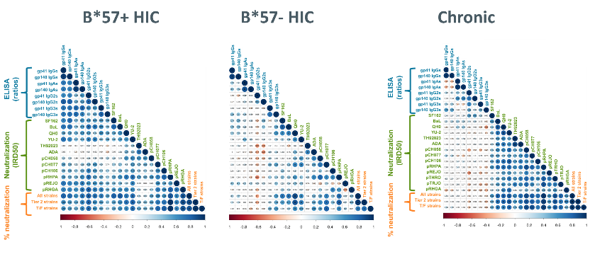
Recent Publications (minimum 5)
- Ducloy C, Bin Su, Luzia Mayr, Jéromine Klingler, Thomas Decoville, Sylvie Schmidt, Géraldine Laumond, Nathalie Salomé, Seiamak Bahram and Christiane Moog HIV transmission from infected CD4R T cells to allogenic T and dendritic cells is inhibited by broadly neutralizing antibodies. 2018, AIDS, in press..
- Mayr L, Decoville T, Schmidt S, Laumond G, Klingler J, Ducloy C, Bahram S, Zolla-Pazner S, Moog C. Non-neutralizing Antibodies Targeting HIV’s V1V2 Domain Exhibit Strong Antibody-Dependent Cell-mediated Cytotoxic Activity. Sci Rep. 2017 Oct 4;7(1):12655. doi: 10.1038/s41598-017-12883-6.
- Rouers A, Klingler J, Su B, Samri A, Laumond G, Even S, Avettand-Fenoel V, Richetta C, Paul N, Boufassa F, Hocqueloux L, Mouquet H, Rouzioux C, Lambotte O, Autran B, Graff-Dubois S, Moog C, Moris A; ANRS CO21 Cohort. HIV-Specific B Cell Frequency Correlates with Neutralization Breadth in Patients Naturally Controlling HIV-Infection. EBioMedicine. 2017 Jul;21:158-169. doi: 10.1016/j.ebiom.2017.05.029. Epub 2017 May 31.
- Mayr L., Su B. and Moog C. Role of non-neutralizing antibodies in vaccines and/or HIV infected individuals Current Opinion in HIV and AIDS, 2017 May;12(3):209-215Room R, BaborT, Rehm J (2005) Alcohol and public health. Lancet
365: 519-530.
5. Su B, Moog C. Which antibody functions are important for an HIV vaccine? Frontiers in Immunology 2014, REVIEW ARTICLE, doi: 10.3389/fimmu.2014.00289

 Biography (150 word limit)
Christiane Moog -PhD, is the Team Leader for “Control of HIV replication by antibodies”. She is responsible for the National Neutralization Laboratory developed under the aegis of ANRS since 1991. Dr. Moog is a pioneer in identifying the role of Fc-mediated antibody inhibitory function in protection against HIV to uncover novel strategies for prevention and treatment of HIV infection and virus-associated diseases. She has been actively participating in HIV vaccine projects, the Vaccine Research Institute (VRI), and European networks; aiming to define immunogens that induce an efficient protective humoral immune response. Her current research focuses on the inhibitory role of Abs during the early stage of HIV transmission at the mucosal site i.e. Ab inhibition in antigen presenting cells, inhibition of HIV cell to cell transmission and lysis of infected cells (ADCC), inhibition by Abs on ex-vivo tissue explants and mechanism of Fc-Fc receptor mediated inhibition.
Email: c.moog@unistra.fr
Phone: +33 3 68853742

Notes/Comment

