The Efficacy of Faecal Microbiota Transplant and Rectal Bacteriotherapy in Patients with Recurrent Clostridioides difficile Infection: A Retrospective Cohort Study

Hengameh Chloé Mirsepasi-Lauridsen 4, Camilla Kara Svensson 1 , Frederik Cold 2,3 , Iben Ribberholt 1 , Mike Zangenberg 1 , , Andreas Munk Petersen 2,4,5 and Morten Helms 1,5,*
¹ Department of Infectious Diseases, Copenhagen University Hospital Hvidovre, 2650 Hvidovre, Denmark
² Gastro Unit, Medical Division, Copenhagen University Hospital Hvidovre, 2650 Hvidovre, Denmark
³ Department of Plant and Environmental Sciences, Copenhagen University, 1871 Copenhagen, Denmark
⁴ Department of Clinical Microbiology, Copenhagen University Hospital Hvidovre, 2650 Hvidovre, Denmark
⁵ Department of Clinical Medicine, Faculty of Health and Medical Sciences, Copenhagen University, 2100 Copenhagen, Denmark * Correspondence: morten.helms@regionh.dk

Abstract
The most effective treatment for recurrent Clostridioides difficile infection (CDI) is faecal microbiota transplantation (FMT); however, the optimal route of administration is thus far unknown.
Methodology and Theoretical Orientation: This retrospective cohort study of 343 patients sought to evaluate the efficacy of treatment with FMT capsules, FMT enema, and rectal bacteriotherapy (RBT) during a five-year period. The primary endpoint was clinical resolution from CDI after eight weeks, and secondary endpoints were time to recurrence and death during the follow-up period.
Findings: The proportion of patients with clinical resolution was 79.9% in the FMT capsule group, 53.3% in the FMT enema group, and 61.8% in the RBT group, corresponding to an adjusted odds ratio of 3.79 (CI: 1.82 to 8.26) in the FMT capsule group compared with FMT enema, and 2.92 (CI: 1.49 to 6.03) compared with RBT. The hazards ratio for recurrence within the first 12 months of follow-up was 0.24 (CI: 0.06 to 0.89) in the FMT capsule group compared with FMT enema, and 0.26 (CI: 0.08 to 0.91) compared with RBT. There was no difference in mortality.
Conclusion & Significance: In conclusion, FMT capsules were more effective than both FMT enema and RBT as treatment of recurrent CDI and reduced the risk of further recurrences.

Biography:
Hengameh Chloѐ Mirsepasi-Lauridsen
M.Sc. (Eng) in Chemistry and biotechnology,
Ph.D. in Medicinal and molecular microbiology
Hengameh Chloѐ Mirsepasi-Lauridsen (HCML)as a researcher at Statens Serum Institut, since 2009 performed research on the clinical implications associated with the intestinal microbiota in chronic inflammatory bowel disease (IBD). Over the past 6 years she has successfully manufactured Fecal Microbiota Transplantation (FMT) capsule from healthy stool donors. Currently HCML as researcher at Copenhagen University Hospital Hvidovre, Denmark, investigate the beneficial clinical effect of FMT capsule in patients with antibiotic resistance C. difficile infection etc.
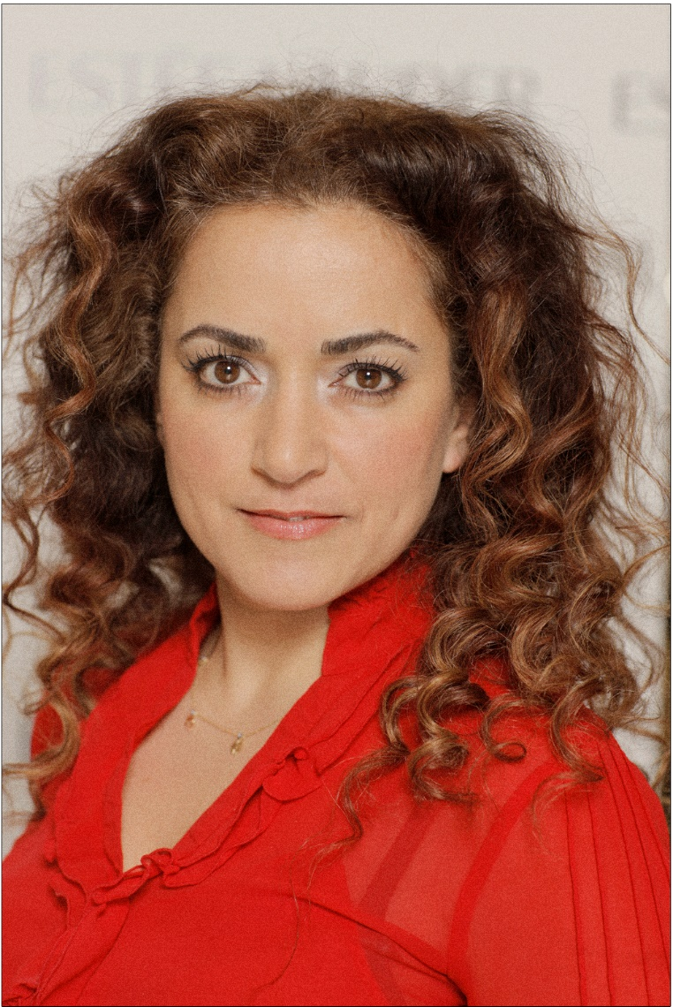
About Research Topic
Clostridioides difficile is an anaerobic, Gram-positive, toxin-producing bacteria, and a well-established cause of nosocomial diarrhoea [1,2]. Infection with Clostridioides difficile is associated with increased morbidity and mortality [3,4], as well as an economic burden to the health care system [5,6]. Despite standard-care treatment, 25–60% of patients experience recurrence of Clostridioides difficile infections (CDI) [7]. Current treatment modalities for recurrent CDI (rCDI) are vancomycin, fidaxomicin and/or Faecal Microbiota Transplantation (FMT). FMT preceded by antibiotic treatment being the most effective treatment option [8–10] with cure rates between 60% and 90% and reduced risk of new recurrences [11]. However, the production method and mode of delivery of FMT varies considerably between studies, and the optimal route of administration is so far unknown [12–14]. Encapsulated FMT is easily administered compared with rectal administration and is a highly effective treatment option with cure rates comparable to other modes of delivery [15]. At Copenhagen University Hospital Hvidovre (CUHH), FMT treatment is managed in the Department of Infectious Diseases, whereas other Danish FMT centres are centred at Departments of Gastroenterology. Therefore, FMT via endoscopy is rarely offered in CUHH, whereas it is more routinely used in the other centres [16]. At CUHH an alternative treatment option, rectal bacteriotherapy (RBT), has been applied. RBT consists of a standardised bacterial mixture of 12 well-defined bacteria strains [17,18].
References:
- Leffler, D.A.; Lamont, J.T. Clostridium difficile infection. N. Engl. J. Med. 2015, 372, 1539–1548.
- Magee, G.; Strauss, M.E.; Thomas, S.M.; Brown, H.; Baumer, D.; Broderick, K.C. Impact of Clostridium difficile-associated diarrhea on acute care length of stay, hospital costs, and readmission: A multicenter retrospective study of inpatients, 2009–2011. Am. J. Infect. Control 2015, 43, 1148–1153.
- McFarland, L. Epidemiology, Risk Factors and Treatments for Antibiotic-Associated Diarrhea. Dig. Dis. 1998, 16, 292–307.
- Reveles, K.R.; Lee, G.C.; Boyd, N.K.; Frei, C.R. The rise in Clostridium difficile infection incidence among hospitalized adults in the United States: 2001–2010. Am. J. Infect. Control 2014, 42, 1028–1032.
- Le Monnier, A.; Duburcq, A.; Zahar, J.-R.; Corvec, S.; Guillard, T.; Cattoir, V.; Woerther, P.-L.; Fihman, V.; Lalande, V.; Jacquier, H.; et al. Hospital cost of Clostridium difficile infection including the contribution of recurrences in French acute-care hospitals. J. Hosp. Infect. 2015, 91, 117–122.
- Braae, U.C.; Møller, F.T.; Ibsen, R.; Ethelberg, S.; Kjellberg, J.; Mølbak, K. The Economic Burden of Clostridioides difficile in Denmark: A Retrospective Cohort Study. Front. Public Health 2020, 8, 562957.
- Kelly, C.P. Can we identify patients at high risk of recurrent Clostridium difficile infection? Clin. Microbiol. Infect. 2012, 18 (Suppl. 6), 21–27.
- Ianiro, G.; Maida, M.; Burisch, J.; Simonelli, C.; Hold, G.; Ventimiglia, M.; Gasbarrini, A.; Cammarota, G. Efficacy of different faecal microbiota transplantation protocols for Clostridium difficile infection: A systematic review and meta-analysis. United Eur. Gastroenterol. J. 2018, 6, 1232–1244.
- Quraishi, M.N.; Widlak, M.; Bhala, N.; Moore, D.; Price, M.; Sharma, N.; Iqbal, T.H. Systematic review with meta-analysis: The efficacy of faecal microbiota transplantation for the treatment of recurrent and refractory Clostridium difficile infection. Aliment. Pharmacol. Ther. 2017, 46, 479–493.
- van Prehn, J.; Reigadas, E.; Vogelzang, E.H.; Bouza, E.; Hristea, A.; Guery, B.; Krutova, M.; Norén, T.; Allerberger, F.; Coia, J.E.; et al. European Society of Clinical Microbiology and Infectious Diseases: 2021 update on the treatment guidance document for Clostridioides difficile infection in adults. Clin. Microbiol. Infect. 2021, 27 (Suppl. 2), S1–S21.
- Baunwall, S.M.D.; Lee, M.M.; Eriksen, M.K.; Mullish, B.H.; Marchesi, J.R.; Dahlerup, J.F.; Hvas, C.L. Faecal microbiota transplantation for recurrent Clostridioides difficile infection: An updated systematic review and meta-analysis. eClinicalMedicine 2020, 29–30, 100642.
- Kao, D.; Roach, B.; Silva, M.; Beck, P.; Rioux, K.; Kaplan, G.G.; Chang, H.J.; Coward, S.; Goodman, K.J.; Xu, H.; et al. Effect of Oral Capsule- vs Colonoscopy-Delivered Fecal Microbiota Transplantation on Recurrent Clostridium difficile Infection: A Randomized Clinical Trial. JAMA 2017, 318, 1985–1993.
- Jiang, Z.-D.; Jenq, R.R.; Ajami, N.J.; Petrosino, J.F.; Alexander, A.A.; Ke, S.; Iqbal, T.; Dupont, A.W.; Muldrew, K.; Shi, Y.; et al. Safety and preliminary efficacy of orally administered lyophilized fecal microbiota product compared with frozen product given by enema for recurrent Clostridium difficile infection: A randomized clinical trial. PLoS ONE 2018, 13, e0205064.
- Youngster, I.; Sauk, J.; Pindar, C.; Wilson, R.G.; Kaplan, J.L.; Smith, M.B.; Alm, E.J.; Gevers, D.; Russell, G.H.; Hohmann, E.L. Fecal Microbiota Transplant for Relapsing Clostridium difficile Infection Using a Frozen Inoculum From Unrelated Donors: A Randomized, Open-Label, Controlled Pilot Study. Clin. Infect. Dis. 2014, 58, 1515–1522.
- Cold, F.; Baunwall, S.M.D.; Dahlerup, J.F.; Petersen, A.M.; Hvas, C.L.; Hansen, L.H. Systematic review with meta-analysis: Encapsulated faecal microbiota transplantation—Evidence for clinical efficacy. Ther. Adv. Gastroenterol. 2021, 14, 17562848211041004.
- Hvas, C.L.; Dahl Jørgensen, S.M.; Jørgensen, S.P.; Storgaard, M.; Lemming, L.; Hansen, M.M.; Erikstrup, C.; Dahlerup, J.F. Fecal Microbiota Transplantation Is Superior to Fidaxomicin for Treatment of Recurrent Clostridium difficile Infection. Gastroenterology 2019, 156, 1324–1332.
- Tvede, M.; Tinggaard, M.; Helms, M. Rectal bacteriotherapy for recurrent Clostridium difficile-associated diarrhoea: Results from a case series of 55 patients in Denmark 2000–2012. Clin. Microbiol. Infect. 2015, 21, 48–53.
- Tvede, M.; Rask-Madsen, J. Bacteriotherapy for chronic relapsing clostridium difficile diarrhoea in six patients. Lancet 1989, 1, 1156–1160. [CrossRef

