Abstract

Title: A Case Report of Acute Lymphoblastic Leukemia cured by Homeopathy

Dr.Ghulam Yaseen
Saher Welfare Foundation, 24-Allama Iqbal Road, Lahore
dryaseen22@gmail.com

Keywords: Acute Lymphoblastic Leukemia, Homeopathy,

- Abstract
Background
Acute lymphoblastic leukemia (ALL) is a cancer of lymphoid line of blood cells characterized by pallor complexion, progressive fatigue, easy bruising and bleeding, enlarged lymph nodes with bone pains. Incidents of ALL are growing globally with fatal results¹. A demographic report published by United Nations showed that 53000 cases of ALL were recorded in 2016 worldwide.
Case presentation
A pre-diagnosed case of acute lymphoblastic leukemia of a 5 years old girl, presented in Homeopathic OPD after the extensive treatment of chemotherapy, with no curative effects. She had recurrent chest infection with 85% blast cells and raised level of WBCs (73.9 x103/l). Her hemoglobin level (7.1g/dl) and Platelets count (33x103/l) was very low. The condition of patient improved clinically upon individualized Homeopathic treatment plan.
Conclusion
This report highlights the potential effects of Homeopathic medicines in the cure of Acute Lymphoblastic Leukemia, where the other persuasive treatments are rife and causing short to long term side effects of medicines.

- Image:

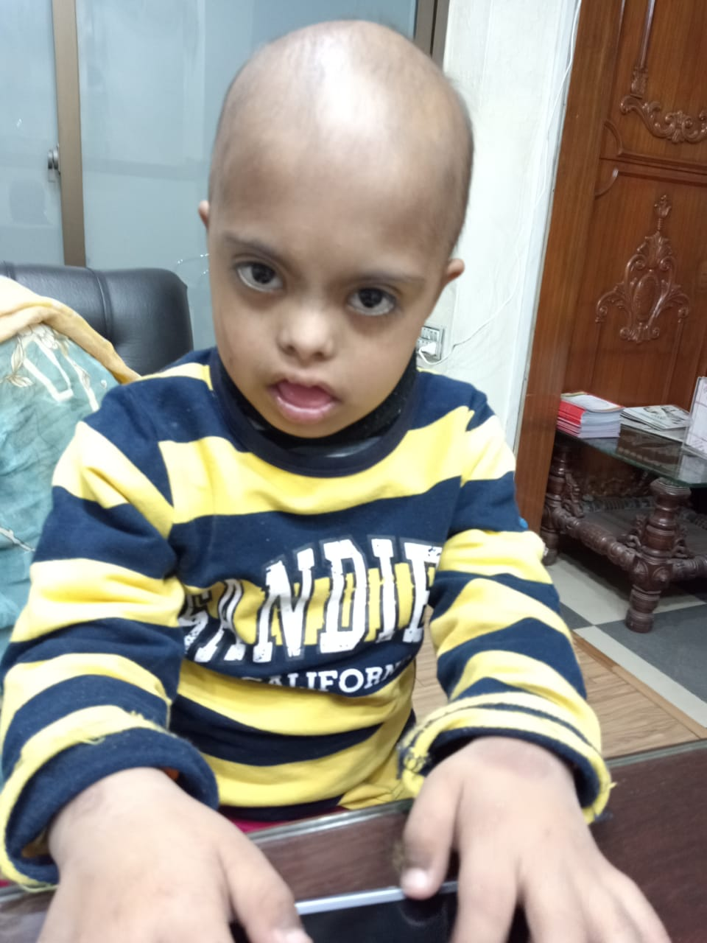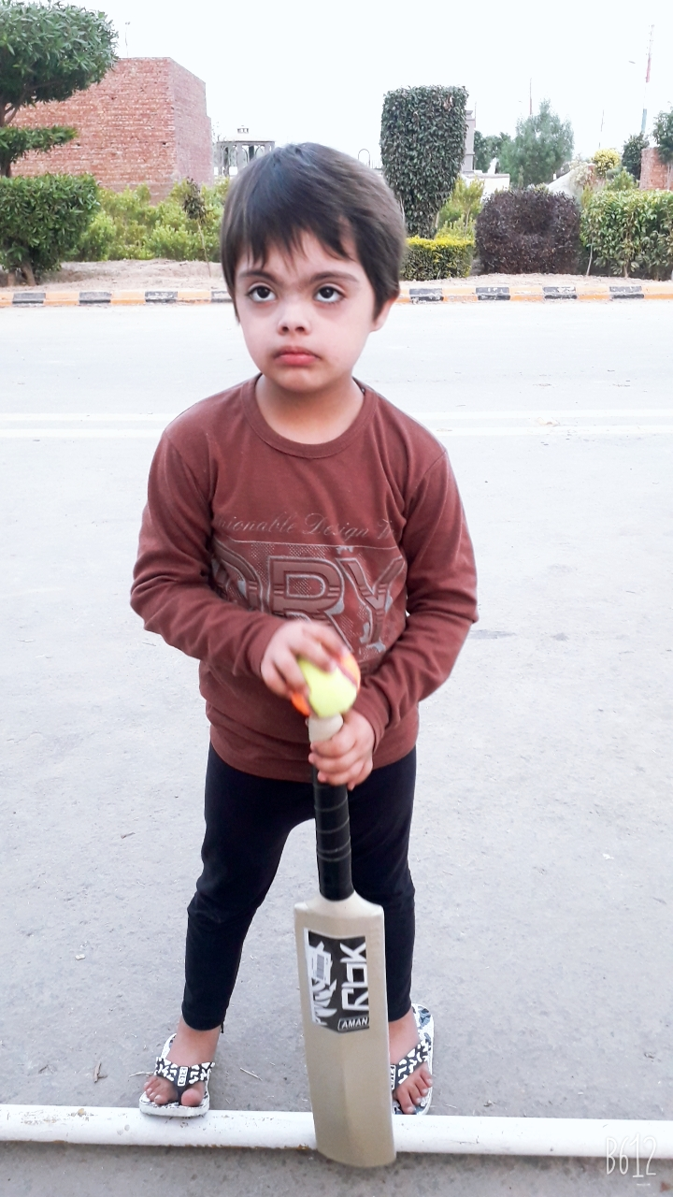

- Reference:
- Ching-Hon Pui,M.D.,and William E. Evans, Pharm.D. 2006, Treatment of Acute Lymphoblastic Leukemia, Engl J Med 2006; 354:166-178
- Biography:
Dr.Ghulam Yaseen has completed his medical graduation (BHMS) from University of Peshawar. He is the President of a non-government organization, Saher Welfare Foundation that treats blood disorder. He is treating Thalassemia, Hemophilia and all types of blood cancers through Homeopathic medicines from 2000. He has presented several cases, cured by Homeopathy in many national and international conferences.
- Presenting author details

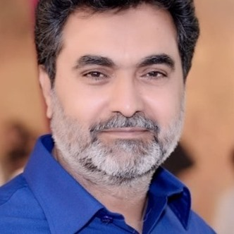
Full Name: Dr.Ghulam Yaseen
Contact number: 0322-4248823
Twitter account:dryaseen21h
Linked In account:
Session name/ number:
Category: Oral presentation
Passport Number: E0147432

