Abstract

Title. Economic evaluations in TCM: necessary elements of an analysis model for assessing costs, benefits, effectiveness and utility

Mucelli Attilio¹, Liakh Olena²
¹Department of Management, School of Economics “Giorgio Fuà”, Università Politecnica delle Marche, Ancona, Italy

²Department of Law, Università di Macerata, Macerata, Italy

Keywords: Traditional Chinese Medicine (TCM), Cost-Benefit Analysis (CBA), Cost-Effectiveness Analysis (CEA), Cost-Utility Analysis (CUA), QALY

- Abstract Body (up to 250 words)
This study provides the much-needed evidence on the potential benefits of Traditional Chinese Medicine (TCM) practices with respect to their costs. In order to define the framework of analysis, different economic evaluations for the healthcare sector are described first. From an initial appraisal it appears that the ones that are possibly applicable to TCM are cost-effectiveness (CEA), cost-utility (CUA) and cost-benefit (CBA) analysis. Nevertheless, only CEAs and CUAs have been widely used for assessing the relative effectiveness of TCM, whereas very few CBAs have been performed so far, due to the challenge of attributing a monetary value to health. What is more, current cost-effectiveness research in TCM lacks the necessary quality and standardization of a proper analysis model. Therefore, based on the findings of the literature review, a possible approach was structured, describing the suggested steps and necessary tools that would have to be adopted in order to run a complete appraisal of the cost-effectiveness of TCM.

- Image:

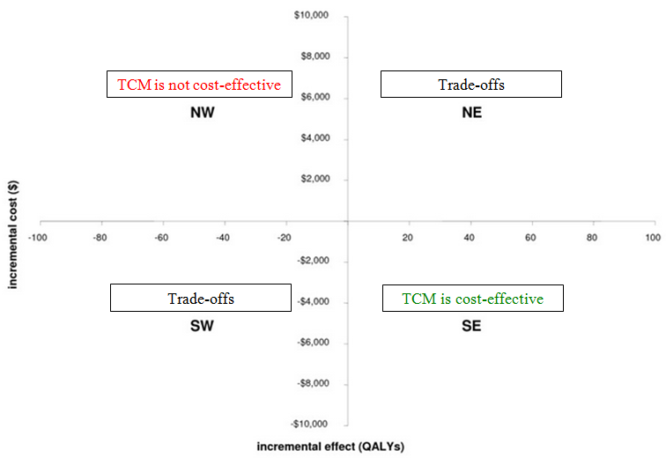

- Reference:
- Brent, R.J., 2003. Cost-Benefit Analysis and Health Care Evaluations. Edw.Elg. Publ. Ltd
- Kennedy, D.A., Hart, J., Seely, D, . Cost Effectiveness of Natural Health Products: A Systematic Review of Randomized Clinical Trials. Evidence-Based Compl. and Alt. Med., 6, 3: 297-304
- Jabbour, M., Sapko, M., Miller, D., Weiss, L. and Gross, M., 200. Economic Evaluation in Acupuncture: Past and Future. The Amer. Acup., 49
- Herman, P.M., Poindexter, B.L., Witt, C.M. and Eisenberg, D.M., 2012. Are complementary therapies and integrative care cost-effective? A systematic review of economic evaluations. BMJ Open, 2, 5
- Zhang, F., Kong, L., Zhang, Y. and Li, S., 2012. Evaluation of impact on health-related quality of life and cost effectiveness of Traditional Chinese Medicine: a systematic review of randomized clinical trials. Journal of Alternative & Complementary Medicine, 18, 12
- Wang, N., Zhang, Z. and Chang, D., 2012. Using markov model to cost-effectiveness analysis of traditional Chinese medicine interference. Zhongguo Zhong Yao Za Zhi, 37, 18
- Li, Y., Xi, H., Zhu, S. et al., 2014. Cost-Effectiveness Analysis of Combined Chinese Medicine and Western Medicine for Ischemic Stroke Patients. Chinese Journal of Integrative Medicine, 20, 8: 570-584
- Li, J., Xie, Y., Li, S. and Yu, X., 2014. Comparison of conventional medicine, TCM treatment, and combination of both conventional medicine and TCM treatment for patients with chronic obstructive pulmonary disease: study protocol of a randomized comparative effectiveness research trial. Trials Journal, 15
- Kim, S.Y., Lee, H.S., Chae, Y.B., Park, H.J. and Lee, H.J., 2012. A systematic review of cost-effectiveness analyses alongside randomised controlled trials of acupuncture. Acupuncture in Medicine, 30: 273-285
- Ambrósio, E.M.M., Bloor, K. and MacPherson, H., 2012. Costs and consequences of acupuncture as a treatment for chronic pain: A systematic review of economic evaluations conducted alongside randomised controlled trials. Compl. Ther. in Med., 20: 364-374
- Ratcliffe, J., Thomas, K.J., MacPherson, H. and Brazier, H., 2006. A randomised controlled trial of acupuncture care for persistent low back pain: cost effectiveness analysis. BMJ, London, 333
- Sun, X., Guo, L., Shang et al., 2015. The cost-effectiveness analysis of JinQi Jiangtang tablets for the treatment on prediabetes: a randomized, double-blind, placebo-controlled, multicenter design. Trials Journal, 16: 496

- Biography:
Olena got her degree in International Economics and Commerce at the Università Politecnica delle Marche and she is currently a PhD student in Legal Sciences at the University of Macerata, Italy. Her field of research is strategic controlling and cost analysis, with a focus on consolidated financial statements controlling, and the evaluation of the healthcare systems in terms of costs and benefits.
Attilio Mucelli is Associate Professor of Management Accounting and Faculty member of the ISTAO Business School. Currently he is also Visiting Professor at the Florida Gulf Coast University (USA). He has coordinated several national and international research projects on the topics of Strategy, Management Accounting, International investment flows and on the Healthcare systems, with a special focus on the integration opportunities between Europa and China.
He is member of the board of the directors, board of auditors and consultant, for Strategic planning & Management control activities, for several public and private Companies.

Presenting author details
  Full Name: Olena Liakh  Contact email: o.liakh@unimc.it  Category: (Oral presentation) |   Full Name: Attilio Mucelli  Contact email: a.mucelli@univpm.it  Category: (Oral presentation)

