Title: Immediate Effect Of Nadishodhana Pranayama On Functional Mobility In Stroke Patients
Author: Dr. Isha Tajane¹, Mr. Aditya Rajput²,
¹Associate Professor in Neurosciences Physiotherapy, K. J. Somaiya College of Physiotherapy, Mumbai, India
²Intern, K. J. Somaiya College of Physiotherapy, Mumbai, India
Keywords: Nadishodhana Pranayama, Functional Mobility, Stroke
Abstract
Yoga is said to be a practice that aims at bringing about a balance and connection between our body, mind and soul. Researchers in modern science have probed into the ancient Indian Philosophy and confirmed or discovered various positive effects of yogic practices on human physiology and psychology. According to the traditional wisdom of Yoga, Pranayama is the key to bring about psychosomatic integration and harmony. In view of inculcation of practice of Pranayama in post-stroke individuals, in particular, practice of alternate nostril breathing (ANB) has been shown to have positive effects on various cognitive and movement parameters and thus could prove consequential in accelerating recovery and restoration of function. This study aimed to determine the immediate effect of Nadishodhana Pranayama (NSP), one of the ANB techniques, on functional mobility in stroke patients. 16 ambulatory stroke patients with adequate cognition attending outpatient Physiotherapy rehabilitation unit participated. Each participant performed 3O cycles of NSP with simple mindful breathing. Performance of a functional mobility task was assessed using Timed Up and Go Test (TUGT). A mean reduction of 6.63 ± 2.77(SD) seconds, in the time taken for TUGT after the intervention of NSP was statistically significant (Wilcoxon Signed Rank test; p<0.00001). This difference very evidently surpassed the Minimal Detectable Change of 2.9 seconds reported in the literature for TUGT in stroke population. Thus, it can be concluded that the practice of Nadishodhana Pranayama immediately improves the efficiency of performance of functional mobility in ambulatory stroke patients. This simple form of ANB could prove useful in prevention of or reducing the risk of falls in stroke patients and also improving their confidence on carrying out functional ambulation independently. It is a simple and cost effective technique that can be inculcated in regular practice during therapy or at home and is with minimal or no limitations, drawbacks or side effects. From the point of view of physical rehabilitation, integration of simple yoga practices which bring about a difference in the body’s functional performance could be of colossal significance.
Image
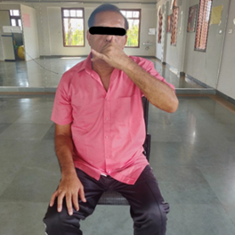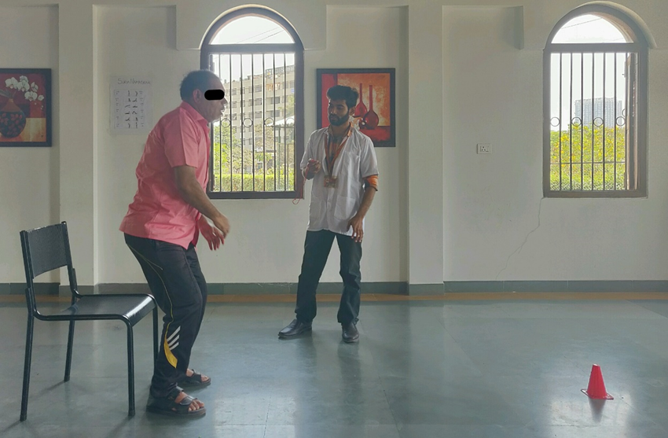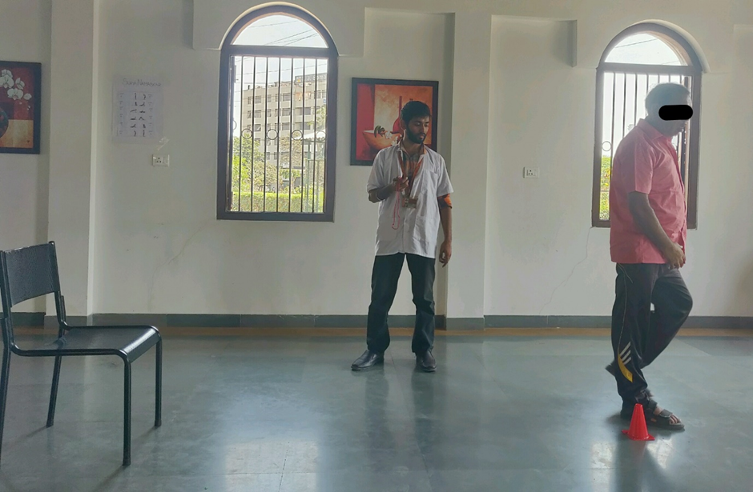
- NDP (b) & (c) TUGT- Rising from sitting position &
Walking 3 meters respectively

References:
- Garg R., Malhotra V., Tripathi Y., Agarawal R. Effect of Left, Right and Alternate Nostril Breathing on Verbal and Spatial Memory. Journal of Clinical and Diagnostic Research.2016; 10(2): CC01-CC03
- Telles S., Gupta R., Yadav A., Pathak S., Balkrishna A. Hemisphere specific EEG related to alternate nostril yoga breathing. BMC Res Notes.2017; 10:306.
- Subbalakshmi N., Saxena S., Urmimala, D’Souza U. Immediate effect of ‘Nadi-Shodhana Pranayama’ on some selected parameters of cardiovascular, pulmonary, and higher functions of brain. Thai journal of physiological sciences. 2005, 18(2):10-16.
- Lazaridou A., Philbrook P., Tzika1 A. Yoga and Mindfulness as Therapeutic Interventions for Stroke Rehabilitation: A Systematic Review. Hindawi Publishing Corporation Evidence-Based Complementary and Alternative Medicine 2013, Article ID 357108:1- 9.
- Schmid A., Puymbroeck M., Altenburger P., Schalk N., Dierks T., Miller K., Damush T., Bravata D., Williams L. Poststroke Balance Improves with Yoga: A Pilot Study. Stroke 2012; 43:2402-2407.

Biography:
Dr. Isha Tajane has completed her Masters in Neurosciences Physiotherapy from the Maharashtra University of Health Sciences, India. She is an Associate Professor in Neurosciences Physiotherapy and Guide for postgraduate studies and In charge of pediatric neurorehabilitation unit at K. J. Somaiya College of Physiotherapy, Mumbai, India. She has published and presented many papers in various national and international conferences and has been serving as a reviewer for journals of repute. She has authored a book on ‘Visual Perception’. She is well versed with the advanced technological equipment used for assessment and therapy in neurological conditions. She has served as an international faculty for balance and mobility academy, USA.

Presenter Author details:

Full name: Isha Ganesh Tajane
Contact number: 91-9769490996
Twitter Account: -
Linked In account: https://in.linkedin.com/in/isha-akulwar-4ab5a073
Session name/ number:
Category: e-poster presentation
Passport number: S2266512

