ABSTRACT TEMPLATE

I.Title: Management of Asthma by Homeopathy
By Dr. Pappur Nikunj., MEHER HOMEO WELLNESS CARE, VISAKHAPATNAM., A.P., INDIA.
Key Words: Different types of Asthma, Summarize the Scope of Homeopathy in Asthma.
- ABSTRACT BODY:
Asthma is such distracting disease and when asthma patient comes to the doctor she is so much distressed from the bronchial spasm needs immediate relief from the acute bronchial spasm and shortness of breath, otherwise the patient will go to hypoxemia condition. There is no enough time in a homeopath hand to ask the detail totality symptoms to give a similimum that can give instant relief. The first step is to make the patient free from the bronchial spasm and make him easy in breathing. For that we should be adequately experienced to study the symptoms from the patient’s attitude and facial expression then to give those remedies in frequent doses to make the patient easy to breath. Here in this way we can give the patient an immediate relief and during that period we can take the detail case history and can give the constitutional remedy what comes from his totality symptoms. So, I applied two way of treatment. First, I try to relieve the acute symptoms which are highly required to make one patient getting relief from his distracting asthma symptoms. Then I take the total case history and select the medicine as per the totality of symptoms. The acute remedies are given at the time of acute attack and along with side by side the constitutional remedies are given for stimulating his immune system. I have achieved grand success with this approach of treatment. It has been my 30 years of expertise in treating successfully Asthma Patients….
- Reference:
Kent Repertory, Boger Repertory, Allen Key Notes.
- Biography:
Dr Pappur Nikunj, Ph.D., worked as Specialist in Homeopathy in Al-Noor Hospital, Abu Dhabi, in U.A.E., in 2005 to 2006, M. Fellow in Homeopathy in Malaysia by Faculty of Homeopathy, Bascic Life Support in Cardiac Emergency Care-Pro, by American Life Support Care, in U.A.E., Ph.D., in Thyroid Cancer Research, in 2009., worked as Asst. Professor & Associate Professor in Mizan Tepi University, & Adigrat Universiy, (Govt. Universities)., in Ethiopia., (East Africa)., working as Associate Professor/ Principal, in Jagannadh Institute of Medical Sciences,
I have Participated & Presented Scientific Papers on Obesity & Skin Diseases Treatment by Homeopathy in 7 International Homeopathy Conferences in, Dubai., Abu Dhabi, Malaysia, Ethiopia & London, United Kingdom.
IV.


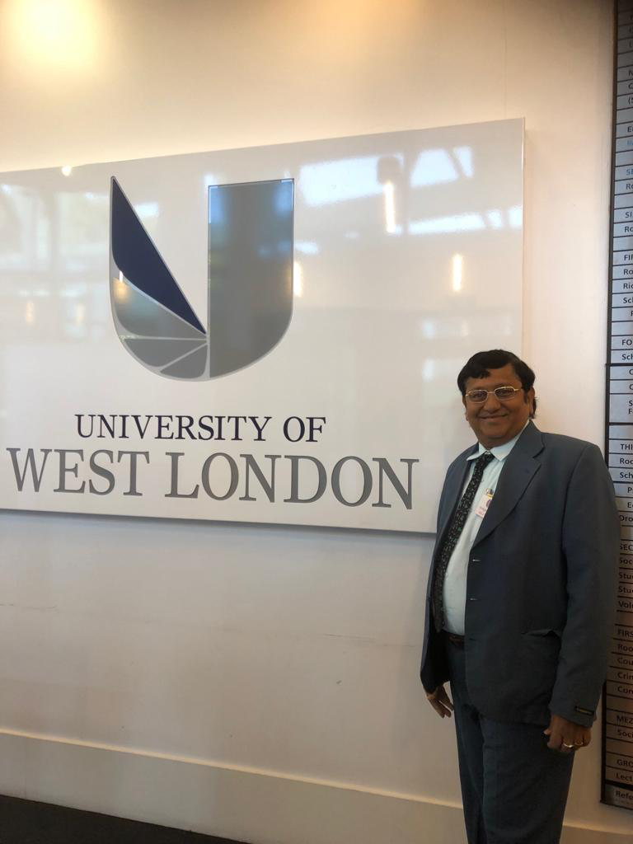
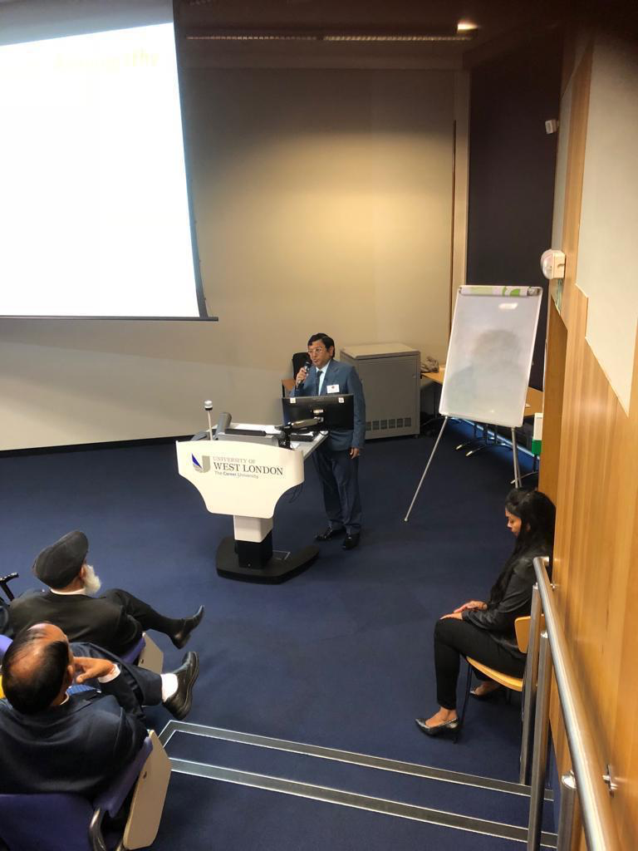
I have given Lecture on "Management of Psoriasis by Homeopathy" in International Homeopathy Congress-London, on 29th September' 2018.,
appreciated by the British, Europe, India, Canada, Homeopathy Doctors in University of West London.

- Presenting Authors Details:
Full Name: Dr. PAPPUR NIKUNJ, Ph.D.,
Contact Number: +91-8885095209 & UK Number: +44-7365918998
Twitter Account: drnpappur
LinkedIn: drnpappur
Session: Conference.,
Category: Oral Presentation
Passport No: Z3749608

