Abstract
Title: Rational use of Traditional Medicine in a district in Ghana
Bio FY¹, Amoa – Gyarteng KG²,
¹Bramuo Medical Centre, Kumasi, Ghana.
²School of Medical Sciences, Kwame Nkrumah University of Science and Technology, Kumasi, Ghana
Keywords: Traditional medicine, district, Ghana  - Abstract Body  It is also estimated that from the cradle to the grave, about 80 % of Africans rely on traditional medicine for their health care needs.  The objective of this study is to assess the extent of rational selection and use of traditional medicine in a district in the Eastern Region of Ghana. This was a cross-sectional descriptive study carried out in a district in the Eastern Region in April/May, 2016. The questionnaire was administered by interview to respondents in their homes and workplaces. The majority of respondents, 161 (80.5%) had used at least one form of traditional medicine, while 39 (19.5%) had never used traditional medicine. As many as 123 (76.4%) of the users most commonly used oral preparations. There was however no gender difference statistically in the use of traditional medicine, 57 (80.3%) male and 104 (80.6%) female, but more predominantly used among the elderly than the younger population. In the opinion of the majority of respondents, 118 (59.0%), inaccessibility and lack of faith, 60 (30.0%), in orthodox medical care the main barriers to the use of orthodox medicine and therefore attract them to use traditional medicine rather than cost. The use of traditional medicine is very predominant among the population. It is much more patronised by the elderly than the younger population, but there is no gender difference. The most significant barriers to the use of orthodox medicine are inaccessibility and lack of faith in health facilities rather than cost | - Reference  - Bagozzi, D (2003). Traditional medicine WHO Media Centre, Factsheet No 134, 2003.  - Chatora R (2003) An Overview of the Traditional Medicine situation in the African Region. African Health Monitor;4(1):4-7  - Gedif T and Hahn H-J (2003). The use of medicinal plants in self-care in rural central Ethiopia. J Ethnopharmacology, 87(2-3):155-161  - MOH (2001). Ministry of Health Annual Report, 2000-2001  - MOH (2003). Ministry of Health Annual Report, 2002-2003  - WHO (2003) Traditional medicine, WHO special report, Geneva, 2003, pp.45- 47  - WHO (2005). Traditional medicine strategy, WHO special report, Geneva 2002 – 2005, pp72 -76.  - Biography  He is a Consultant Public/Occupational Health Physician, a Fellow of the Ghana College of Physicians and Surgeons and a member of the international Commission on Occupational Health (ICOH). He is an Adjunct Associate Professor at the Robert Wood Johnson Medical School, Rutger’s University, New Jersey, USA.  He studied at The Kwame Nkrumah University of Science and Technology (KNUST), Kumasi, Ghana for his Bachelor of Medicine and Surgery (MB ChB), the University of Leeds, UK, for his Master of Public Health (MPH) and then to The University of Birmingham, UK for a PhD in Occupational Health. He is a former Director of the University Health Services of KNUST.  - Presenting Author Details  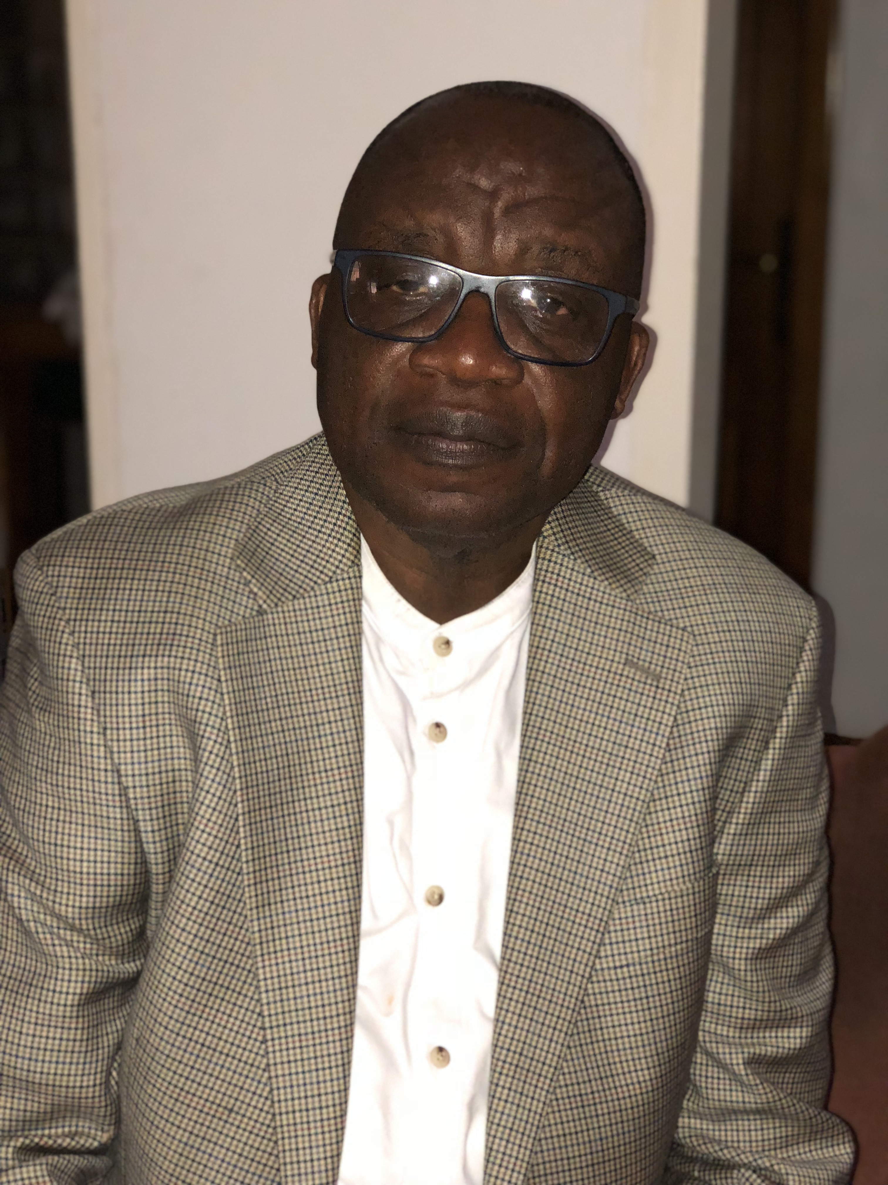  Full Name: Fred Yaw Bio  Contact number: +233 208 153302  Twitter account: @yawb97  Linked In account:  Session name/ number: Traditional Medicine  Category: Oral presentation  Passport Number:

