Evaluation of Anti-diarrhoeal Activity of Coconut Water on Castor Oil Induced-Diarrhoea in Adult Wistar Rats
Gabriel D. Edem¹, Anozeng O. Igiri², Emmanuel B. Etuk³
¹Department of Anatomy, Faculty of Basic Medical Sciences, University of Uyo, Nigeria
² Department of Anatomy, Faculty of Basic Medical Sciences, University of Calabar, Nigeria
³University of Uyo Teaching Hospital, Uyo, Nigeria

I Abstract
This study was designed to evaluate the anti-diarrhoeal activity of coconut water on castor oil
induced-diarrhoea in adult albino Wistar rats. Sixty five adult male Albino Wistar rats weighing 150– 250 g were used in this study. The study was carried out in three experiments (A, B and C).
Experiment A was the castor oil induced-diarrhoea test consisting of 25 animals randomly divided into 5 test groups. Experiment B was the gastrointestinal test consisting of 20 animals randomly divided into 4 test groups and experiment C was the castor oil induced enteropooling test consisting of 20 animals randomly divided into 5 test groups. Animals in experiment A were treated with water (control). 2 ml of castor oil/kg bd.wt, 30 ml of coconut water/kg bd.wt + 2 ml of castor oil/kg bd.wt orally, 40 ml of coconut water/kg bd.wt + 2 ml of castor oil/kg bd.wt and 4 mg of loperamide/kg bd.wt + 2 ml of castor oil/kg bd.wt in group 2, 3 4 and 5 respectively. Light
microscopic observations were made on formalin-fixed, 5 μm thick paraffin sections of stomach
stained with haematoxylin stains. Animals in experiment B were tested for anti-motility effect of
coconut water using charcoal meal and were treated with water (control), 30 ml of coconut
water/kg bd.wt, 40 ml of coconut water/kg bd.wt and 4 mg of loperamide/kg bd.wt in group 2, 3 and 4 respectively. Animals in experiment C were tested for intestinal fluid accumulation and were treated with 2 ml/kg bd.wt of castor oil (control), 30 ml of coconut water/kg bd.wt + 2 ml of castor oil/kg bd.wt, 40 ml of coconut water/kg bd.wt + 2 ml of castor oil/kg bd.wt and 4 mg of
loperamide/kg bd.wt + 2 ml of castor oil/kg bd.wt in group 2, 3 and 4 respectively. Result from this study revealed that coconut water given orally to rats in all the experimental test groups
significantly reduced copious diarrhoea, inhibit charcoal transit in the small intestine, inhibit
intestinal fluid accumulation which was comparable to loperamide, the standard anti-diarrhoeal
drug. Also protects the gastric mucosa and other components of the stomach from the irritating
stimuli produced by castor oil induced-diarrhoea in a dose dependent manner. Based on these
results, we concluded that coconut water may be useful in the treatment of diarrhoea especially in areas where conventional anti-diarrhoeal drugs are not readily accessible.
II Image
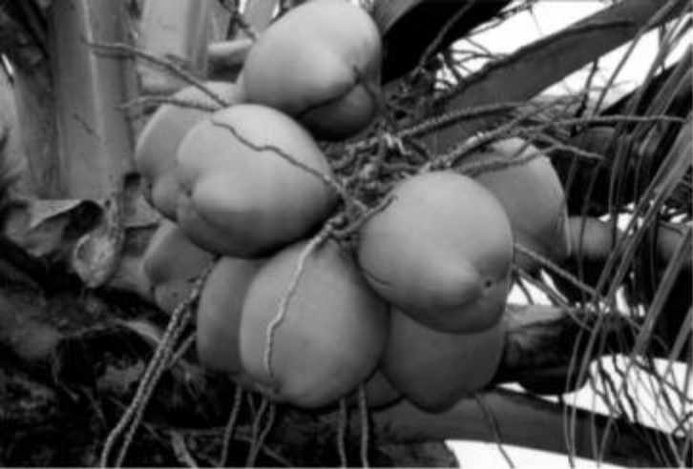
III Reference
- Punchihewa PG, Aranco RN. Coconut: Post-harvest operations. Inpho Information
Network on Post-harvest Operations;2005. Available:www.google.com

- Kuberski T. Appropriate technology: Coconut water for the oral rehydration of childhood diarrheas. New Zealand Medical Journal. 1980;91-390.

- Carpenter CC, Mondal A, Mitral PP. Green coconut water: A readily available source of potassium ion for cholera patients. School of Tropical Medicine. 1964;12:20.

- Food and Agricultural Organization (FAO). AG21: Magazine New sports drink:Coconut water.

IV Biography

Gabriel Edem is a Lecturer in the department of Anatomy, University of Uyo, He is a Researcher and is currently undergoing a Ph.D programmes in one of the Nigerian Universities. He has interest in traditional medicine

V Presenting Authors Detail


Full Name: Gabriel D Edem
Contactnumber:2347032875051
Twitteraccount:Nil
Linked In account: Facebook
Sessionname/number:
Category: (Oral presentation
Passport Number: A05577062

