Abstract

Title:
FUNCTION FUNCTIONALIZATION OF CARBON NANOTUBES FOR POLYMERS NANOCOMPOSITES DEVELOPMENT
Faisal Abbas^{1, 2}, Syed Tajammul Hussain¹, Riaz Ahmed^{, 2},
1National Center for Physics Quaid e Azam University Islamabad Pakistan
2Institute of Physics and Electronics University of Peshawar KPK Pakistan

Key words:
nanocomposites, multiwalled carbon nanotunes, functionalization, conducting organic polymers, layer-by-layer in situ polymerization
Abstract
Multi-walled carbon nanotubes (MWCNTs) have been functionalized by H₂SO₄:HNO₃ and HNO₃:H₂O₂ treatments. Nanocomposite materials of conducting organic polymers and CNTs were obtained by in-situ and chemical polymerization of functionalized MWCNTs and the corresponding monomer. The synthetic, morphological and electrochemical properties of PPY/CNTs, PANI/CNTs, PTh/CNTs, and PPY+PANI+PTh/CNTs nanocomposites were compared. The functional groups attached to the surface of MWCNTs have been confirmed by using Fourier Transform Infrared Spectroscopy (FTIR). Elemental analyses have been done by using Rutherford Back Scattering (RBS) techniques and Particle Induced X-ray emission (PIXE) by using 5MV Pelletron Tandem Accelerator. The samples were heat treated at high temperature to get the samples free from impurities. The properties of these samples have been characterized using particle size analyzer, X-ray Diffractometer (XRD), Scanning Electron Microscope (SEM), Energy Dispersive X-ray Spectroscope (EDX), and Thermo Gravimetric /Differential Thermal Analysis (TG/ DTA). Dielectric properties including dielectric constant, dielectric loss and electrical properties like conductivity were measured by LCR-meter. AC and DC conductivities have been measured by using 2-probe and 4-probe methods. TGA results showed the enhancement in thermal stability of the polymers by the addition of MWCNTs. Electrical conductivity is also considerably increased with the addition of MWCNTs in polymers. Frequency dependent AC conductivity was found to follow the universal Power Law. Dielectric studies of the nanocomposites also exhibited significant increase in dielectric constant and loss factor with the addition of MWCNTs in the composites which has been attributed to hopping of electrons in the MWCNTs.
- Image:
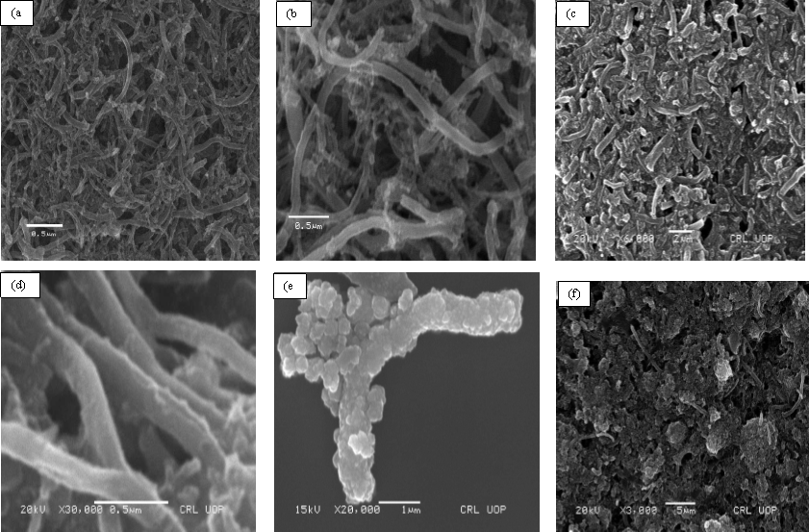

- Reference:
Paper Published:
- New polyaniline/polypyrrole/polythiophene and functionalized multiwalled carbon nanotube-based nanocomposites: Layer-by-layer insitu polymerization
Syed Tajammul Hussain1, Faisal Abbas1, Ayesha Kausar1 and Muhammad Riaz Khan2
1Nanosciences and Catalysis Division, National Centre For Physics, Quaid-i-Azam University Campus, Islamabad, Pakistan
2 Institute of Physics and Electronics, Department of Physics, University of Peshawar, Pakistan
Journal Link:
High Performance Polymers 1–9 ª The Author(s) 2012
Reprints and permission: sagepub.co.uk/journalsPermissions.nav
DOI: 10.1177/0954008312456048
hip.sagepub.com
- Facile Synthesis and Properties of Multilayered Polyaniline/Polypyrrole/Epoxy/Polystyrene/Functionalized Carbon Nanotube Composites
Saima Nawaz1,2, Muhammad Siddiq2, Ayesha Kausar1, Syed Tajammul Hussain1, and Faisal Abbas1
1 Nanosciences and Catalysis Division, National Center for Physics, Quaid-i-Azam University
Campus, Islamabad, Pakistan
2 Department of Chemistry, Quaid-i-Azam University, Islamabad, Pakistan
Journal Link:
Polymer-Plastics Technology and Engineering, 53: 661–670, 2014
Copyright # Taylor & Francis Group, LLC
ISSN: 0360-2559 print=1525-6111 online
DOI: 10.1080/03602559.2013.874032
- One-pot synthesis of a composite of monodispersed CuO nanospheres on carbon nanotubes as anode material for lithium-ion batteries
Syed Mustansar Abbas, Syed Tajammul Hussain, Saqib Ali, Faisal Abbas, Nisar Ahmad, Nisar Ali, Yaqoob Khan
PAPER link:
https://www.sciencedirect.com/science/article/abs/pii/S0925838813011298
https://www.infona.pl/resource/bwmeta1.element.elsevier-05ecda10-ddd1-3bc6-9f5e-889b57ffd2ac
M.Phil Thesis Topic:
- Biography:
Has completed Phil Physics and research work experience of 3 years in the field of Nanotechnology. Published one research paper and has research contribution in two international papers as mentioned above. Also has 6.5 years teaching and administrative experience in Government High School Mowara. Write thesis on above research topic of about 120 pages. Presented work as a speaker in international conference at national center for physics and also three time participated in poster presentation.
- Presenting author details


Full Name: Faisal Abbas
Contact number:+923455389517
email: janjuaphysicist@gmail.com
Raja_faisal143@yahoo.com
Linked In account:
Session name/ number:
Category: (Oral presentation/ Poster presentation)
Passport Number:

