Abstract Template

Title: Antioxidant and antibacterial effects of essential oils
Atlas Pistachio (pistacia atlantica)

TERRAS Mohamed ¹, BERROUKECH Abedlkrim ²,
¹Laboratoire resources Hydrique et Environnement, université Dr.Tahar Moulay , Saida , Algérie
² Laboratoire resources Hydrique et Environnement, université Dr.Tahar Moulay , Saida , Algérie

Keywords: antioxidant activity, antibacterials, chemical compounds, pistachio atlas, Saida, Algeria

- Abstract Body (up to 250 words)

At the level of the wilaya of Saida (Algeria), the genus pistacia is represented by three species; pistachio atlas, pistachio lentiscus and pistachio terebinth.
The pistachio tree of the atlas is resistant to the conditions of the region (cold during the winter and prolonged drought during the summer period) as well as the type of soil slightly deep and low in organic matter.
Indeed, the natural antioxidants are the subject of many researches whose final objective the exploitation of the secondary metabolites notably the polyphenols as well in the health and vis-à-vis the diseases related to the modes of feeding (cancer) as in food industry. These compounds, which are represented by the flavonoid family (flavonols, isoflavonoles, flavones, isoflavones, flavanes, isoflavans, flavanols, isoflavanols, flavanones, isoflavanones, aurones and anthocyanidins), are widely sought after for their biological properties: anti-oxidants, anti-inflammatories , antibacterial and anti-carcinogenic. Noting that the potent effectiveness of these substances in stopping radical reactions by neutralizing free radicals is mainly due to their phenolic structures.
The antioxidant compounds are the subject of many works for their anti-oxidant effects, we are interested in this work to the study of phenolic compounds and the evaluation of the antioxidant properties of extracts of pistacia atlantica, The second part is the study the antimicrobial activity of the essential oil of Pistachio in vitro. The results show a good antioxidant activity with respect to the controls used, for the antimicrobial activity activity was recorded on certain pathogenic strains including Staphylococcus aureus and Escherichia coli.

- Image:

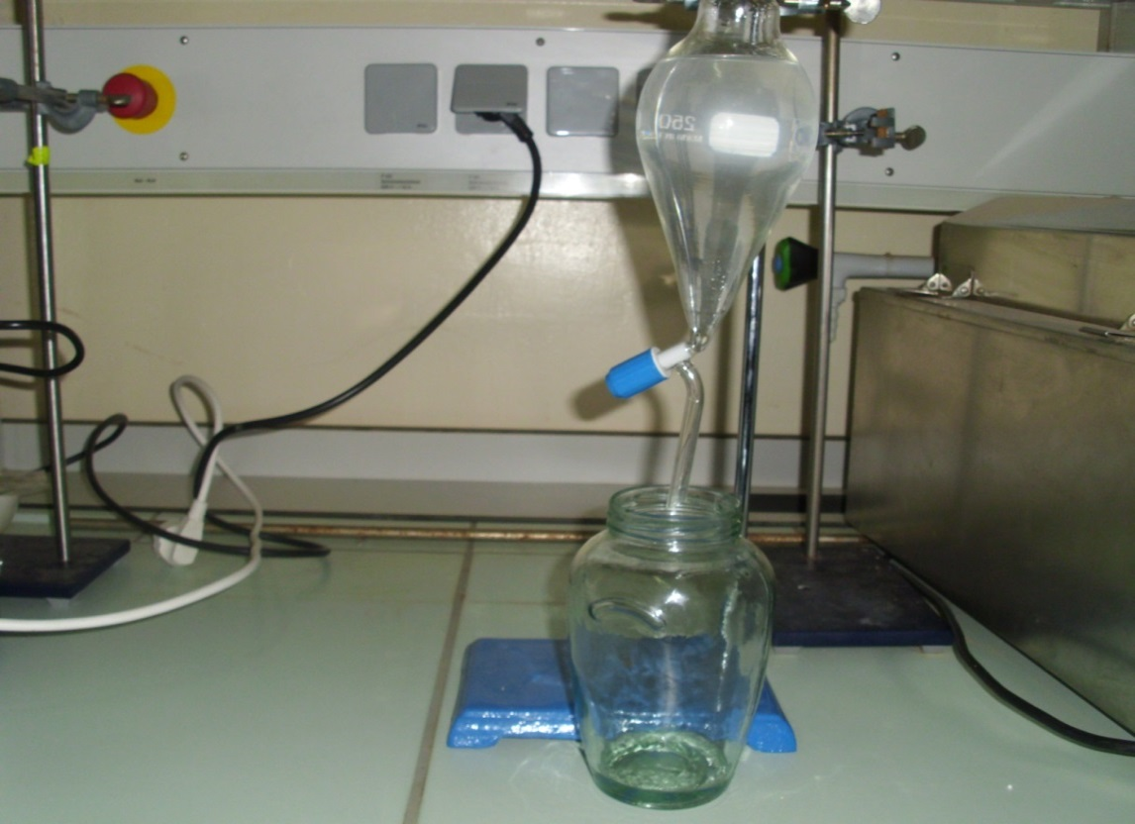
figure 1; extraction of essential oils from Pistacia atlantica

- Reference:
1-Alyaffi J, 1979 : Approche systématique et écologique du genre Pistacia de la région méditerranéenne. Th. De 3eme cycle F.S.T. ST JEROME.
2-Al-Balany, MR.(2004). Effect of crude plant extract and vasicinealkaloide of adhatoavasica in some pathogenic microorganisme. Thèse de doctorat. Faculté des sciences. Université de Baghdad. Iraq.
3-Aiyegoro, OA, et OKOH, AI, (2010). Preliminary phytochemical screening and in vitro antioxydant activities of the aqueous extract of Helichrysumlongifolium DC, BMC complement AlternMed.
4-Abdelkader yaaqobi, latifa al hafid, benyouneshaloui : étude biologique du pistacciaatlanticadesf .de la région orientale du Maroc,
Laboratoire de Biologie des Plantes et des Microorganismes, Département de Biologie. Faculté des sciences, Université Mohamed I, Oujda (Maroc).
5-Abdelkader HARFOUCHE, Nadjiba CHEBOUTI-MEZIOUet YahiaCHEBOUTI, 2005 : comportement comparés de quelques provenances algériennes du pistachier de l’atlas introduites en réserve naturelle de mergueb.

- Biography:
Dr. TERRAS Mohamed, I completed my doctoral studies in forestry in 2011, I also hold a master of science at the International Center of Advanced Agricultural Studies of Saragossa, Spain in 2003; I have authored several scientific publications and I am now working on medicinal plants in the Saida region, Algeria
- Presenting author details

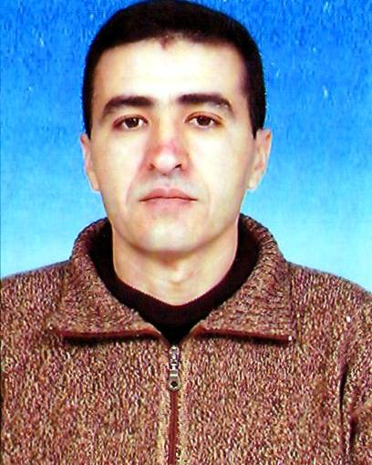
Full Name: TERRAS Mohamed
Contact number:00213560191604
Twitter account:
Linked In account:

Session name/ number:
Category: (eposter)
Passport Number:

