Abstract Template

Title: Empathy and Practitioner Burnout: How to have a happy sustainable practice

Crouch, SP ¹
¹One Medicine Integrative Health, Putney Vermont, USA, Adjunct Professor, School of Graduate and Professional Studies, Western States University. Portland, Oregon, USA.

Keywords: Practitioner Burnout, Empathy, Secondary Traumatic Stress, Psychospiritual Occupational Health and Safety, Burnout Prevention, Burnout Treatment.
- Abstract Body (up to 250 words)
Practitioner burnout is becoming a common topic of discussion in alternative medicine as well as conventional medicine. The practitioner’s capacity for empathy has been postulated to be both the cause of, and inoculation against burnout. As practitioners we are taught to practice occupational health and safety procedures regarding physical contamination, but none are taught regarding emotional, mental or spiritual contamination. Such procedures would go a long way toward preventing certain types of burnout.

Many traditional, complementary, alternative and integrative approaches spend significant time on in-depth interviewing of the patient, learning the details of their histories and in many cases their trauma history. Empathic practitioners who spend time listening to the trauma stories of their clients can sustain secondary traumatic stress. On an energetic level, the stories appear to lodge in the practitioner’s energy field in specific locations according to their compatible resonance. As the practitioner’s energy field fills with such they become saturated and burnout ensues.

Several energy practices for preventing secondary traumatic stress will be presented, and approaches to treating severe burnout will be discussed.

- Image:

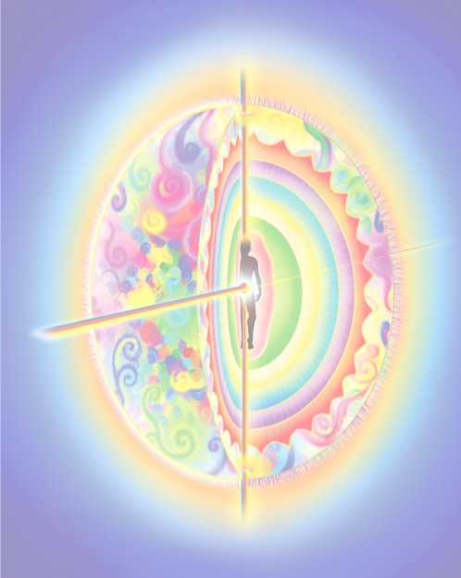

- Reference:
- Huggard, P., 2003, Compassion fatigue: How much can I give? Medial Education, 37:2 pp.163-164. Doi: 1365-2923.2003.01414.x
- Wilkinson, H., Whittington, R., Perry, L., and Eames, C., Examining the relationship between burnout and empathy in healthcare professionals: A systematic review, Burnout Research, Sept. 2017, 6, 18
- Zenasni F., Boujut E., Woerner A. and Sultan S., Burnout and empathy in primary care: three hypotheses. The British Journal of General Practice. 2012;62(600):346-347. doi:10.3399/bjgp12X652193. PMID: 22781970
- Biography:
Seroya Pauline Crouch, ND graduated from National University of Natural Medicine in Portland Oregon in 1985. She has practiced general naturopathic medicine as well as process therapy and several approaches to energy psychology. She was Director of Education at Endeavour College of Natural Health in Australia where she oversaw six practitioner programs in different disciplines. She was recently a Founding Director of the AIHM Interprofessional Fellowship in Integrative Health and Medicine, and currently lives and practices in Vermont, USA. Known as a “healer of healers” she works with all types of practitioners preventing and treating burnout and teaching energy hygiene.

- Presenting author details

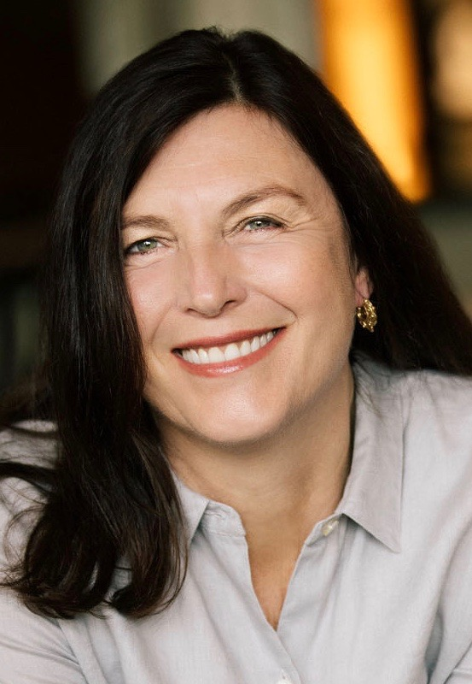
Full Name: “Seroya” Pauline Alison Crouch
Legal name on passport: Pauline Alison Crouch
Contact number: 001-707-934-7167
Twitter account: @seroya
Linked In account: Seroya Pauline Crouch ND
Session name/ number: Unknown
Category: (Oral presentation – Keynote)
Passport Number: 468159310 (USA)

