New Approach to Impact Saliva Medicinal leech in the treatment of livestock diseases

Saeed Safavi Pour, Young Researcher and Elite Club, Isfahan (Khorasgan) Branch, Islamic Azad University, Isfahan, Iran.

Abstract

Saliva Medical leeches such as Hirudomedicinalis and Hirudo Orientalis are commonly used in Hirudotherapy.This natural product contains more than 100 active substances with various therapeutic effects, including anticoagulants, vasodilators, vascular anti-obstruction, anti-inflammatory and anti-inflammatory properties. Recently, leeches have been successfully used in veterinary medicine for the treatment of many animal diseases, especially dogs, cats and horses. The most common symptom for the use of leeches in dysplasia (abnormal cells) of the hip and elbow, chronic and acute arthritis, diseases associated with swelling of the tandems, ligaments, connective tissues, vertebral diseases and wound healing. Leech Therapy is a painless method that lasts about 30 to 120 minutes, depending on the size of the animal. All leeches used in this medical procedure should originate from registered farms only. Maintaining sterile conditions for the cultivation, transfer and maintenance of medical leeches is very important to protect animals from microbial infection. Leech therapies are widely used in European veterinary medicine, especially when traditional and common treatments are not effective, the effect of treatment is very slow, or after surgery, when the tissues may have venous congestion. But in Iran this category is still not used and given the high production potential of animal and organic products in human nutrition, traditional treatment of livestock will have a special place. Leech therapy is relatively inexpensive and safe, and often when leishmaniasis fails, the leech is the best solution. Given that in most livestock farms in the country, the cost of treating a trap is daily 30% of monthly production. This is a very high cost for the producer, so, with the spread of leeches in animal diseases, it is expected that the cost of a cassette producer can be reduced by reducing the consumption of commonly used chemical drugs.

Keywords: medical leeches, saliva, treatment, traditional medicine, veterinary medicine
Image
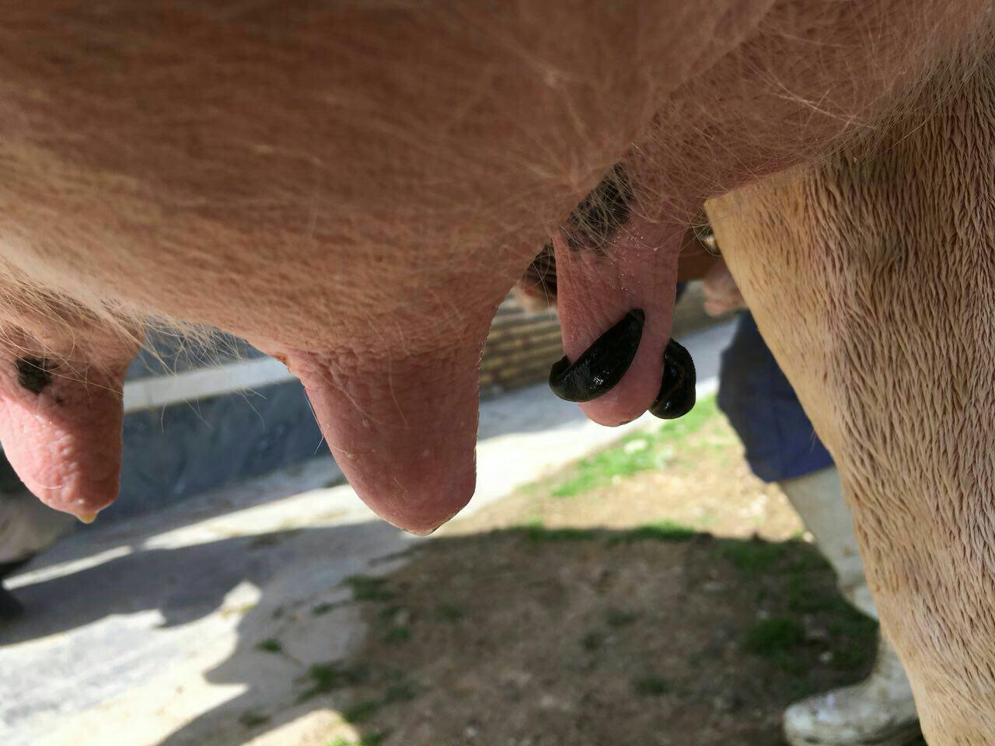
Recent publications
- Hibsh D, Schori H, Efroni S, Shefi O .2015. De novo transcriptome assembly databases for the central nervous system of the medicinalleech. Sci Data 2:150015.
- Kvist S, Min GS, Siddall ME .2013. Diversity and selective pressures of anticoagulants in three medicinal leeches (Hirudinida:hirudinidae, Macrobdellidae). Ecol Evol 3(4):918–933.
- Kantyka M., Sobczak N. 2013. Hirudotherapy – a new trend in veterinary medicine, Annals of Parasitology 59 supplement:117.
- Henne A. 2010. Blutegeltherapie bei Tieren Methodik, Indikationen und Fallbeispiele. Uni -medica, Kandern.

 Biography

I’m a Ph.D Candidate of Animal Nutrition at Isfahan Azad University. i worked on leech behavior and leech breeding in Iran in 10 years. I am member of in BAH & IAHH. in Iran i have first national leech magazine and i published each season. I am the CEO of the company Iran leech industry.

Email: Damyar.info@Gmail.com

Notes/Comments:

