Historical aspects of Black Seed (Nigella sativa) and their link to present day scientific investigations

Mohammad Akram Randhawa¹ and Qiuwei (Abdullah) Pan²

¹Department of Pharmacology, College of Medicine, Northern Border University, Arar, Saudi Arabia
²Department of Gastroenterology and Hepatology, Erasmus MC-University Medical Center Rotterdam, The Netherlands

Key words: Nigella sativa, black seed, historical aspects, ancient medicinal uses, present day scientific investigations.

I. Abstract

Nigella sativa (Black seed) is a well known herbal remedy and has been used for treatment of many ailments in Arabic, Ayurvedic, Chinese and Greek systems of medicine since ancient times. It was found in tomb of Tutankhamen (1341-1323 BC), an Egyptian pharaoh, as a burial good, perhaps, for treatment of his epilepsy or cerebral malaria in next life. Present day investigations have demonstrated its antiepiletic and antimalarial properties. It was recoverd in a pilgrim flask from monuments of Old Hittites (1650 BC) in Anatolia, Turkey, It is mentioned in some principal religeous books, like Old Testament of Bible (Isaiah, 28: 25, 27), 8th-century BC; and books of 'Hadith', i.e. sayings of Prophet Mohammad (Peace be upon him), 570-722 AD, emphasizing healing properties of black seed. It was named as 'Melanthion' by ancient Greek physicians. Hipocratus (460 - 370 BC) used it for diseases of women and children (Including vaginal and oral thrush) and Dioscorides (40-90 AD) recommended for skin conditions. Presently, studies have shown its antimicrobial and antipsoriatic effects. Galen (129-200/216 AD) prescribed it for common cold, besides many other ailments. Now it is known to possess antihistaminic and antipyretic actions. Ibn Sina (980-1037 AD), in his book “The Canon of Medicine,” has described many medicinal uses of black seed, including treatment of 'Sartan' (Cancer). Recently, many studies have reported its anticancer activity. In brief, N. sativa seed, its oil and active components have a great potential for discovery of new drugs for intractable diseases.

II. Image

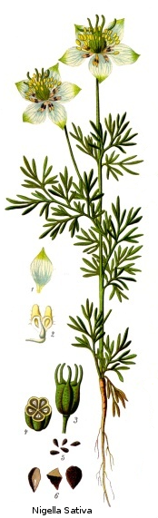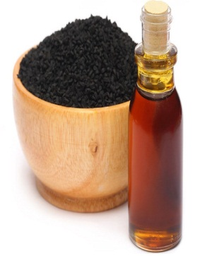

III. References

1. Hawass Z, Gad YZ, Ismail S, Khairat R, Fathalla D, et al. Ancestry and pathology in King Tutankhamun's family. JAMA. 17 Feb 2010;303(7): 638-47

2. Abdulelah, HAA and Zainal-Abidin BAH. In Vivo Anti-malarial Tests of Nigella sativa (Black Seed) Different Extracts American Journal of Pharmacology and Toxicology, 2007 2 (2): 46-50, ISSN 1557-4962.

3. Salih H.M. Aljabre, Omar M. Alakloby, Mohammad A. Randhawa. Dermatological effects of Nigella sativa. Journal of Dermatology & Dermatologic Surgery, 2015; 19(2): 92-98

4. Mohammad Akram Randhawa and Mastour Safar Alghamdi. Anticancer Activity of Nigella sativa (Black Seed) - A Review. American Journal of Chinese Medicine, 2011; 39, (6): 1075–1091

IV. Biography

Mohammad A Randhawa is a medical graduate from King Edward Medical College, Lahore, Pakistan. Possesses M Phil and Ph D degrees in Pharmacology as well as Post-graduate Fellowship in Clinical Pharmacology from St Bartholomew’s Hospital, London, UK. Currently, he is working as Professor and Head of the Department of Pharmacology, College of Medicine, Northern Border University, Arar. There are over 50 publications in international scientific journals in his account, which include some of his original contributions related to trans-membrane diffusion of drugs, gastro-esophageal reflux disease and Nigella sativa (Black seed).

V. Presenting Author Details

Prof. Dr. Mohammad Akram Randhawa
Mobile: 00966506883523
E-mail: <mrakramsa@yahoo.co.uk>
Session name/ number: Herbal Remedy
Category: Oral presentation
Passport Number: AK9772041

