Abstract Template

Title: Ayugenomics: Traditional Medicine to Modern Pharmacogenomics

Kalpana Joshi
Department of Biotechnology, Sinhgad College of Engineering Affiliated to Savitribai Phule Pune University, Pune, INDIA

Keywords: Ayurveda, Pharmacogenomics, Ayugenomics, Rasayana, rejuvination
- Abstract Body (up to 250 words)
Ayurveda is one of the most ancient and yet living traditions documented and practiced widely in India. It has strong philosophical, experiential and logical foundation that addresses health holistically. The concept of Prakriti or constitution has central role in understanding health and disease in Ayurveda. Prakriti of a person is taken into account for prescribing medicines or diet or lifestyle in Ayurveda.
Research in Ayurveda has been dominated by studies on medicinal plants and the development of herbal drugs; however, basic research which employs modern biology, immunology, and chemistry to investigate the fundamental concepts in Ayurveda such as Prakriti, panchakarma procedures, rasayanas has received little attention.
Our study for the first time established molecular basis for classification of individuals based on Tri-doshas or constitutional types^{1, 2, 3}. The findings suggested that prakriti has a genetic basis and the prakriti-based therapy is consistent with personalized medicine. We also demonstrated differential DNA methylation signatures in three distinct prakriti phenotypes revealing the epigenetic basis of dosha prakriti ⁴. These observations are likely to have significant impact on phenotype – genotype correlation, drug discovery, pharmacogenomics and personalized medicine. We also explored prakriti variation in treating asthma Ayurvedic way and found that the therapy works at the root cause of disease⁵. Rasayana in rejuvenation is another concept which was studied using stem cells⁶. It remains important to believe, respect, support traditions and also explore them using tools and techniques of modern science.

- Image:

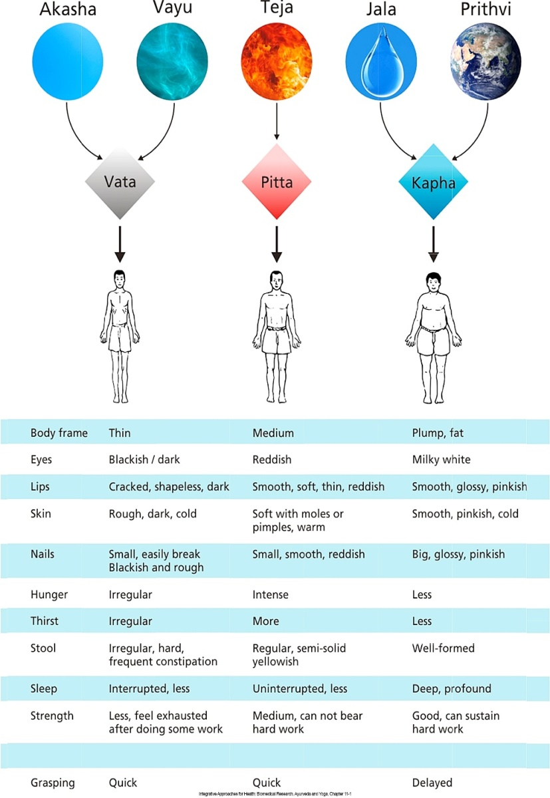
Prakriti (Constitution) of Ayurveda and five elements
- Joshi Kalpana et al. CYP2C19 gene Polymorphism associated with the metabolic variability in major constitutions described in Ayurveda Traditional Medicine to Modern Pharmacogenomics. Evid Based Complement Alternat Med Vol 2011; 2011: 249528.
- Joshi Kalpana et al. Classification of Human Population Based on HLA Gene Polymorphism and the Concept of Prakriti in Ayurveda. Journal of Alt Compl Med. 2007;11(2), 349-53.
- Kalpana S. Joshi, et al. (2015). Genome-wide analysis correlates Ayurveda Prakriti. Nature Scientific Report doi:10.1038/srep15786, 5, Article number: 15786, ISSN 2045-2322
- Kalpana S Joshi, et al. DNA Methylation Analysis of Phenotype Specific Stratified Indian Population. Journal of Translational Medicine (2015) 13:151-162, DOI 10.1186/s12967-015-0506-0, ISSN-1479-5876,
- Kalpana S Joshi et al. , Dosha Phenotype specific Ayurveda intervention ameliorates asthma symptoms through cytokine modulations: Results of whole system clinical trial. Journal of Ethnopharmacology, DOI: 10.1016/j.jep.2016.07.071(Aug 2016)
- Kalpana Joshi et al. Herbal pre-conditioning induces proliferation and delays senescence in Wharton’s Jelly Mesenchymal Stem Cells. Biomedicine & Pharmacotherapy 93 (2017) 772–778
- Biography:
Dr. Kalpana Joshi, Professor and head of the Biotechnology. Dr. Joshi’s research areas include drug discovery, Genomics and Ayurveda Biology. She lead several projects in Ayurveda Biology and public health supported by Indian Government funding agencies like DST, SERB, ICMR and Office of Principal Scientific Advisor. Recently she received prestigious M. M. Sharma award for research in Science and Technology Dr. Kalpana was Lupin Endowment Fellow at ICT (former UDCT) for the year 2010. She has published about more than 100 research papers and reviews in journals of repute with Scholar h-index 24 and over 2000 citations. She is one of the authors of top ten most cited research paper.
- Presenting author details

Full Name:Dr. (Mrs) Kalpana Shrikant Joshi
Contact number: +919881230157
Category: (Oral presentation) Passport Number: L9658073

