The Effect of Acupuncture on Working Memory and Anxiety --- Jason Bussell PhD, L.Ac

Background: Anxiety has been shown to impair working memory and test performance; and acupuncture has been shown to reduce anxiety. Objective: To investigate whether acupuncture can improve memory and reduce anxiety. Design, Setting and Subjects: A two-group, randomized, single-blind study of 90 undergraduate university students. Interventions: Subjects completed the State-Trait Anxiety Inventory (STAI) form Y-1 (State Anxiety, SA) and Y-2 (Trait Anxiety, TA). Each subject then laid on a treatment table for 20 minutes. Acupuncture group had needles inserted into select acupoints; Control subjects had points touched and swabbed, but no needles were inserted. Subjects then completed the STAI form Y-1 again. Then subjects completed the Automated Operation Span Task (AOSPAN)- a computerized test of working memory. Main outcome measures: AOSPAN and STAI scores. Results: Acupuncture group scored 9.5% higher than Control on the AOSPAN Total Correct Score (65.39 vs. 59.90 p=0.0134), and committed 36% fewer math errors (2.68 vs. 4.22, p=0.0153). Acupuncture subjects also reported lower SA after intervention than Control (26.14 vs. 29.63, p=0.0146).

Image: 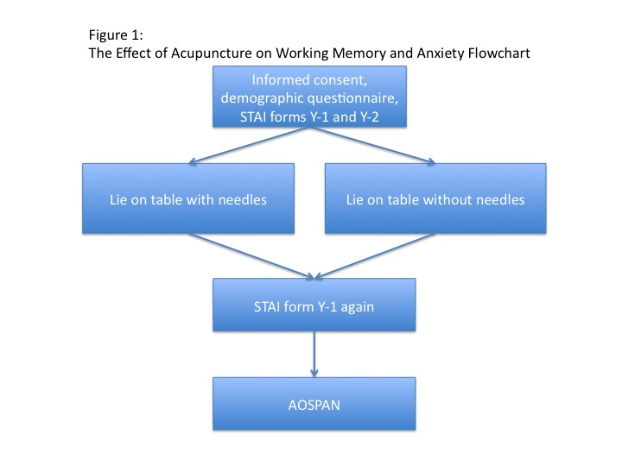

Biography: Jason Bussell is one of the first Americans to earn his PhD in Acupuncture from the Guangzhou University of Chinese Medicine. He has served as President of the Illinois Association of Acupuncture and Oriental Medicine and Vice-Chairman of the Illinois State Government’s Acupuncture Board. He has taught at the university level; and he has published articles in peer-reviewed journals, lay publications, and a book, “The Asian Diet”. Currently, he is pursuing a Masters in Public Health and another Masters in Business Administration at Johns Hopkins; and he is a post-doctoral research scholar at the Memorial Sloan Kettering Cancer Center’s Bendheim Center for Integrative Medicine. He also maintains a private acupuncture practice near Chicago.

