EFFECT OF JUR UR-4 ON ANIMAL MODEL OF DIABETES

Anu A¹*, Oyuntsetseg N¹ PhD.
¹MNUMS Mongolian International Medical University

Abstract
In Mongolia, there has been an explosive increase in prevalence of diabetes associated with unhealthy eating patterns, alcohol use and cigarette smoking. Symptoms of diabetes are similar to that of a certain condition named thirstiness in traditional Mongolian medicine. Jur ur-4 is used for treatment of thirstiness in traditional medicine. It is composed of Gardenia jasminoides Ellis., Coriandrum sativum L., Gentiana barbata Froel., and Vitis vinifera L. In this study, effects of Jur ur-4 on alloxan-induced diabetic animal models were examined. Metods: Alloxan monohydrate (120 mg/kg body weight) was administered intraperitoneally to rats. Jur ur-4 at doses of 200 and 400 mg/kg was given orally to rats 21 days after the alloxan administration. After 3, 7, 14 and 21 days of alloxan administration blood levels of glucose in measured. Pancreatic tissues were subjected to histopathological analysis. Islets density was determined at 100x magnification; thought, the islet diameter, islet’s cell number were determined at 400x magnification. Results: Average lethal dose (LD50) of Jur ur-4 was found to be 10.3 g/kg. Jur ur-4 presented no toxicity in the chronic toxicity study. After 7 to 21 days of alloxan administration, Jur ur-4 decreased blood glucose levels 2.1-2.3- and 1.7-2.4-fold at doses of 200 and 400 mg/kg respectively (p<0.05). Partial thromboplastin time was prolonged 1.8- and 1.9-fold (p<0.05) by Jur ur-4 at doses of 200 and 400 mg/kg respectively. Moreover, fibrinogen levels were decreased 1.8 fold by Jur ur-4 at dose of 200 mg/kg. Histopathological analysis revealed that Jur ur-4 (400 mg/kg) enhanced recovery of cells in the Langerhans islets of rats administered alloxan. Conclusions: Jur ur-4 is safe to animals. Jur ur-4 has an anti-hyperglycemic effect in alloxan-induced diabetic rats. Jur ur-4 inhibits blood coagulation in rats administered alloxan by prolonging partial thromboplastin time and reducing levels of fibrinogen. Moreover Jur ur-4 has protective effects againstissues.

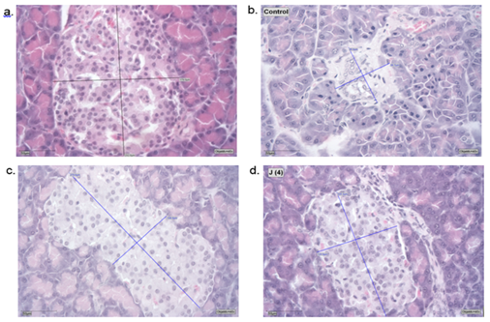
Figure 1. Photomicrographs (400x magnification) of pancreatic islets of Langerhans of normal group (a), control+Allx (120 mg/kg) group (b), Allx + Jur ur-4 (200 mg/kg) group (c), Allx + Jur ur-4 (400 mg/kg) group (d).
Note a conserved islet diameter, islet number in Jur ur-4 treated versus alloxan control group (scale bar = 50 µm)

Publications
- Uddin R, Saha MR, Subhan N, HPLC-Analysis of Polyphenolic Compounds in Gardenia jasminoides and Determination of Antioxidant Activity by Using Free Radical Scavenging Assays. Adv Pharm Bull. 2014;4(3):273-281.
- Sreelatha S, Inbavalli R, Antioxidant, antihyperglycemic, and antihyperlipidemic effects of Coriandrum sativum leaf and stem in alloxan-induced diabetic rats. J Food Sci. 2012 Jul;77(7):119-123.
- Ankur Rohilla. Alloxan Induced diabetes: mechanisms and effects. International journal of research in pharmaceutical and biomedical sciences. Apr Jun 2012;3(2):819-823
- Etuk, E.U. Animals models for studying diabetes mellitus. Agric Biol J N Am. 2010;1(2):130-134.
- Berraaouan A, Abderrahim Z, Hassane M, Abdelkhaleq L, Mohammed A, Mohamed B. Evaluation of protective effect of cactus pear seed oil (Opuntia ficus-indica L. MILL.) against alloxan-induced diabetes in mice. Asian Pac J Trop Med. 2015;8(7):532-537.



Biography

My name is Anu. Born in 1990. Master’s degree in traditional medicine in 2017. My research work is Effect of Jur Ur-4 on animal
model of diabetes. This research study will continue to study clinical trial of Jur ur-4 and possible solution to have new medicine
against second effects of diabetes.

Email: aaanuka@yahoo.com

