Scientifically Evidenced Traditional Chinese Medicine in Treating Osteoarthritis
David Y. W. Lee, PhD,
Harvard Medical School/McLean Hospital, Belmont, MA 01890 USA

Abstract
There are two major therapeutic approaches in treating human diseases. One involves the use of sophisticated molecular approach for the development of novel medicine, which target specifically at certain disease genes, receptors, or enzymes. The other involves the use of holistic approach with herbal medicine such as traditional Chinese medicine (TCM). The later trend has gain increasing popularity because Western medicine is seen either ineffective in certain chronic diseases, or produces adverse effects, or too costly. Interestingly, both Western medicine and herbal medicine share the common believe that human health is associated with functional balance. However, the Western medicine though provides fast relief of symptoms at the disease site, particularly under critical conditions, however, the single chemical entity usually targeting on single receptor site or a section of gene may not be sufficient to restore the functional balance of the entire body. On the other hand, herbal medicine with multi-components/multi-targeted approach, strives to focus on the functional balance of the body in a holistic manner. Therefore, in a broader perspective, herbal medicine should have certain advantages in dealing with human diseases especially in chronic diseases. This presentation will demonstrate the scientific basis of traditional Chinese medicine in treating osteoarthritis. TCM stands an excellence chance to serve as “Alternative Therapies” in treating human diseases in the 21st century

Image
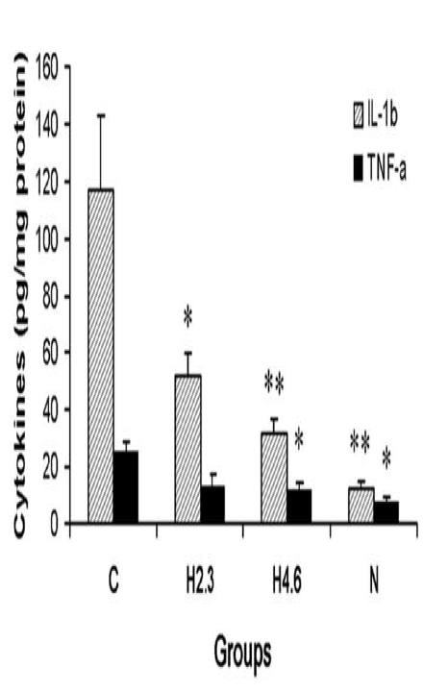
Figure 1. Effect of HLXL on IL-1β and TNF-α levels (pg/mg protein, Mean ± S.E.) 25 days post-CFA injection.

Recent Publications (minimum 5)
- Lao L, Fan AY, Zhang RX, Zhou A, Ma ZZ, Lee YWD, Ren K and Berman B. Anti-hyperalgesic and Anti-inflammatory Effects of the Modified Chinese Herbal Formula Huo Luo Xiao Ling Dan (HLXL) in Rats. Am J Chin Med 2006; 34:833-44.
- Rajaiaha R, Lee YWD, Ma Z, Lao L, Fan AY, Fong HS, Berman BM, Moudgila KD. Huo-Luo-Xiao-Ling Dan modulates antigen-directed immune response in adjuvant-induced inflammation. J Ethnopharmacol 2009;123:40-4.
- Zhang RX, Fan AY, Zhou AN, Moudgil KD, Ma ZZ, Lee YWD, Fong HS, Berman BM, Lao L. Extract of the Chinese herbal formula Huo Luo Xiao Ling Dan inhibited adjuvant arthritis in rats, J of Ethnopharmacology 2009; 121: 366-71.
- Yang YH, Rajaiah R, Lee YWD, Ma Z, Yu H, Fong HH, Lao L, Berman BM, Moudgil KD. Suppression of ongoing experimental arthritis by a chinese herbal formula (huo-luo-xiao-ling dan) involves changes in antigen-induced immunological and biochemical mediators of inflammation. Evid Based Complement Alternat Med 2011; 2011:642027.
- Nanjundaiah SM, Lee YWD, Ma Z, Fong HH, Lao L, Berman BM, Moudgil KD. Modified huo-luo-xiao-ling dan suppresses adjuvant arthritis by inhibiting chemokines and matrix-degrading enzymes. Evid Based Complement Alternat Med 2012; 2012:589256.
- Yu H, Lee YWD, Nanjundaiah SM, Venkatesha SH, Berman BM, Moudgil KD. Microarray analysis reveals the molecular basis of antiarthritic activity of huo-luo-xiao-ling dan. Evid Based Complement Alternat Med 2013; 2013: 524746.
- Nanjundaiah SM, Lee YWD, Berman BM, Moudgil KD. Chinese herbal formula Huo-Luo-Xiao-Ling Dan protects against bone damage in adjuvant arthritis by modulating the mediators of bone remodeling. Evid Based Complement Alternat Med 2013; 2013: 429606.
- Wang H, Zhang C, Wu Y, Ai Y, Lee YWD, Dai R. Comparative pharmacokinetic study of two boswellic acids in normal and arthritic rat plasma after oral administration of Boswellia serrata extract or Huo Luo Xiao Ling Dan by LC-MS. Biomed Chromatogr 2014; 28:1402-8.
- Wang F, Ai Y, Wu Y, Ma W, Bian Q, Lee YWD, Dai R. Systematic chemical profiling of a multicomponent Chinese herbal formula Huo Luo Xiao Ling Dan by ultra-high performance liquid chromatography coupled with electrospray ionization quadrupoletime-of-flight mass spectrometry. J Sep Sci 2015; 38:917-24.
- Ai Y, Wu Y, Wang F, Ma W, Bian Q, Lee YWD, Dai R. A UPLC-MS/MS method for simultaneous quantitation of three monoterpene glycosides and four alkaloids in rat plasma: application to a comparative pharmacokinetic study of Huo Luo Xiao Ling Dan and single herb extract. J Mass Spectrom 2015; 50:567-77.
- Wu Y, Wang F, Ai Y, Ma W, Bian Q, Lee YWD, Dai R. Simultaneous determination of seven coumarins by UPLC-MS/MS: Application to a comparative pharmacokinetic study in normal and arthritic rats after oral administration of Huo Luo Xiao Ling Dan or single-herb extract. J Chromatogr B Analyt Technol Biomed Life Sci 2015; 991:108-17.
- Wang F, Wu Y, Ai Y, Bian Q, Ma W, Lee YWD, Dai R. Metabolites identification of Huo Luo Xiao Ling Dan in rat urine by UPLC coupled with electrospray ionization time-of-flight mass spectrometry. Biomed Chromatogr. 2016;30(3):396-409.
- Ma W, Wang W, Peng Y, Bian Q, Wang N, Lee YWD, Dai R. Ultra-high performance liquid chromatography with tandem mass spectrometry method for the simultaneous quantitation of five phthalides in rat plasma: Application to a comparative pharmacokinetic study of Huo Luo Xiao Ling Dan and herb-pair extract. J Sep Sci. 2016;39(11):2057-67.
- Ma W, Peng Y, Wang W, Bian Q, Wang N, Lee YWD, Dai R. Pharmacokinetic comparison of five tanshinones in normal and arthritic rats after oral administration of Huo Luo Xiao Ling Dan or its single herb extract by UPLC-MS/MS. Biomed Chromatogr. 2016;30(10):1573-81.
- Lee YWD, Liu J, Zhang SZ, Huang P, Liu-Chen LY. Asymmetric Total Synthesis of Tetrahydroprotoberberine Derivatives and Evaluation of Their Binding Affinities at Dopamine Receptors. Bioorg Med Chem 2017; 27:1437-1440.

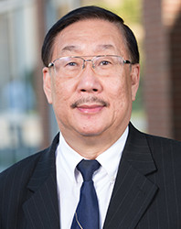
Dr. Lee is an associate professor at Harvard Medical School and the Director of the Bioorganic and Natural Products Laboratory at McLean Hospital. He completed his Ph.D. degree in Natural Products Chemistry at Columbia University. Dr. Lee has worked on numerous projects in drug discovery and development related to traditional Chinese medicine. Dr. Lee has contributed significantly to the development of alternative therapies for treating human diseases. He was the principal investigator on a program project grant funded by the National Institutes of Health entitled “Alternative Therapies for Alcohol and Drug Abuse.” Under this program, several isoflavone glycosides have been identified and assessed in animal models of alcoholism. Dr. Lee is also serving as Co-PI on the development of the herbal remedy (HLXL) for osteoarthritis. Dr. Lee received an institutional development award in 1985. He has published 130 papers and holds 18 U.S. and international patents. In this presentation, he will speak on the “Evidenced Traditional Chinese Medicine for the Treatment of Osteoarthritis” with emphasis on the re-discovery of ancient Chinese remedies.

Email:dlee@mclean.harvard.edu

Notes/Comments:

