Evaluation of therapeutic potential of folk plants extracts against Acanthamoeba in vitro

Abdul Matin, PhD, PDPhil, PGCHE, Majmaah University, KSA
Hafiz Muhammad Sohaib, International Islamic University, PAK
Salik Nawaz, University of the Punjab, PAK

Abstract
Statement of the Problem: Acanthamoeba is an opportunistic protozoan pathogen and one of the most prevalent organisms in our natural environment (i.e., air, soil and water). It is recognized to cause fatal brain infection (granulomatous encephalitis) and eye infection (blinding keratitis). Treatments for both infections are problematic because of the amoebic cysts resistance to therapeutic agents. That’s why there is no effective anti-amoebic drug available to date. The purpose of the present study was to evaluate in vitro strength of plants extracts on the viability and biological properties of Acanthamoeba castellanii (T4 genotype) and its cytotoxic effects on human corneal epithelial cells (HCEC). Methodology & Theoretical Orientation: Using HCEC, adhesion, cytotoxicity and amoebicidal, amoebisttic and growth assays were performed. Findings: Normally Acanthamoeba exhibited >90 % binding and >80 % cytotoxicity to HCEC cells which was remarkably inhibited by plant extracts to >70 and 60 % respectively. It was also observed that extracts (ranging from 0.1 to 1.5 mg/ml) exhibited amoebicidal effects, i.e., >50 % of trophozoites were killed at 1.5 mg/ml within 1 h. However, the residual amoeba remained static for quite some time. Furthermore, extracts also inhibited >50 % amoeba numbers up to 7 days during growth assay. Furthermore, plant extracts (1 to 30mg/ml) exhibited amoebicidal effects against Acanthamoeba cysts. Furthermore Acanthamoeba encystment was also inhibited in concentration dependent manner with maximum inhibition at 2µg/ml after 48h. Among all Peganum harmala seed extratcs showed optimal activity against amoeba. Our results confirmed that extracts has toxic effects against both cysts and trophozoite. Conclusion & Significance: Overall, we reported for the first time that selested plant extracts exhibited inhibitory effects on biological properties of Acanthamoeba without any toxic effects on HCEC cells in vitro. Recommendations: Further experiments are required with purified fractions of plant extracts to identify the active ingredients and to elucidate the mechanism of action of the effective compounds both in vitro and in vivo which may provide a new series of chemotherapeutic agents.

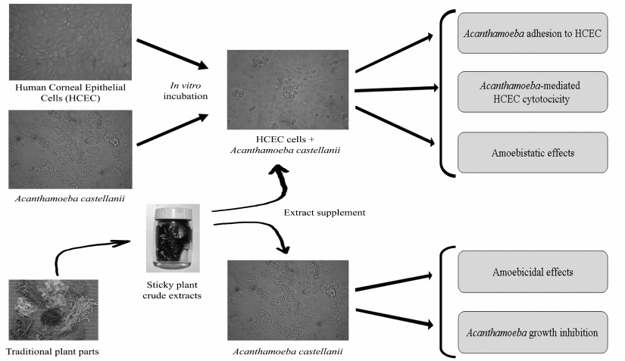

Figure 1: Use of folk plants extract on Acanthamoeba in the presence of human corneal epithelial cells (HCEC) in vitro. Methanolic extracts showed very promising activity against Acanthamoeba wthout harming HCEC cells.
Recent Publications:
- Arshad N, Zitterl-Eglseer K, Hasnain S, Hess M (2008) Effect of Peganum harmala or its ß-Carboline Alkaloids on Certain Antibiotic Resistant Strains of Bacteria and Protozoa from Poultry. Phyto. Res. DOI: 10.1002/ptr.2528.
- Marciano-Cabral F, Cabral G (2003) Acanthamoeba spp. as agents of disease in humans. Clin. Microbiol. Rev. 16: 273–307.
- Sohaib HM, Nawaz S, and Matin A (2016) Methanolic extracts of Peganum harmala exhibit potent activity against Acanthamoeba castellanii cysts and its encystment in vitro. Pakistan Journal of Pharmaceutical Sciences 29(6):1993-1996.
- Shoaib HM, Muazzam AG, Mir A, Jung SY, Matin A. Evaluation of inhibitory potential of some selective methanolic plants extracts on biological characteristics of Acanthamoeba castellanii using human corneal epithelial cells in vitro. 2012. Parasitol Res.
- Visvesvara GS, Moura H, Schuster FL (2007) Pathogenic and opportunistic free-livingamoebae: Acanthamoeba spp., Balamuthia mandrillaris, Naegleria fowleri and Sappinia diploidea. FEMS Immunol. Med. Microbiol. 50: 1-26.

Biography
Our broad research interests include the epidemiology and pathogenic mechanism of emerging parasitic diseases with special interest on role of blood-brain barrier in central nervous system infections. Our aim is to understand the basic molecular mechanism of pathogenesis and pathophysiology of serious infections (i.e., encephalitis). These studies will help us to identify potential targets, which may lead to the development of therapeutic interventions. Currently, we are looking at role of the blood-brain barrier to understand how these pathogens traverse the blood-brain barrier to gain entry into the central nervous system to produce disease. Furthermore, using multi-disciplinary approach we are looking for potential novel synthesized compounds or nanoparticles or/and obtained from plants or insects to discover potential drug candidates for drug delivery system to alleviate the burden of life threatening infections. We are conducting research using state-of-the-art technologies in the field of infectious diseases.
Email: amawan@live.co.uk

Notes/Comments:

