Toxicological Effects of Aqueous Root Extracts of Jatropha curcas and Jatropha gossypiifolia in Alloxan-Induced Diabetic rats Liver

Raliat A. Aladodo¹* Ph. D, KWASU Ilorin, Nigeria
Elizabeth. A. Balogun² Ph. D, Unilorin Ilorin, Nigeria

Abstract
Statement of the Problem: Previous study has shown that either single or combined aqueous extract of Jatropha curcas and Jatropha gossypiifolia (root) was able to ameliorate diabetic condition but failed to address their toxicity potential. Therefore, this study was aimed at assessing the effects of the concentrated aqueous root extracts of Jatropha curcas, Jatropha gossypiifolia (roots) and their mixture on functional indices and histopathology of the liver in diabetic condition.
Methodology & Theoretical Orientation: Twenty-four (24) male rats with average weight of 135 ± 25.50 g were randomized into four groups of six (6) animals each. Group A received 0.5 ml of distilled water while Group B, C and D received 450 mg/kg b. wt. of the extracts (orally) for fourteen (14) days. The levels of total protein, albumin and globulin in the serum and the activities of gamma glutamyl transferase (GGT), alkaline phosphatase (ALP), alanine amino transferase (ALT) and aspartate amino transferase (AST) in the serum and liver were determined. The histopathological change in the liver architecture was also investigated.
Findings: The results from the study revealed that the liver functional indices of the tested groups were significantly (p< 0.05) lower than the control values. There was also a significant (p < 0.05) reduction in the liver enzymes activities with a concurrent increase in their serum values. The histopathological study also confirmed the results of the biochemical study that the extracts may be injurious to the liver tissue.
Conclusion and Significance: The present work suggest that concentrated aqueous extracts of Jatropha curcas, Jatropha gossypiifolia and their mixture may affect normal liver function in rats. Thus the extracts should be taken with caution.
Keywords: Liver, Toxicity, Diabetic-rats, Jatropha-curcas, Jatropha-gossypiifolia

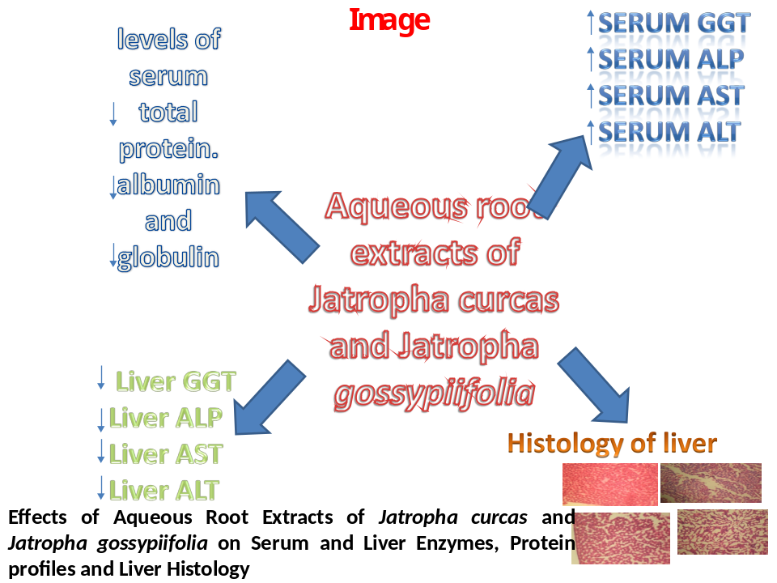
Recent Publications
- Ukoha U. U., Mbagwu S. I., Ndukwe G. U. and Obiagboso C. (2015). Histological and Biochemical Evaluation of the Kidney following Chronic Consumption of Hibiscus sabdariffa Advances in Biology Volume 2015 (2015), Article ID 486510, 5 pages http://dx.doi.org/10.1155/2015/486510

- Ahed J AlKhatib, Ilham A AlKhatib, M. A. Sulaiman, S. M. Shuaibu, Mosleh A Alkhatatbeh, M. Abdulhadi and A. B. Maikano (2014). U. Pilulifera Mimics the Action of Metformin in Lowering Liver Enzymes in Alloxan Diabetic Model. European Scientific Journal August 2014 edition vol.10, No.24

- A. Bushra Abbas, “Effects of aqueous extract of Hibiscus sabdariffa L. on some biochemical indices of liver and kidney function in male albino rats,” Magazin of Al-Kufa University for Biology, Vol. 6, No. 2, 2014.

- Adesokan A. A., Olu I. O. and Turay B. Ms. (2010). Kidney and Liver Function Parameters in Alloxan-Induced Diabetic Rats Treated with Aloe Barbadensis Juice Extract. Sierra Leone Journal of Biomedical Research Vol. 1 (1) pp. 33-37, July, 2009

- E. M. Hamad, E. A. Abdel-Rahim and E. A. Romeih (2011). Beneficial Effect Of Camel Milk On Liver And Kidneys Function In Diabetic Sprague-Dawley Rats. Int. J. Dairy Sci.

Presenting author details
Full name: Raliat Abimbola ALADODO
Contact number: +2348060260160
Linked In account: aladodoraliatabimbola@yahoo.com
Category: (e-Poster presentation)

