Alpha Chloralose, a rodenticide already identified : clinical and analytical description of a case report
M. RIFFI ^{1,*}, F. KERKOUB ² , K. ZEGHACHE ¹, M. MECHROUKI ², S. ETTAIB ERRAHMANI ², R. ABTROUN ², B. ALAMIR ¹
1: National Center of Toxicology, NIPA, Algies, Algeria.
2 : Service of toxicology, Bab El Oued Hospital, Algies, Algeria.
* : Correspondance autor (mohamedtox@hotmail.fr).

Abstract:

We report the first non lethal intoxication case study of a 24-year-old woman with Alpha-Chloralose. Admitted in intensive care unit, she presented gastralgia with excitement followed by generalized seizure. The suspected poisoning was confirmed by urinary analysis for Alpha Chloralose using Fujiwara Ross method, and showed urine level at 103 mg/L (sampled 4 hours later) and 55 mg/L (24 hours later); no other substance was detected. Moreover, biological specimens (blood, urine), also the products supposing ingested, were sent to the National Center of Toxicology in orther to confirm these results. In fact, twoproducts have been incriminated : RATICIDE 70 and wax blocks.A specific screening was achieved by liquid chromatography hyphenated with mass spectrometry tandem (LCMSMS) and revealed presence of Alpha Chloralose (rt 2,0 min) in blood, urine, The gastric lavage fluid and RATICIDE 70. Brofacicum (rt 6.3 min) was not found in biological samples, although it was detected in wax blocks.

Key words: Alpha Chloralose, pesticide, Rodenticide, seizure, Fujiwara Ross method, Mass spectrometry.

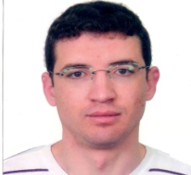

Image :

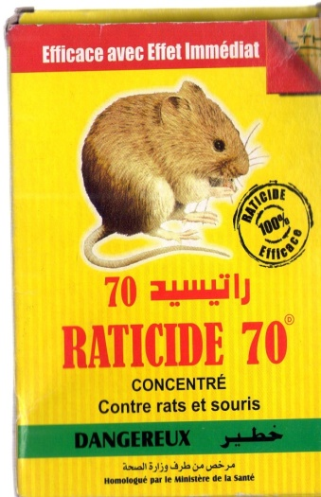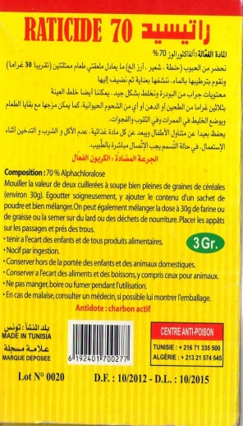

Recent Publications :

[1] C. Ragoucy-Sengler. Alpha-chloralose : vers un possible détournement de l’usage du produit. Annales de ToxicologieAnnalytique.Vol. XVII, n°3, 2005 ; 153.
[2] K. Hunter. Determination of chloralose residues in animal tissues by liquid chromatography-electrospray ionization tandem mass spectrometry. Journal of Chromatography B. Vol 805, 15 Avril 2004; 303 – 309.
[3] F.Sporkert. Drug-facilited crime – Unexpected poisoning with the rodenticide alphachloralose.Annales de Toxicologie Analytiques. Vol. XVII, 2005; 127.
[4] N. Kouraichi. Intoxication par le chloralose : facteurs pronostiques et prise en charge. Reanimation. Vol 19, 10 Juin 2010 ; 581 – 586.
[5] L. Gamelin. Rodenticides. EMC-Toxicologie Pathologie.Vol 2, 2005 ; 89 – 97.

Biography
Dr Riffi Mohammed has completed his PhD at the age of 25 years from Tlemcen University and postdoctoral studies from Algiers University School of Medicine. He is a membership of SoHT. He has published one paper in “Toxicologie analytique et clinique”.

