Toxic mystery in the depths - a case study of the Baltic Sea

ASTEL A¹, BIGUS K¹
¹Department of Environmental Chemistry, Institute of Biology and Environmental Protection, Pomeranian University in Słupsk, POLAND

Keywords: toxicity, chemical munitions, World War II, sand sediments

- Abstract Body
The distribution of heavy metals in coastal sediments of three Polish beaches was assessed. Core sediments collected in the central part of the Polish coast were characterized by seasonally increased concentration of Cd, Ag, Ba, Al, Cu, Cr and Bi. Despite the fact the majority of dredge material collected could be classified as light or trace contaminated by Cr, Cu, Zn, Ca and Hg among the studies beaches the highest content of Cd and Ag was discovered in Czołpino, located in the area of national park. It was discovered that 13 km of the beach in Czołpino was incidentally contaminated by an unidentified substance probably originated from chemical munitions dumped in the Baltic Sea after World War II. Chemicals originating from chemical warfare materials can spread from the disposal sites of the containers due to the impact of waves and sea currents. The behaviour of warfare agents in the marine environment is additionally influenced by the
physical properties of the agents. All warfare agents react with sea water, but reaction rates can vary enormously depending on the chemical structure. Such reaction products are usually less or no longer toxic. Some compounds, however, show an extremely low solubility and slow degradability and this is why wide-scale threat to the marine environment from dissolved chemical warfare agents still exists.

- Image:

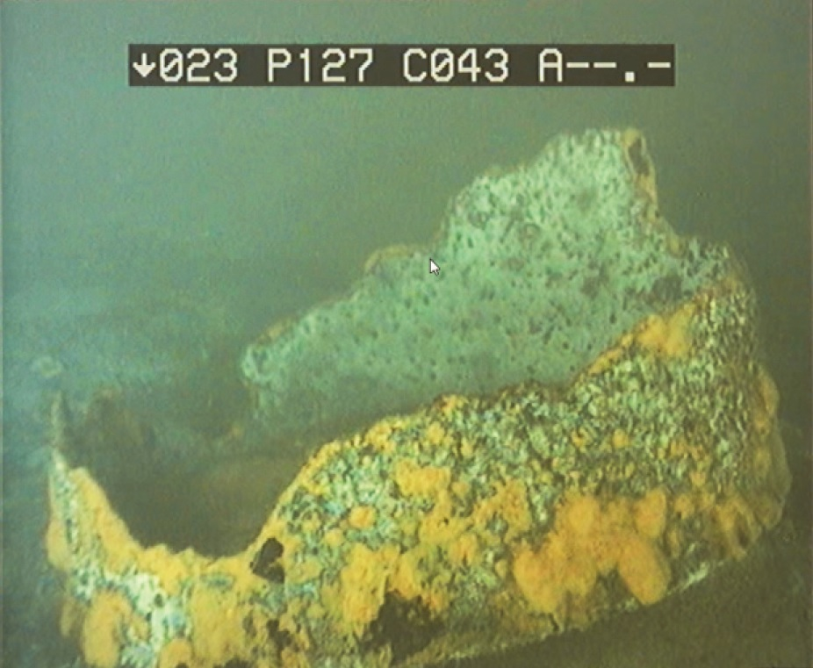

- Reference:
- HELCOM CHEMU, Report to the 16th Meeting of Helsinki Commission 8-11 March 1994, Danish Environmental Protection Agency, Helsinki 1994.
- Paka, V., Spiridonov, M., Research of dumped chemical weapons made by R/V "Professor Shtokman" in the Gotland, Bornholm and Skagerrak dump sites, in: Chemical munition dump sites in coastal environments, Brussels, 2002.
- Biography:
Katarzyna Bigus has completed her PhD in Pomeranian University in Słupsk. Her thesis concerned "Spatiotemporal variation of chemical and biological properties of sand sediments of selected beaches of the southern Baltic Sea" and was prepared under supervision of Prof. Jan Trojanowski. Till the 2016 she is a vice-director of the Institute of Biology and Environmental Protection. Current research areas concern:
• ion chromatography application to assess surface water quality,
• heavy metals determination in environmental compartments,
• influence of anthropopression on beach ecosystem of the southern Baltic Sea,
• toxicity assessment by the use of Microtox system.
- Presenting author details

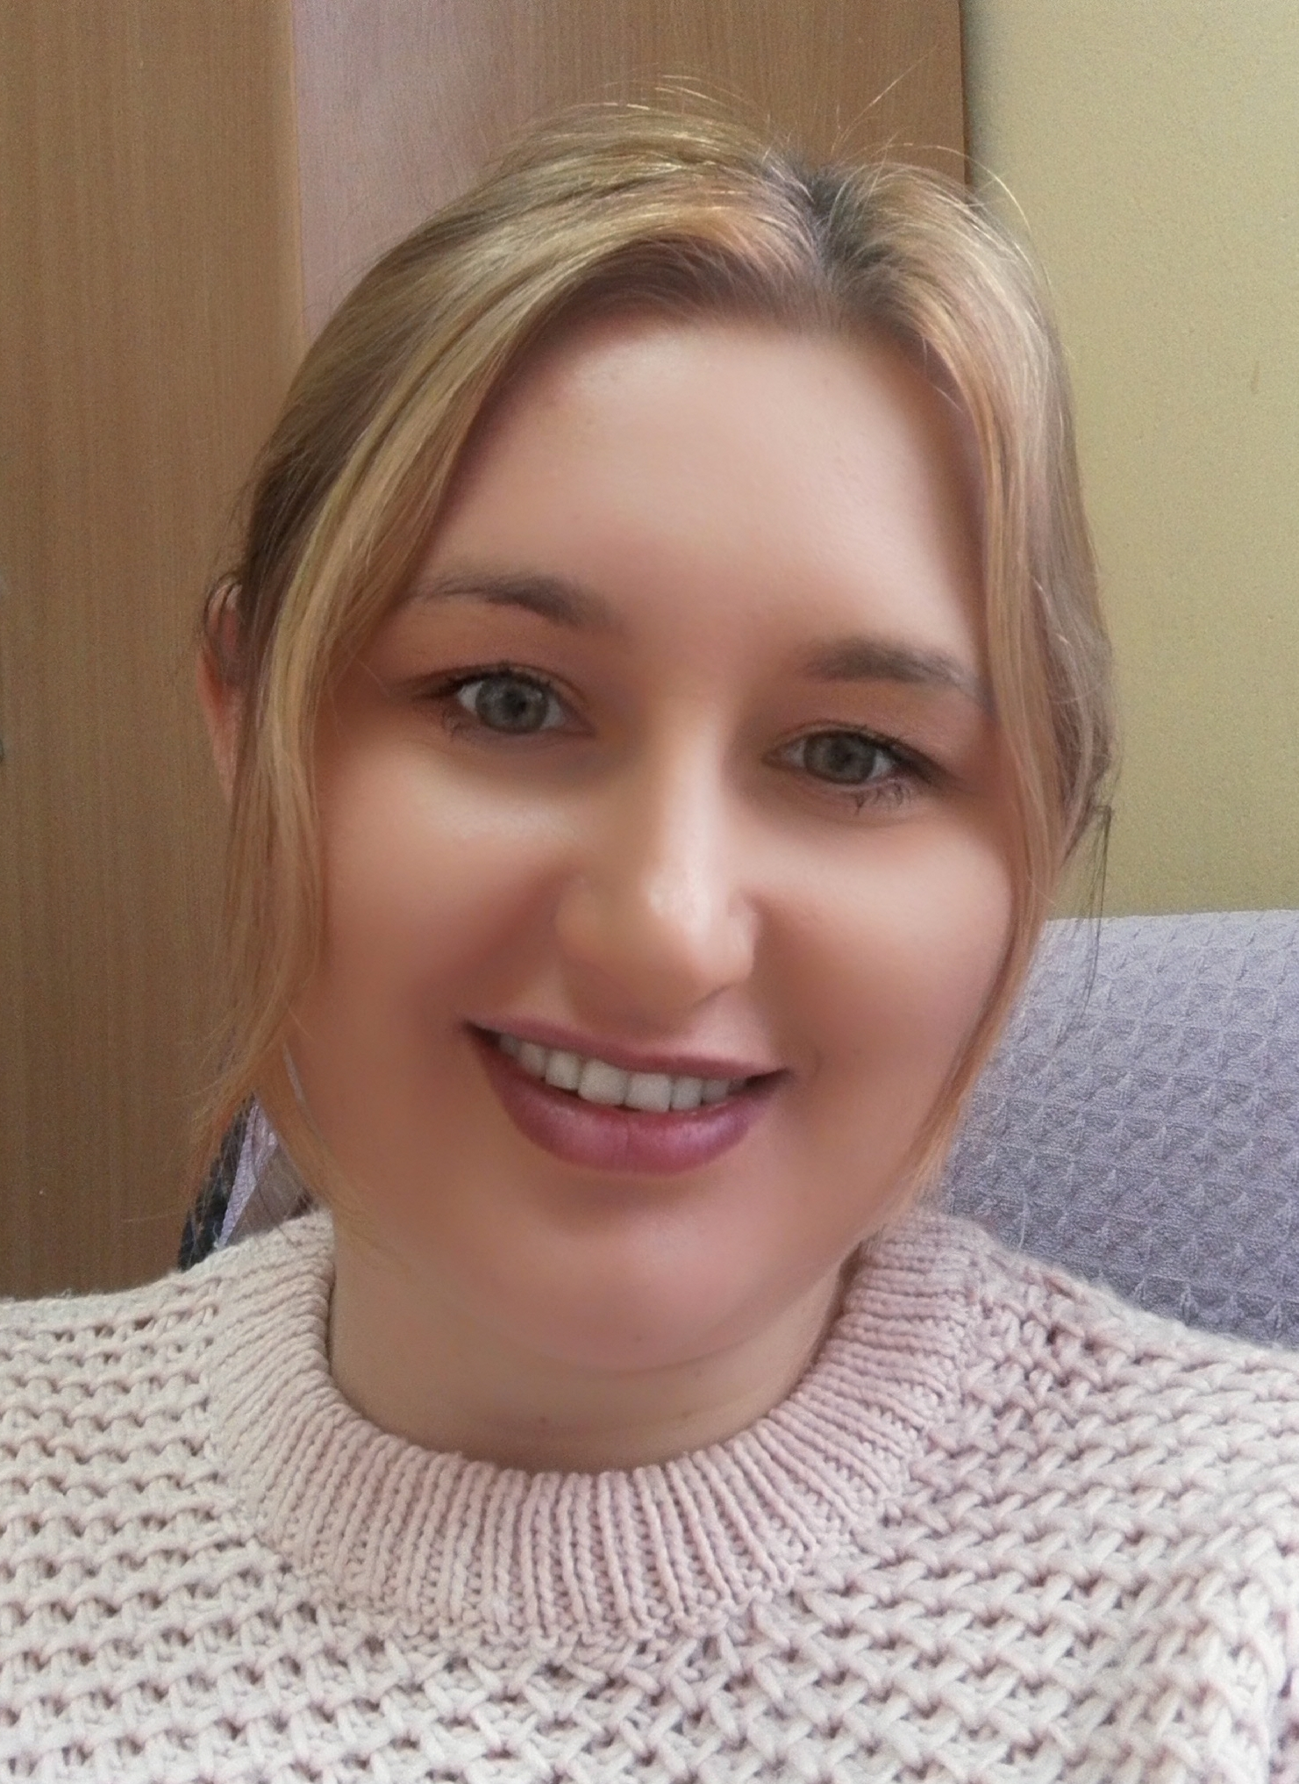
Full Name: KATARZYNA BIGUS
Contact number: +48 59 8045-422
Email-id(s): katarzyna.bigus@apsl.edu.pl
Session name/ number: Environmental Toxicology and Risk Assessment
Category: Oral presentation

