Toxico-pathological impact of subacute exposure to Acephate on health biomarkers of broiler chicks
Syamantak Mani Tripathi¹*, Prem Kumar G.¹¥, Megha Kadam Bedekar²§, L. N. Sankhala³, R. K. Sharma¹, V.N. Gautam⁴, Aswin M. Thaker⁵
¹Department of Veterinary Pharmacology & Toxicology, College of Veterinary Science & A.H., Madhya Pradesh Pashu Chiktsa Vigyan Vishwavidyalaya, Jabalpur (M.P.), India
²Diagnostic and Therapeutics Division, Animal Biotechnology Centre, Madhya Pradesh Pashu Chiktsa Vigyan Vishwavidyalaya, Jabalpur (M.P.), India
³Department of Veterinary Pharmacology & Toxicology, College of Veterinary Science & A.H., Rajasthan University Veterinary & Animal Science, Bikaner, (R.J.), India
⁴Department of Livestock Production Management, College of Veterinary Science & A.H., Madhya Pradesh Pashu Chiktsa Vigyan Vishwavidyalaya, Jabalpur (M.P.), India
⁵Department of Veterinary Pharmacology & Toxicology, College of Veterinary Science & A.H., Anand Agricultural University, Anand (G.J.), India

Key words: Acephate, Subacute, Immunotoxicity, White Leghorn Birds

- Abstract
The present study aimed to investigate the immuno-toxicopathologic effects of environmental contaminant acephate (Ace) in experimentally exposed one day old White Leghorn broiler chicks (n = 150). The Ace was reconstituted in groundnut oil as vehicle (1 ml/kg) to obtain a final concentration of a single dose to the birds 21.3, 28.4 and 42.6 mg/kg body weight (BW) for twenty eight days of the experiment through the stomach tube. The chicks in the vehicle control group was given groundnut oil 1 ml/kg only while the chicks of plane control group had received only ad lib standard feed and water. Birds exposed to high dose (42.6 mg/kg BW) showed signs of toxicity (salivation, lacrimation, gasping, convulsions, frequent defecation and tremors). The birds exposed to low dose Ace showed marked increase in the body weight of chicks while medium and high doses (28.4 and 42.6 mg/kg) showed significantly (P ≤ 0.05) decreased body weight. Non-significantly (P ≥ 0.05) decreased TEC, Hb concentration, PCV and TLC were observed in the high dosed group as compared to control and other low dosed fed birds. Initially a non-significant compensatory increase followed by significant decrease in serum protein was observed during the study period. Serum albumin showed a significant (P ≤ 0.05) decrease in high dosed Ace fed birds on 28th day of study. Non significant increase and significant decrease in serum on 14th and 28th day of study was observed respectively. The AChE activity was significantly (P ≤ 0.05) decreased in blood, serum and plasma in Ace fed birds compared to control birds. we found significantly (P ≤ 0.05) higher levels of serum ALT and AST in Ace fed birds as compared to control. During the experimentation Ace had showed dose dependant immunosuppressive effect on humoral immune response of birds from 28th day of experimentation. The Bursa of Fabricius in treated birds showed increased inter-follicular connective tissue proliferation, severe moderate cytoplasmic vacuolation, edema, and degenerative changes such as pyknosis and fragmentation of nuclei that depleted the follicles of lymphoid cells. In the spleen, disorganization of follicular patterns, severe congestion, cytoplasmic vacuolation, degenerative changes, and hyperplasia of reticular cells were noted. The thymus in treated birds exhibited congestion, hyper-cellularity, and a presence of immature monocytes in the medullary region, as well as myoid cell necrosis. In conclusion, these studies clearly demonstrated that Ace could induce immuno-toxicopathological effects on health biomarkers of broiler chicks.
- Image
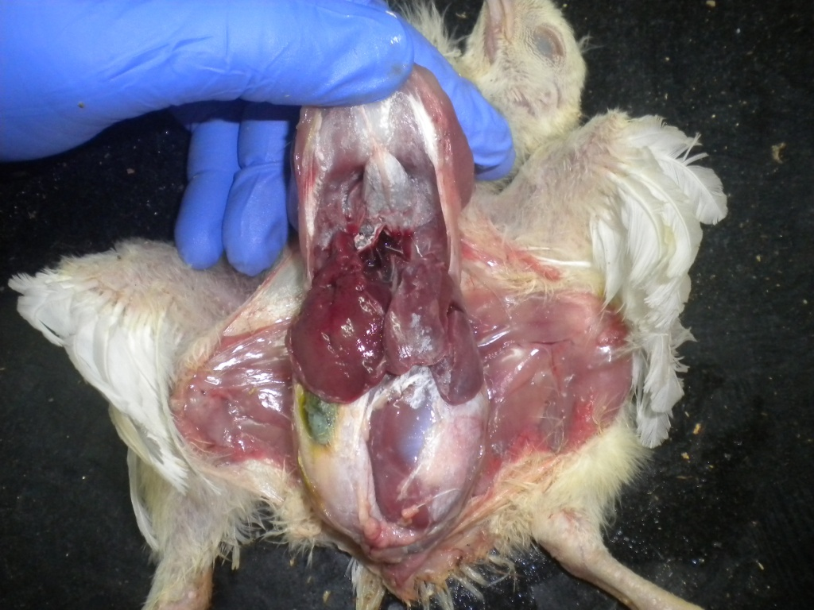
- Reference:
- Tripathi, S.M.; Thaker, A.M.; Joshi, C.G.; Garg, S.P. and Sankhla, L.N. (2007). Immunotoxicity induced by subacute Acephate exposure in White Leghorn Cockerels. J of the Indian society of Toxicol. 003(001):13-21.
- Tripathi, S.M.; Thaker A.M.; Joshi C.G. and Snakhla L.N. (2011). Acephate immunotoxicity in white leghorn cockerel chicks upon experimental exposure. Env. Toxicol. and Pharmacol., 33 (1):192-199

- Biography of Dr. Syamantak Mani Tripathi
Dr. Syamantak Mani Tripathi is an Assistant Professor in the Department of Veterinary Pharmacology and Toxicology, College of Veterinary Science and Animal Husbandry, Chhattisharh Kamdhenu Vishwavidalya, Durg-491001 (Chhattisgarh) India. He has over ten years experience with hand-on applications including teams of researchers and technicians in the Pharmacology & Toxicology and Biotechnology division. His training and experience also includes applied animal investigation skills as a research scholar in the field of pesticide induced immunotoxicology and safety pharmacology studies. He has worked in multiple successful research projects funded by Indian Council of Agricultural Research and Department of Biotechnology, Government of India, supporting clinical development and leading to strong regulatory submissions for pesticides uses in agriculture. His research program is focused on the study of immune response to pesticide and xenobiotics in avian model. He received his Bachelor’s in Veterinary Science and Animal Husbandry from Jawaharlal Nehru Krishi Vishwavidyalaya, Jabalpur (MP), India; Master’s of Veterinary Pharmacology from Anand Agricultural University, Anand (Gujarat), India and his Ph.D. in Veterinary Pharmacology and Toxicology from the Nanaji Deshmukh Veterinary Science University at Jabalpur (MP), India. His academic work was focused on “Immuno-genotoxicity of organophosphorous insecticide ‘acephate’ in white leghorn birds”. His work contributes towards understanding the molecular mechanism of acephate toxicity in avian model; studying interleukin gene(s) associated with immunity and development of test series to study immunotoxicity. Memberships he has include the Indian Society of Toxicology, Indian Society of Veterinary Pharmacology and Toxicology.
- Presenting author details


Full Name: Dr. Syamantak Mani Tripathi,
Assistant Professor, Veterinary Pharmacology & Toxicology, CGKV, Durg, India
Contact number: +91-9755272827
Email-id(s): vjt93@yahoo.com
Twitter account: ---
Linked In account: ...
Session name/ number: Environmental Toxicology and Risk Assessment/ Toxicology
Category: (Oral presentation/ Poster presentation): Oral presentation
Passport Number: N7165963

* Assistant Professor and Deputy Director Research, Chhattisgarh Kamdhenu Vishwavidyalaya, Durg (C.G.), India
¥ Postdoctoral Fellow, Department of Biomedical Engineering, UAB-The University of Alabama at Birmingham, 1670 University Blvd Volker Hall-G102B, Birmingham, AL 35294 USA
§ Senior Scientist, Central Institute of Fisheries Education, Mumbai, India

