Title: COMPUTER AIDED CLASSIFICATION OF MARKER PROTEINS FOR CELL SURVIVAL /CELL DEATH

Shruti Jain PhD, SMIEEE, Jaypee University of Information Technology, India

Abstract
The signaling system underlying cell death allows the cell to process input signals capturing information coming from the environment of the cell to lead to one of two possible outputs: cell survival or cell death. This work examines signaling networks that control the survival decision treated with combinations of the pro-death cytokine, tumor necrosis factor-α (TNF), and the pro-survival growth factors, epidermal growth factor (EGF) and insulin. There are ten different combinations of TNF, EGF and insulin whose values are in ng/ml. We have considered the heat map image which is showing 11 different proteins : MK2, JNK, FKHR, MEK, ERK, IRS, AkT, IKK, pAkT, ptAkT and EGFR for the HT carcinoma cells which helps in cell survival/ death. The average of all outputs were taken which were normalized to maximum. Data mining methods have the potential to identify groups at high risk. There are different steps for processing the data so as to extract their results: data collection, data pre-processing, feature extraction, feature selection, data partitioning, and data classification.
In this paper different regression analysis methods were discussed on marker proteins. There are different types of regression analysis. Out of which simple regression and multiple regressions was considered. For calculation purpose we have used PLS analysis which calculates squared r values. We have validated our results by calculating adjusted regression coefficient, predicted regression coefficient regression coefficient cross validation, rm² , F-test values, Coefficient of determination, ANOVA, t-value, Durban Watson statistics for the different proteins. Later multiple regressions were used as we have different independent variables (proteins). To validate the results we have calculated the coefficient, standard error, standard coefficient, tolerance, t value and p value, variation explanation of predictors and estimators which gives cumulative percentage.
After analysis we get 7 proteins (AkT, Epidermal growth factor receptor (EGFR), Extracellular-regulated kinase (ERK), c-jun N-terminal kinases(JNK), Mitogen-activated protein kinase-activated protein kinase 2 (MK2), Insulin receptor substrate (IRS) , and Forkhead transcription factor (FKHR))as the marker (best) proteins which were used for classification. A CAD system for the classification of MAPK proteins (ERK, JNK and p38/MK2), receptor proteins (EGFR and IRS) and AkT for HT-29 human colon adenocarcinoma cells using different wavelet transform (discrete wavelet filter and gabor wavelet filter) for different classification techniques which gives decision on apoptosis-survival. Till yet all the communicated thesis/ paper have done analysis on gray scale images while here we have worked with coloured images. The maximum accuracy of 80% was obtained using bior 3.3 wavelet energy descriptors by using SSVM classifier for MAPK proteins, accuracy of 86.67 % was obtained using SVM classifier for receptor proteins and accuracy of 80% was obtained using biorthogonal (bior 4.4) & daubechies (db6) wavelet transforms by using SSVM classifier for AkT proteins.

Image (If Any)

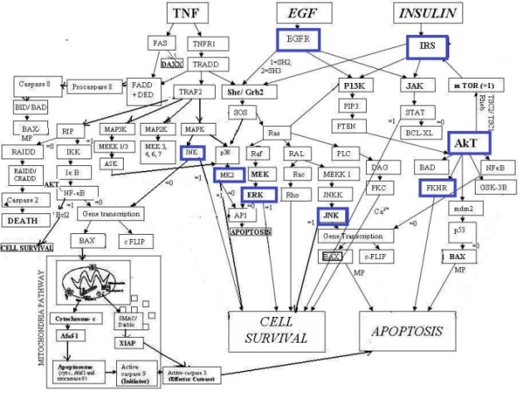
Recent Publications (If Any)
- Jain S. (2012) Communication of signals and responses leading to cell survival / cell death using Engineered Regulatory Networks. PhD Dissertation, Jaypee University of Information Technology, Solan, Himachal Pradesh, India.
- Weiss R (2001) Cellular computation and communications using engineered genetic regulatory networks. PhD Dissertation, MIT.
- Gaudet S, Kevin JA, John AG, Emily PA, Douglas LA, and Peter SK. (2005) A compendium of signals and responses trigerred by prodeath and prosurvival cytokines. Manuscript M500158-MCP200.
- Normanno N, De Luca A, Bianco C, Strizzi L, Mancino M, Maiello MR, Carotenuto A, De Feo G, Caponiqro F and Salomon DS. (2006) Epidermal growth factor receptor (EGFR) signaling. Cancer Gene. 366 : 2–16.
- Jain S, Naik PK and Bhooshan SV. (2011) Mathematical modeling deciphering balance between cell survival and cell death using insulin. Network Biology. 1(1):46-58.
- Jain S, Naik PK (2012) Communication of signals and responses leading to cell death using Engineered Regulatory Networks, Research Journal of Pharmaceutical, Biological and Chemical Sciences . 3(3) :492-508
- White MF.(2003) Insulin Signaling in Health and Disease. Science. 302 : 1710–11.
- Jain S 2017. Parametric and Non Parametric Distribution Analysis of AkT for Cell Survival/Death, International Journal of Artificial Intelligence and Soft Computing. 2017 : 6(1), 43- 55.
- Jain S (2016) Regression analysis on different mitogenic pathways, Network Biology. 6(2) : 40-46 .
- Jain S (2018) System Modeling of AkT using Linear and Robust Regression Analysis Current Trends in Biotechnology and Pharmacy, 12 (2), 177-186, April 2018.
- Jain S (2018) Classification of Protein Kinase B Using Discrete Wavelet Transform International Journal of Information Technology, 10(2) : 211-216.
- Jain S, Chauhan DS (2015) Mathematical Analysis of Receptors For Survival Proteins. International Journal of Pharma and Bio Sciences. 6(3) : 164-176.
- Jain S, Naik PK and Bhooshan SV. (2010) Petri net Implementation of Cell Signaling for Cell Death. International Journal of Pharma and Bio Sciences. 1(2) : 1-18.
- Bhusri S., Jain S, and Virmani J, (2016) Classification of Breast Lesions Using the Difference of Statistical Features, Research Journal of Pharmaceutical, Biological and Chemical Sciences(RJPBCS), 1366.
- Alam S.K., Feleppa E.J., Rondeau M., Kalisz A., and. Garra B.S (2011).Ultrasonic multi-feature analysis procedure for computer-aided diagnosis of solid breast lesions, 33(1) pp. 17–38.
- Rana S., Jain S., and Virmani J. (2016) SVM-Based characterization of focal kidney lesions from B-Mode ultrasound images, research J of pharmaceutical, biological and chemical sciences (RJPBCS). 7(4) : 837.
- Sharma S., Jain S., Bhusri S. (2107)classification of breast lesions using Gabor WAVELET Filter for Three classes, Internaltion Confrence on computer for sustainable global development, BVICAM.628-6284.
- Amandeep, Jain S., Bhusri S. (2017) CAD system for non small cell lung carcinoma using laws’ mask analysis, international conference on computing for sustainable global development, BVICAM, 6285-6288.
- S Sharma, Jain S, Bhusri S (2017) Two Class Classification of Breast Lesions using Statistical and Transform Domain features, Journal of Global Pharma Technology 9(7): 18-24.

Fig 1 : Marker Proteins due to combination of input proteins that leads to cell death/ survival [1].

Biography
S. Jain has received PhD degree from Jaypee University of Information Technology, Waknaghat, Solan. She has a teaching experience of around 14 years. She has specialization in Biomedical Signal Processing, Computer- Aided design of FPGA and VLSI circuits, combinatorial optimization. She has published more than 50 papers in reputed journals and 30 papers in International conferences. She is a senior member of IEEE, life member of Biomedical Engineering Society of India and member of IAENG. She has completed one externally funded project funded by DRDO entitled “Fabrication of Energy Harvesting Prototypes Using Piezoelectric Materials “ and one accepted project in Himachal Pradesh Council for Science, Technology & Environment (HIMCOSTE), H.P. entitled “Design and Analysis of a Thermoelectric Generator for Energy Harvesting System from Waste Heat for the State of Himachal Pradesh”. She has guided 1 PhD student and now has 4 registered students. She is a member of Editorial Board of many reputed journals. She is also a reviewer of many journals and a member of TPC of different conferences.

Name: Shruti Jain
Email: jain.shruti15@gmail.com
Phone Number: 9318039036

