POLYMERIC SCAFFOLDS: TOUR DE FORCE IN POST-SURGERY CANCER MANAGEMENT

Juhi Verma, Product Development Cell, National Institute of Immunology, New Delhi, India

Abstract
The conventional post-surgical chemotherapy has been the main modality of treatment for cancer patients. However, its effectiveness is usually hampered by factors, such as, limited accessibility of drug at the tumor site, development of secondary malignant neoplasm, etc. To tackle this issue, controlled delivery of chemotherapeutic agents has been considered as a promising approach. In this regards, L-asparaginase is considered as an effective chemotherapeutic agent. It catalyzes the conversion of circulating L-asparagine in serum to aspartic acid and ammonia, leading to diminished level of L-asparagine for transformed cells and ultimately cell death. However, it has been associated with severe hypersensitivity reactions upon intravenous injection. Therefore, in the present investigation, we have developed poly (D,L-lactic acid) (PDLLA) scaffold for controlled and sustained release of recombinant L-asparaginase (r-Asp). The r-Asp was expressed in E. coli and active protein was purified via ion-exchange chromatographic technique. The r-Asp encapsulated PDLLA scaffolds were fabricated via two steps: (i) encapsulating r-Asp in PDLLA microparticles using double emulsion solvent evaporation technique; (ii) microparticles fusion with methanol to form an interconnected porous scaffold. The encapsulation efficiency was investigated using bicinchoninic acid assay. In vitro release studies demonstrated sustained release of active protein with minimal burst release during the initial phase. In vitro cytotoxicity studies in breast cancer cells (MCF-7) revealed that the scaffolds exhibited better cytotoxicity as compared to soluble r-Asp. Therefore, this approach may be considered as a promising alternative strategy for post-surgical management of solid tumors, featuring local chemotherapeutic effect with tissue regeneration.

Image
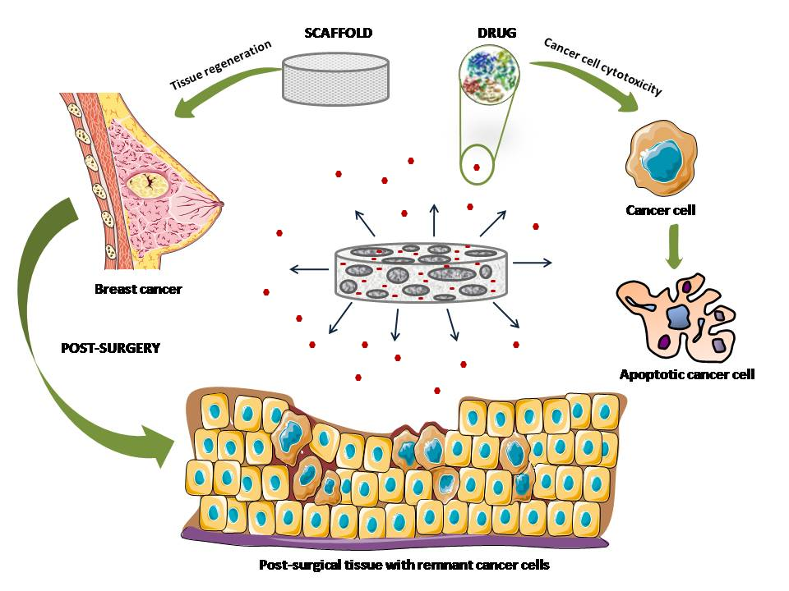

Biography
Juhi Verma has completed her Master’s of Technology from Indian Institute of Technology, Kharagpur. She is currently pursuing doctorate from National Institute of Immunology, New Delhi. Her area of research includes tissue engineering, scaffold designing, protein purification and downstream processing. She is compassionate about her research and is keenly interested in learning new.
Email: vermajuhi@nii.ac.in

