Development of human organs using nanocomposite materials and stem cells technology

Alexander M. Seifalian
Professor of Nanotechnology & Regenerative Medicine
Nanotechnology Regenerative Medicine Commercialisation Centre (Ltd)
The London Bioscience Innovation Centre, London, United Kingdom

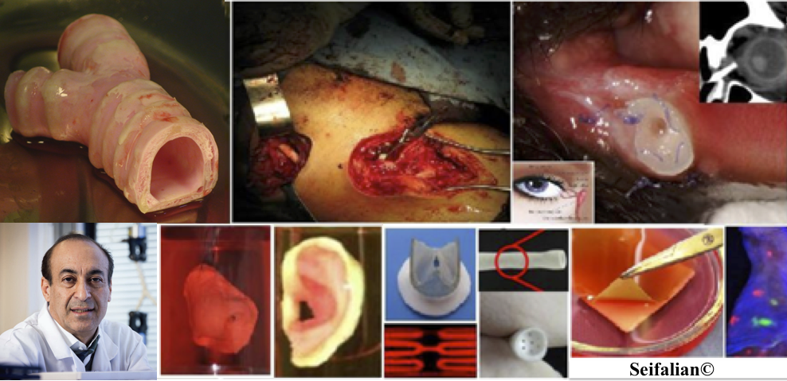
Application of nanotechnology, nanocomposite materials and stem cells are a new generation of tools in the development of human organs. Their research and development are based on a multidisciplinary team approach from basic science to the clinician. We have developed a family of nanocomposites materials in the development of organs, and, in addition, have been using stem cells to enhance organ function.
In this talk, I will present the development of cardiovascular implants, as well as other organs including facial organs using 3D scaffold made from nanocomposite materials and fabricated using a 3D printer. I also address our experience in the translation of this technology from the laboratories to the patient and commercialisation of products.
Taking organs to patients and commercialisation is challenging in term of regulatory as well as manufacturing under GMP/GLP. In this talk will discuss the pathway and time scale taking the organs to the clinical trial from laboratories products.

