Induced pluripotent stem cell modeling for hereditary cerebral small vessel disease

Amerikos Argyriou¹, Tao Wang^{1,2}

¹ Faculty of Biology, Medicine and Health, University of Manchester, Manchester, United Kingdom
² Manchester Centre of Genomic Medicine, Manchester University NHS Foundation Trust, Manchester, United Kingdom

Keywords: in vitro disease model; genetic small vessel disease; CADASIL; 3D disease model; induced pluripotent stem cell

Abstract
Cerebral small vessel disease targets the arterioles and capillaries, with hereditary forms resulting from the pathological protein expression of a single gene mutation. The neurovascular unit is affected by such mutations, as its proper functioning relies on complex bidirectional communication between neural and vascular cell-types for blood-brain-barrier regulation. In small vessel disease, the neurovascular unit depicts pathological dysfunction of the blood-brain-barrier, cerebral blood-flow as well as damage to the mechanical integrity of the microvessel itself. Although the causal genetic mutations have been identified in the literature, the processes that precipitate these hereditary stroke and dementia syndromes have yet to be fully uncovered. Induced pluripotent stem cells have exponentially grown since their inception as a valuable cell-line which can be easily sourced and differentiated into any somatic cell-type. In vitro models have also recently risen to the forefront, attempting to recreate biomimetic systems capable of recapitulating disease mechanisms by stimulating cells to behave as they do in vivo. These include 2D, 3D and dynamic disease models that incorporate cutting-edge tissue engineering technology. Furthermore, CRISPR/Cas9 gene editing can augment stem cell modeling via fine manipulation of cell genotypes, allowing for isogenic controls and even direct genetic manipulation on diseased cells for phenotype-rescue. Induced pluripotent stem cell-derived in vitro models have shown huge potential in mimicking the in vivo environment and their continuous advancement will lead to a greater understanding of both biomolecular and physiological aspects of disease, with potential future therapeutic interventions arising out of the knowledge gained from their use.

(Word count: 249)

Image (A & B):

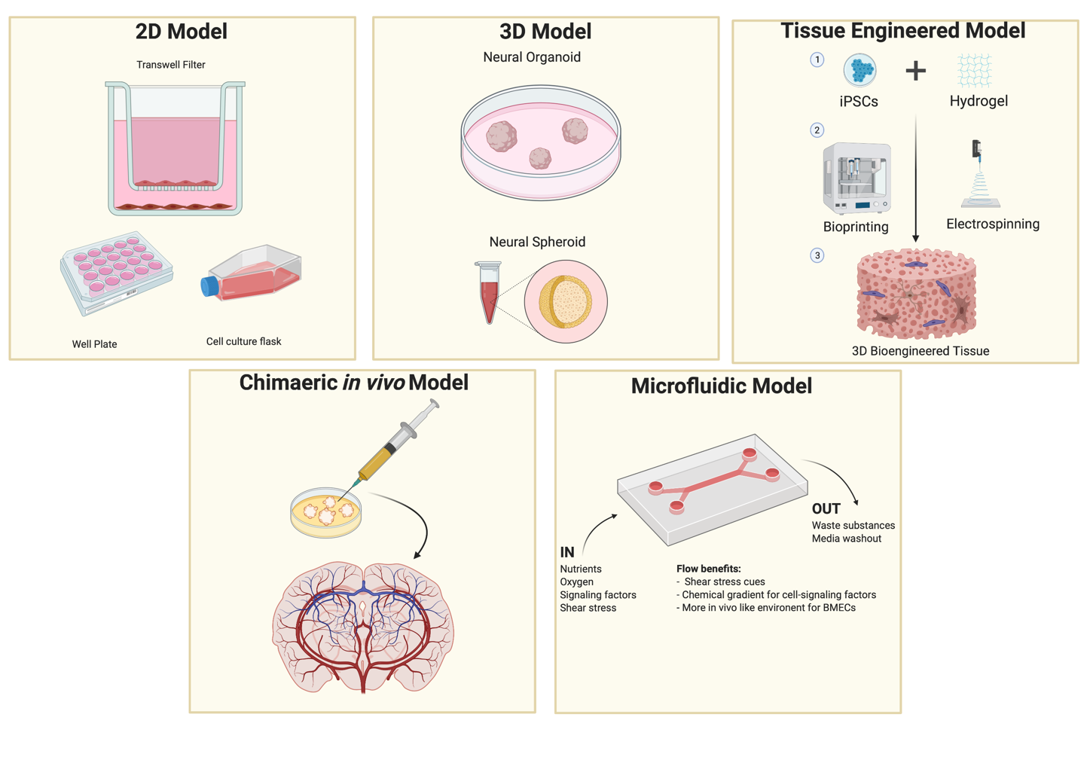
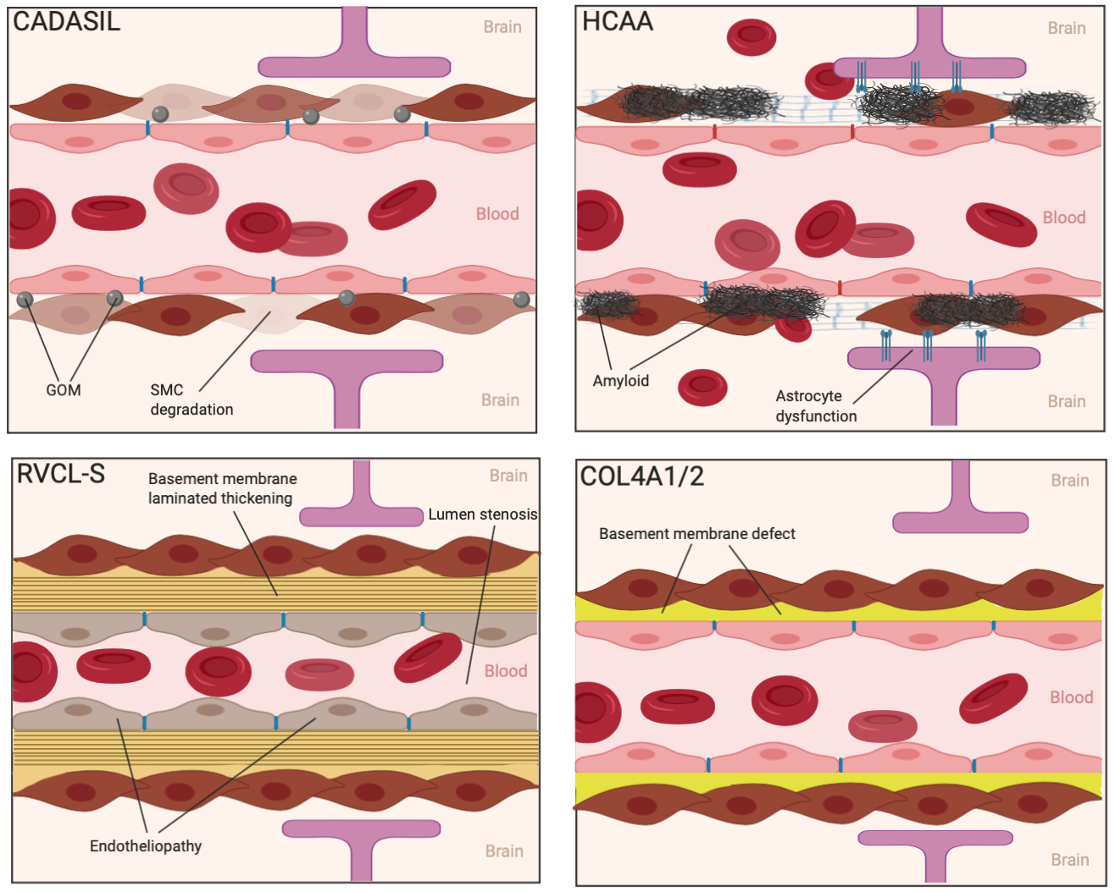

Biography:

Amerikos Argyriou is a 4th Year Medical Student at the University of Manchester who took a year off the program to pursue his interests in Stem Cell research and Regenerative Medicine by completing a Master’s degree in Tissue Engineering & Regenerative Medicine at the University of Manchester (MRes, Distinction) with dissertation work focusing on CADASIL and other small vessel disease models using iPSCs. He is currently hoping to publish his work on CADASIL and on cerebral small vessel disease models.

Author Details:

Full Name: Amerikos Argyriou
Contact number: +44 07491217317
Twitter account: -
Linked In account: https://www.linkedin.com/in/aargyriou/
Session name/ number: Young Scientist Award
Category: Oral Presentation

