Title: Manganese-Labeled Hydrogels as a Multifunctional Carrier of Cells and Drugs for MRI-Guided Interventions

Golubczyk D¹, Kalkowski L¹, Kwiatkowska J¹, Janowski M², Holak P³, Milewska K¹,
Walczak P², Malysz-Cymborska I¹,

¹ Dept of Neurosurgery, School of Medicine, Collegium Medicum, University of Warmia and Mazury, Olsztyn, Poland
I. Abstract Body
Administration of stem cells to the central nervous system remains to be a challenge and that is particularly evident in case of diseases with disseminated pathology such as ALS. Infusion into cerebrospinal fluid spaces is promising but cells were shown to sediment, cell survival was low and engraftment was disappointing. To address this problem we propose to embed the cells in injectable, MRI-visible alginate-based biomaterial to facilitate precise placement of the injected composite as guided by interventional MRI. Manganese as divalent ion covalently binds with alginate and we hypothesized that such property and supplementation with Mn can be exploited for imaging [1, 2]. Here we report on application of Mn contrast for interventional MRI, of intrathecal injection of alginate hydrogels in pigs.
Four juvenile Large White domestic pigs were used. MRI-compatible catheter was introduced via lumbar puncture and advanced under guidance of x-ray C-arm into thoracic section of the spinal cord. Immediately before infusion, cross-linker (CaM particles) was mixed with LVM/MnCl2 hydrogel and dynamic T1-weighted images were acquired to monitor hydrogel biodistribution in real-time. Intrathecal injection of hydrogel in swine demonstrated that gelation dynamics allowed for infusion of the biomaterial up to two minutes after mixing with the cross-linker. Dynamic imaging during hydrogel infusion revealed hyperintensity in the area of the catheter tip which further expanded rostrally and caudally over the infusion duration. The rostral-caudal distribution of the hydrogel ranged between 15-22 cm in tested pigs. Concluding, Mn2+ supplementation of alginate hydrogels is safe and enables visualization of biomaterial placement in real-time.
² Center for Advanced Imaging Research and Department of Diagnostic Radiology and Nuclear
II. Figure
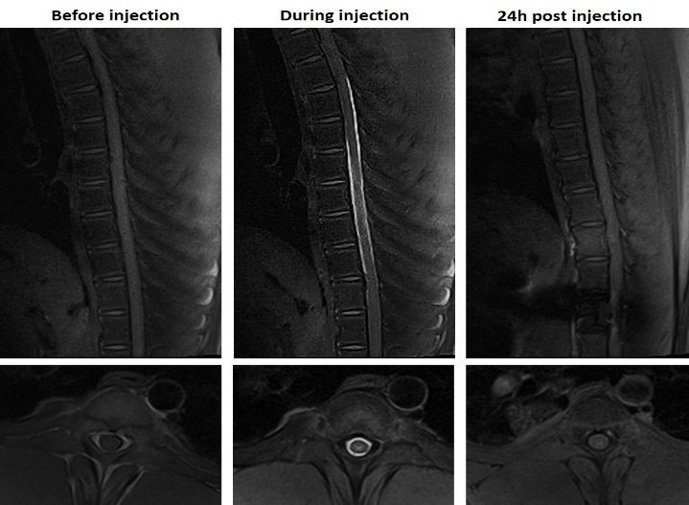
MRI T1 isotropic scans before, during and 24 hours post injection of the alginate with MnCl₂
III. References
1. Lee KY and David J. Mooney. Alginate: properties and biomedical applications. Prog Polym Sci. 2012 Jan; 37(1): 106–126.
2. Pan D, Schmieder AH, Wickline SA, and Lanza GM. Manganese-based MRI contrast agents: past, present and future. Tetrahedron. 2011 Nov 4; 67(44): 8431–8444.
IV. Biography
Dr Malysz-Cymborska has completed her PhD in 2015 at Institute of Animal Reproduction and Food Research of Polish Academy of Sciences in Olsztyn, Poland. She is a Postdoctoral Fellow in the Department of Neurosurgery in the School of Medicine in Olsztyn and for several years she has been working on the application of biomaterials supporting stem cells in the treatment of neurodegenerative diseases.
V. Presenting author details
Full Name: Izabela Malysz-Cymborska
Contact number: +48605118887
Session name/ number: Scaffolds Used for Tissue Engineering
Category: Young Scientist Award
Medicine, University of Maryland School of Medicine, Baltimore, MD, USA
³ Dept of Surgery and Radiology, Faculty of Veterinary Medicine, University of Warmia and Mazury, Olsztyn, Poland
Keywords: Hydrogel, Alginate, MRI, Cells transplantation, Swine

