Abstract

Title: Preparation and characterization of pectin/CMC/MCC composite as second degree burn
wound dressing on Wistar rat (Rattus novergicus) model

Muhammad Alfath¹, Ciptati¹, Rachmawati¹
1Department of Chemistry, Institut Teknologi Bandung, Bandung, Indonesia

Keywords: Biopolymers, Carboxymethyl cellulose, Composite, Burn wound, Microcrystalline cellulose, Pectin, Wound dressing

- Abstract Body
Porous scaffolds made of biopolymers are the main topic in tissue engineering for living organism in this recent time. Biopolymers were choosen because their cheap price, widely available in nature, non-toxic, and non-allergic. A novel material was developed from composite of pectin, carboxymethyl cellulose (CMC) and microcrystalline cellulose (MCC) with lyophilization technique. The composites that have been made are then determined for their physical properties and ability in healing second-degree burns in the Wistar rat model. Composite optimization results consisting of pectin 0.3% (w/v), CMC 0.12% (w/v) and MCC 0.03% (w/v) indicates the ideal pore size (d = 30-300 μm) for the growth of fibroblasts in the process of wound closure. Addition of MCC to composites can reduce the rate of in vitro degradation of composites in a phosphate buffer system of pH 7.4 and temperature of 37ºC. The addition of MCC to composites is also able to significantly increase the thermal resistance of composites compared to composites without MCC. In vivo studies conducted on Wistar rats showed significantly different results (p <0.05) between the treated group and the negative control group. On the 21st day, the remaining wound size in the treated group were 16.38 ± 10.04% and the remaining wound size negative control group was 43.59 ± 19.10%. The results of this study indicate that the pectin/CMC/MCC composite material has the potential to be used as a second-degree burn wound dressing.

Image:
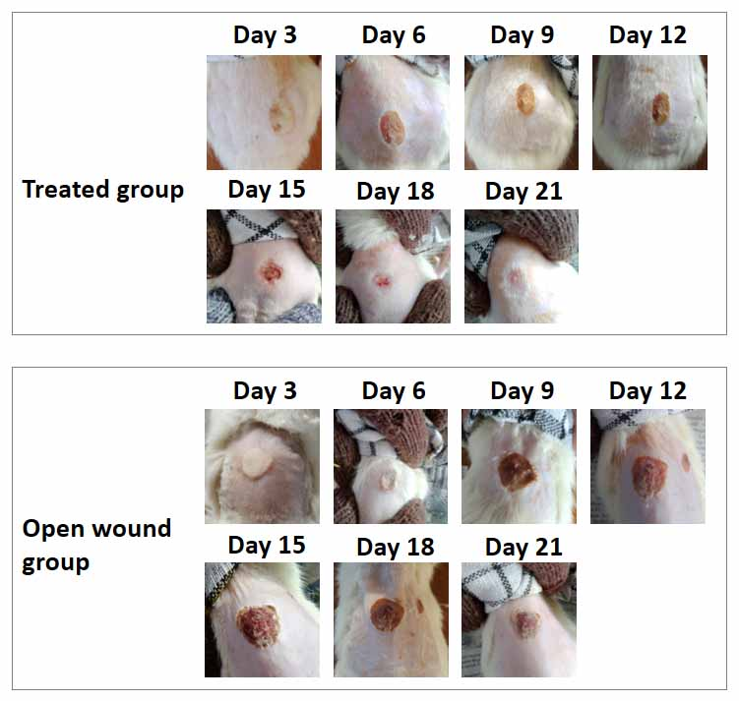
- Reference:
- Kim, B. S. et al. Design of artificial extracellular matrices for tissue engineering. Prog. Polym. Sci. 36, 238–268 (2011).
- Ma, X., Chang, P. R. & Yu, J. Properties of biodegradable thermoplastic pea starch/carboxymethyl cellulose and pea starch/microcrystalline cellulose composites. Carbohydr. Polym. 72, 369–375 (2008).
- Treimank, A. et al. Microcrystalline cellulose fillers for use in hybrid composites with polyethylene and lignin. Cellul. Chem. Technol. 50, 117–125 (2016).

Biography:
Muhammad Alfath is undergraduate student of Department of Chemistry, Institut Teknologi Bandung, Indonesia. He works for his project in bioorganic division under supervision of Dr. Ciptati, MS, M.Sc and Dr. Rachmawati.

Presenting author details

Full Name: Muhammad Alfath
Contact number: +6281224786657
Twitter account: @alfath005
Linked In account: Muhammad Alfath
Session name/ number:
Category: Poster presentation
Passport Number:

