Bioinspired chitosan-apatite resin nanoconjugate: A ternary biocompatible hybrid as efficient bone construct

Reshma Jollyª, Mohammad Shakirª, Aijaz Ahmed Khan^{b}, Syed Sayeed Ahmed^{c}, Mohd. Ahmadullah Farooqi^{d}
ªDepartment of Chemistry, Aligarh Muslim University, Aligarh, 202002, India.
^{b}Neuroanatomy Lab, Department of Anatomy, JNMC, AMU, Aligarh, 202002,India.
^{c}Department of Oral & Maxillofacial Surgery, Dr. Ziauddin Ahmed Dental College, Aligarh Muslim University, Aligarh, 202002, India.
^{d}Department of Civil Engineering, Zakir Husain College of Engineering and Technology, AMU, Aligarh, 202002, India.

Keywords: Chitosan, Resin, Bone tissue engineering

- Abstract
A ternary novel nanocomposite conjugate incorporating chitosan with ceramic nanoparticles (Liu et al. 2014) and resol (CHA-RHC) has been successfully developed using co-precipitation for bone tissue engineering applications (Neves & Ph 2011). The CHA-RHC nanocomposite was investigated for its various physicochemical, biocompatible and cytotoxic properties. The results of XRD, TEM, SEM and AFM studies revealed that the size and surface roughness of the CHA-RHC nanocomposite has decreased and increased respectively relative to the CS/ceramic binary nanocomposite. There were significant intermolecular interactions observed between the various components of the CHA-RHC system as indicated by FTIR spectrum of CHA-RHC. Therefore, it suggests that the incorporation of resol resin (Puglia et al. 2007) have considerable influence on the morphology of the surface. The in vitro biomineralization analysis [Fig.1] revealed bioactive nature of CHA-RHC demonstrating the nucleation inducing ability of the resol, referring a step towards possibility of making direct bond to living bone if implanted (Huan & Chang 2009). MTT assay suggested non-toxic nature of the CHA-RHC nanocomposite to human osteoblasts like cells MG-63(Sagar et al. 2012). In vivo profile study of the CHA-RHC nanocomposite suggested its bone regeneration capacity in a critical size defect in albino rat model. Hence it may be suggested that the CHA-RHC nanocomposite would be a competent candidate in the field of Bone tissue engineering and regenerative medicine.

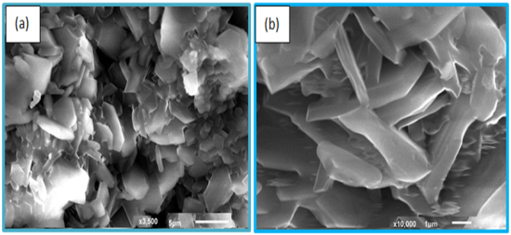
Fig1. (a) Biomineralization study of CHA-RHC nanocomposite after 8 weeks incubation in simulated body fluid (b) magnified view.

Reference:

Huan, Z. & Chang, J., 2009. Novel bioactive composite bone cements based on the β-tricalcium phosphate-monocalcium phosphate monohydrate composite cement system. Acta Biomaterialia, 5(4), pp.1253–1264.

Liu, T. et al., 2014. Enhancing in vitro bioactivity and in vivo osteogenesis of organic–inorganic nanofibrous biocomposites with novel bioceramics. Journal of Material Chemistry B, 2(37), pp.6293–305.

Neves, N.M. & Ph, D., 2011. Scaffolds Based Bone Tissue Engineering : The Role of Chitosan. , Tissue Engineering: Part B,17(5).pp1-17.

Puglia, D., Kenny, J.M. & Nanocomposites, M., 2007. Structure -properties relationship in resol / montmorillonite nanocomposites , Journal of Applied Polymer Science,104, pp.3082-3089.

Sagar, N., Soni, V.P. & Bellare, J.R., 2012. Influenceof carboxymethyl chitin on stability and biocompatibility of 3D nanohydroxyapatite/gelatin/carboxymethyl chitin composite for bone tissue engineering. Journal of biomedical materials research. Part B, Applied biomaterials, 100(3), pp.624–36.

Biography: Dr. Reshma Jolly joined the Department of Chemistry, AMU as Assistant Professor in August 2018.At present, she is working as Research Associate (CSIR) in Department of Chemistry, AMU. She was awarded PhD on "Synthesis, characterization and applications of Polymer Nanocomposite materials" under the supervision of Prof. Mohammad Shakir, Dept. of Chemistry, AMU. During her doctoral studies, she has been awarded MANF-JRF and SRF fellowship from University Grant Commission (UGC), New Delhi. She has received her B.Sc. (Hons) degree in Chemistry in 2009 and M.Sc. degree in Chemistry in 2011 from Aligarh Muslim University. She was selected by DST to participate in its prestigious Nano Mission School on Nanoscience and Nanotechnology at CeNS, Bengaluru, in 2017. She qualified Graduate Aptitude Test (GATE, Chemical Science) in 2013.

Her research interest lies at the interface of Chemistry, engineering and medicinal biology to synthesize bioactive bone implant scaffolds using cost effective methodologies and their physicochemical and biological characterizations for bone tissue engineering applications. Her keen interest is to explore different fabrication techniques for combining varying degrees of synthetic and natural materials to construct highly tailored scaffolds which can be employed to reconstruct damaged bone tissue. Her research work has been published in various journals of international repute.

Presenting author details


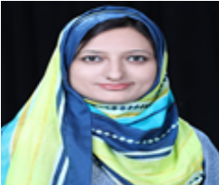
Full Name: Reshma Jolly
Contact number: 9997182611
Twitter account: Linked In account: Reshma Jolly
Session name/ number:
Category: (Oral presentation/ Poster presentation) : Oral
Passport Number

