Title: Injectable Bovine Serum Albumin hydrogel formed at the physiological condition for bone tissue engineering.

Arghya Karmakar1, Devendra Verma1
1Department of Biotechnology and Medical Engineering, National Institute of Technology, Rourkela, India.

Keywords: Biomaterial, Bovine Serum Albumin, hydrogel, protein, mechanical properties, 3-D cell culturing, osteoblast

- Abstract

Proteins are ideal raw materials for preparing biomaterials with better biocompatibility and larger elastic range than synthetic polymer. In extracellular mimicking materials, hydrogels have been exploited for their characteristic micro and macro-environments for cellular growth and differentiation. Here, we’ve presented a simple and cost-effective method of bovine serum albumin (BSA) hydrogel preparation by thermal gelation procedure at physiological pH. We discuss the viscoelastic properties, the secondary structure transformation before and after gelation (via ATR-FTIR spectroscopy), degradation and swelling characteristics of the BSA hydrogel. The mild gelation process with divalent cation Ca²⁺ at physiological pH and the excellent biocompatibility enables us to exploit the hydrogel to various 3-D cell culturing procedures. As albumin is a transporter protein and enables numerous ligand-binding sites, we have incorporated gelatin for RGD domain and hydroxyapatite (bioactive) at various concentrations (w/v) for osteoblast cell line MG-63 attachment and spreading.

Image:
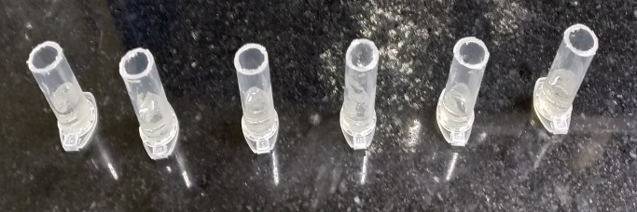

Reference:
Fig 1: 10 % BSA dissolved in PBS at pH 7.34 and at room temp.
A B C D E F

1 T. Peters Jr., in All About Albumin, Academic Press, San Diego,1995, pp. 9–II,
DOI: 10.1016/B978-012552110-9/50004-0.
2. K. Baler, R. Michael, I. Szleifer and G. A. Ameer,
Biomacromolecules, 2014, 15, 3625–3633.
3. N. A. Peppas, J. Z. Hilt, A. Khademhosseini and R. Langer,
Adv. Mater., 2006, 18, 1345–1360.

Biography:
Arghya Karmakar is a post-graduate student at the age of 25 years from National Institute of Technolgy, Rourkela, India. Devendra Verma is the Assistant Professor of Department of Biotechnology and Medical Engineering, National Institute of Technology, Rourkela. He has published more than 30 papers in reputed journals and with 2 patents.

Presenting author details
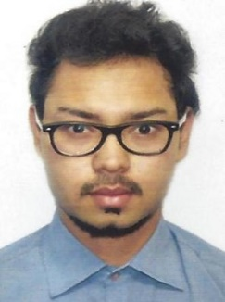

Full Name: Arghya Karmakar Contact number: 7980969709
Linked In account:
Session name/ number:
Category: (Oral presentation)
Passport Number: J486082
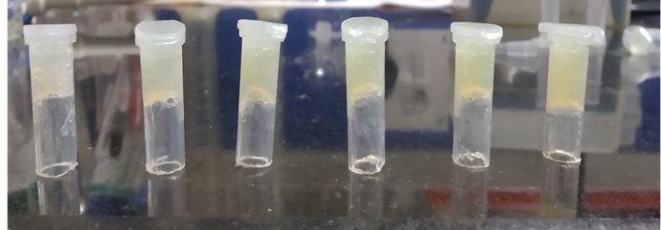

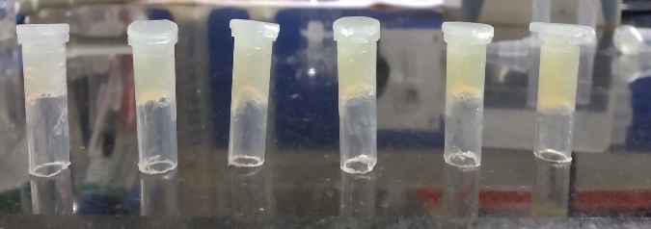
Fig 2: Inverted test, hydrogel formed was stable.
A B C D E F

