Abstract

To Produce Different Thicknesses Veins With Electrospinning Method and Investigation of Mechanical
Properties

DOÇ. DR.OĞUZHAN GÜNDÜZ1, MERVE MİNE ŞEKER 2,
1Department of Metallurgy and Materials Engineering, Marmara University, Istanbul, Turkey
2Department of Mechanical Engineering, Marmara University, Istanbul, Turkey

Keywords: Electrospinning, Blood Vessels, Tissue Engineering

- Abstract Body

Nano fibers, natural textures before these tissues to replace the texture
can be used as a temporary support. Electrospinning thanks to nanofiber obtained according to the method, large surface area; controlled porosity, structure and mechanical properties, such as the requested parameters.
In this study, different polymers manufacturing vessel design and production of different thicknesses using the optimum mechanical properties were evaluated for performing system. It was assessed by analysis of the mechanical tests performed accordingly .
Initially, PLA and PCL polymers were mixed in different proportions. On the collectors with different diameters, the scaffold architecture which is similar to a blood vessel has been developed morphologically and mechanically by electrospinning method. Mechanical properties of the results were examined using SEM, FITR and tensile test.

Image:

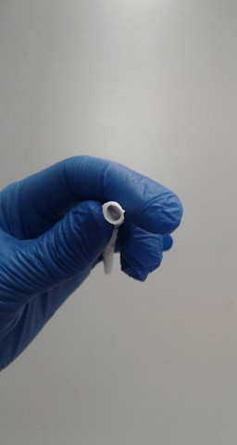
- Reference:

- CAMPBELL GR, CAMPBELL JH: Development of tissue engineered vascular grafts. Curr Pharm Biotechnol 8: 43-50, 2007.
- SHIN H, JO S, MIKOS AG: Biomimetic materials for tissue engineering. Biomaterials 24: 4353-4364, 2003.

Biography:
Merve Mine ŞEKER has completed her Bachelor Degree on Mathematical Enginieering from Yıldız Technical University, Istanbul. She went to Spain for Erasmus for one year. She has completed her Master Degree on Mechanical Engineering from Marmara University, Istanbul and her master's thesis was on artificial vein production.

Presenting author details
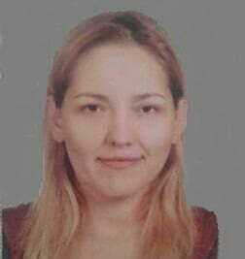
Merve Mine Şeker
00905324133122
mervemineseker@gmail.com
Poster presentation
34870495864

