Abstract

Title: Development and characterization of a polymeric scaffold as a wound dressing material.
Neelima Varshney¹, Ajay Kumar Sahi¹, Sanjeev Kumar Mahto^{1, 2}*
1 Tissue Engineering and Biomicrofluidics Laboratory, School of Biomedical Engineering, Indian Institute of Technology (Banaras Hindu University), Varanasi 221005, Uttar Pradesh, India.
2 Centre for Advanced Biomaterials and Tissue Engineering, Indian Institute of Technology (Banaras Hindu University), Varanasi 221005, India.

Keywords: Three-dimensional scaffold, cell viability, PDMS, wound dressing, material.

- Abstract Body
The present work has focused on the development of polydimethylsiloxane (PDMS) based three dimensional (3D) scaffold as a wound dressing material. Delay wound treatment may cause invasion of microorganism which can retard wound healing and convert acute wounds to non-healing and chronic wounds. Wound dressing material should be able to form a protecting barrier to the outer environment, and as well as enhancing the healing process by providing drugs such as growth factors, antibiotics etc. In this context, polymeric scaffolds have attracted a plethora of attention mainly due to their properties like high surface-to-volume ratio, high porosity, very small pore size, bio-degradability and mechanical strength. PDMS is a repeating chain of Si-O molecules with two methyl groups attached to silicon atoms. Its various properties like high flexibility, gas permeability and optical transparency, make it an ideal scaffold material for wound dressing material. In this study we utilized the chemical-free particulate leaching method for the fabrication of macroporous 3D PDMS scaffold. The porous structure of scaffold with effective pore size range between 60 to 210 μm provides abundant effective porosity for quick drug preloading and release. Furthermore, we characterized PDMS scaffolds for other essential properties such as interconnectivity, surface wettability and mechanical strength. Liquid retention capacity studies show 151.5±7.4% liquid retention in 1X PBS at room temperature. In addition, cell viability and proliferative potential of skin specific cells within the fabricated scaffold were also investigated which can be ascertained that fabricated scaffold are non-toxic and supportive enough to the cells. We also evaluate the water vapor transmission rates (WVTRs) of scaffold to check their ability to maintain adequate moisture at wound area. All these results confirm the suitability of the proposed PDMS scaffold as a future dressing material in wound care applications.
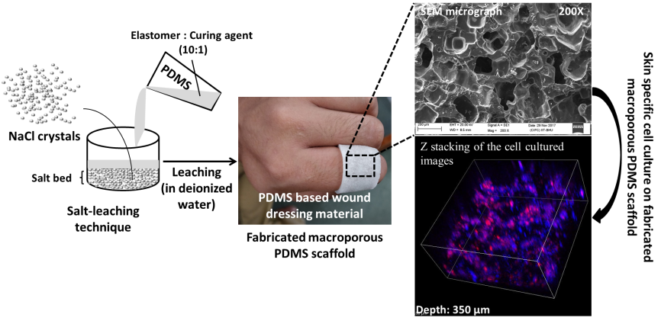
II. Image:
III. Reference:

- Zhang Y, Ishida M, Kazoe Y, Sato Y, Miki N, 2009. Water-vapor permeability control of PDMS by the dispersion of collagen powder. IEEJ Trans Electr Electron Eng, 4:442–9
- Merkel TC, Bondar VI, Nagai K, Freeman BD, Pinnau I, 2000. Gas sorption, diffusion, and permeation in poly(dimethylsiloxane). J Polym Sci Part B Polym Phys, 38:415– 34
- Lee E, Zhang H, Jackson JK, Lim CJ, Chiao M, 2016. Janus films with stretchable and waterproof properties for wound care and drug delivery applications. RSC Adv, 6:79900–9
- Toworfe GK, Composto RJ, Adams CS, Shapiro IM, Ducheyne P, 2004. Fibronectin adsorption on surface activated poly(dimethylsiloxane) and its effect on cellular function. J Biomed Mater Res A, 71:449–61

IV. Biography:
Neelima Varshney has completed her M.Tech from Gautam Buddha University, Greater Noida, India and currently pursuing her PhD from Indian Institute of Technology (Banaras Hindu University), Varanasi, India. She has published 1 research paper in reputed international journal. She has qualified national level examinations- NET and GATE with All India Rank (AIR) - 32 and 660 respectively.

V. Presenting author details


Full Name: Neelima Varshney
Contact number: +91 8004279509, 8744095807
Twitter account: - -
Linked In account: - -
Session name/ number: Skin Tissue Engineering, Scaffolds Used in Tissue Engineering, Biomaterials and Bioengineering
Category: Oral presentation
Passport Number: S1303057

