Using Telemedicine to Improve Access to Care as Part of the Employee Medical Home: A Feasibility Study
Sherry C. Ellis, RN/BSN

Abstract:
Statement of the Problem: Employees of Tift Regional Health System located at Cook Medical Center and affiliated clinics in Adel, Georgia need better access to the care and services offered by the TRHS Employee Medical Home. The location of the EMH at the main campus in Tifton makes it difficult for the employees in Adel to take advantage of the free services offered by the EMH to the employee. Underutilization of the EMH by the employee creates increases in claims data and thereby increases cost to the organization. Methodology & Theoretical Orientation: A project management methodology was used to structure the project. A 13-question survey was administered to employees at CMC to examine willingness to use a telemedicine service. A retrospective review of 2017 claims data was analyzed to project potential cost savings if utilization of the TRHS EMH is increased. Theoretical Framework includes Orem’s Self-Care Deficit Theory and Blum’s DIKW theory. Findings: The survey results demonstrated that 67% of the 78 respondents are willing to use a telemedicine service. The retrospective review of the claims data showed that only a 5% increase in utilization of the EMH is needed to project significant savings to the organization. The study is limited due to the small sample size and also due to the lack of data available on use of the Employee Medical Home at TRHS. Conclusion & Significance: Feasibility of successful adoption of a telemedicine survey is positive based on the survey response. Projected cost savings to the organization is significant and supports expanding the EMH via telemedicine to a remote TRHS location.

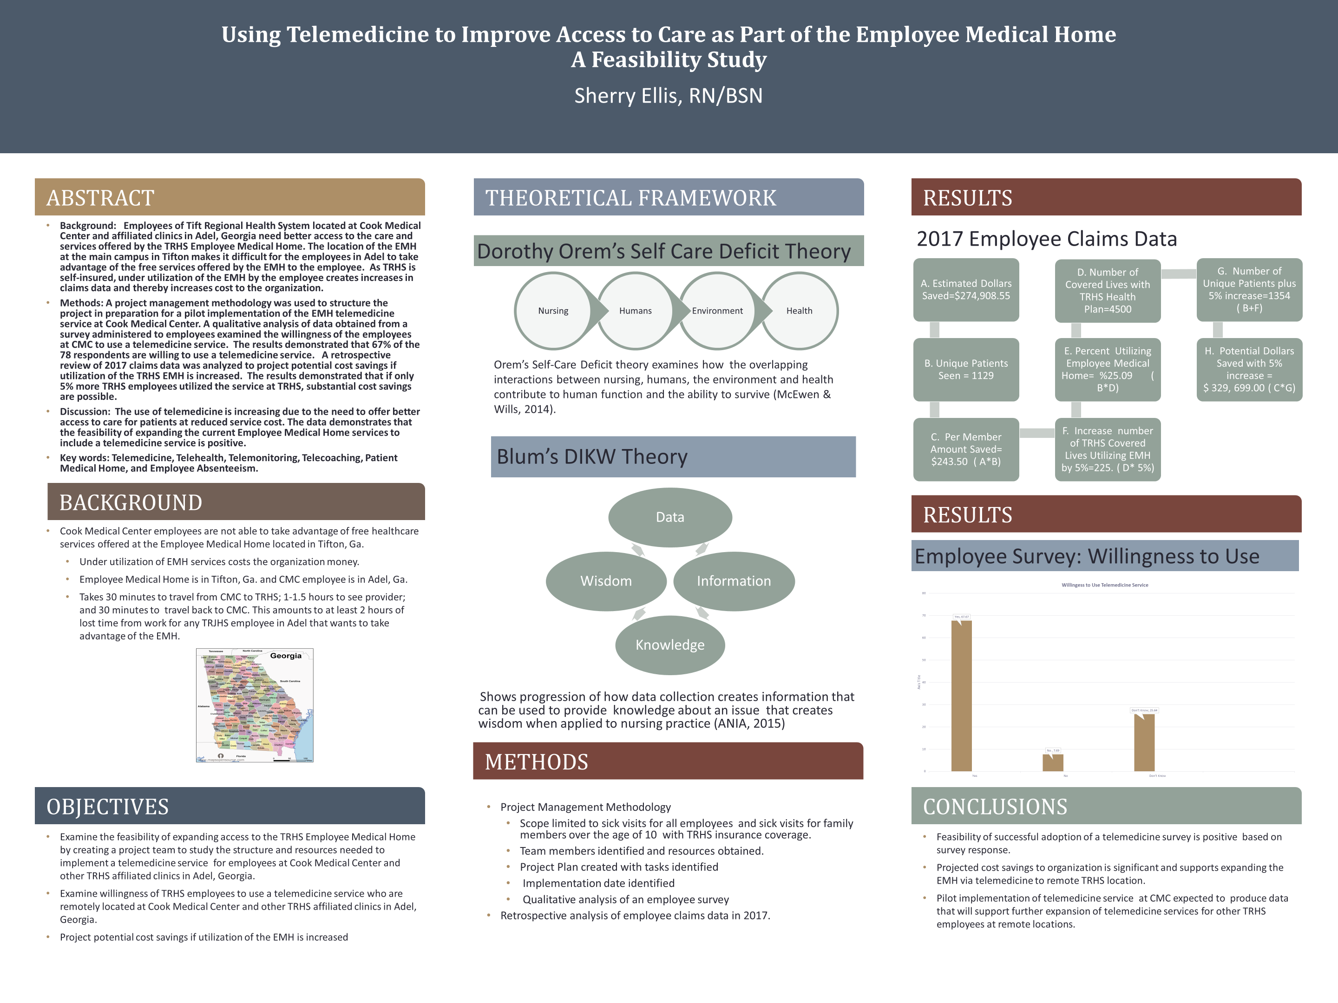


Sherry Ellis currently serves as the Director of Clinical Informatics at Tift Regional Health System. Sherry has 18 years as a practicing nurse at TRHS having worked in Critical Care, Nursing Administration and IT. She supervises 7 nurse informaticists and oversees adoption of the EMR by clinical staff and physicians in acute and ambulatory settings. Her staff recently received an award by Vizient in Georgia for collaborative alliance with nursing for improvement in bar code medication compliance across the organization. Sherry is a candidate for her MSN in Informatics at Georgia Southwestern State University and is expected to graduate in May, 2018.
Email: sherryellis151@hotmail.com

References

About Telemedicine. (2017, January 27). Retrieved from American Telemedicine Association: http://www.americantelemed.org/about/about-telemedicine
American Nurses Association. (2015). Nursing Informatics: Scope and Standards of Practice (2nd ed.). Silver Spring, Maryland: Nursesbooks.org.
Binks, R. (2017, October). District nursing in the digital area. British Journal of Community Nursing, 22(10), 478-483.
Brown Cooper, S. (2015). OPINION LEADERS' PRRSPECTIVE OF THE BENEFITS AND BARRIERS IN TELEMEDIIN. Quarterly Review of Distance Education, 16(1), 25-54.
Eisenbeis, L. (2013). Workplace Health Center How the right onsite facility lowers cost, improves health management. Smart Business Pittsburg, p. 16.
Matney, S. A. (2015, October 30). Toward an Understanding of Wisdom in Nursing. OJIN: The Online Journal of Issues in Nursing, 21(2). doi:10.3912/OJIN.Vol21No01PPT02
Maurer, R. (2017, November). Health Care's Staffing Crisis. HR Magazine, pp. 41-45.
McEwen, M. &. (2014). Theoretical Basis for Nursing (Fourth ed.). Philadelphia, PA: Lippincott Williams & Wilkins.
Project Insight. (2018, March 3). 5 Basic Phases of Project Management. Retrieved from Project Insight: https://www.projectinsight.net/project-management-basics/basic-project-management-phases
Pyrillis, R. (2017, March-April). A Checkup on Value Based Health Care. Workforce, pp. 34-48. Retrieved from www.workforce.com
Shop AliveCor. (2017). Retrieved from Amazon: https://www.amazon.com/AliveCor/
TereKhova, E. T. (2017, June). Telemedicine in primary care: Eho are the current users in British Columbia? BC Medical Journal, 59(5), 264-268. Retrieved from www.bcmj.org
Topaz, M. (2013). The Hitchhiker's Guide to nursing informatics theory: using the Data-Knowledge-Information-Wisdom framework to guide informatics research. Online Journal of Nursing Informatics(OJNI), 17(3). Retrieved from http://ojni.org/issues?p=2852
Yuen, J. T. (2015). Patient experience survey for spinal cord injury patients. Spinal Cord, 53(4), 320-323. doi:10.1038sc/2014.247

