Facilitators and Barriers to Urologists’ Engagement with the eConsult Service at Dartmouth-Hitchcock
John Anagnost, MS, The Dartmouth Institute, USA
Jacque Kihwele, MD MPH,The Dartmouth Institute, USA

Abstract (300 word limit)

Background. Electronic consultations (eConsults) allow primary care physicians to ask questions to specialists regarding the care management of individual patients through a shared electronic health record system. Although specialists’ perceptions and experiences with eConsults have been thoroughly examined in the Canadian and VA health systems, similar rigorous qualitative work has yet to be done in the context of academic medical centers in the US which are characterized by a balance between research, patient care, and teaching. Methods. Participants were recruited based on their level of engagement with eConsults at the AMC: established users (n=3), new users (n=2), and non-users (n=3). Qualitative semi-structured interviews were conducted from February 2018 to March 2018. Data analysis was focused on familiarization, coding, and theme development. Some codes were theory-driven based on previous literature while other codes emerged from the data specific to interviewees’ experiences. Thematic analysis followed a modified grounded-theory framework. Results. Participants generally perceived eConsults outside of their sub-specialties to be less interesting and more time consuming. Similarly, most felt that eConsults were “extra” work, lacked a financial incentive, and required a similar amount of effort and time as face-to-face visits of comparable complexity. However, participants were interested in eConsults because they facilitated quick and effective education of primary care physicians- having a downstream effect of improving referral prep work, decreasing redundant questions, limiting unnecessary referrals, and reducing patient travel. Recommendations to improve engagement included integrating eConsults into normal workflow, increasing the number of providers doing eConsults, distributing general eConsults among mid-level providers, and separating out paychecks for eConsults. Conclusions. Optimal ways to balance these different factors should be considered in future strategies to improve specialist engagement with eConsults, especially in settings driven by productivity measures like RVUs.
Image
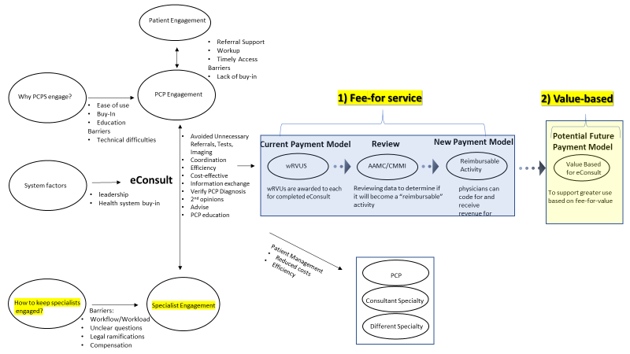

Biography (150 word limit)
John Anagnost has his expertise in health services research, both qualitative and quantitative methods. He has conducted in-depth qualitative research about the eConsult program at Dartmouth-Hitchcock, a telemedicine application that improves communication between specialists and primary care physicians. He is excited to share his research with other academics interested in telemedicine.
Email: jhanagnost@gmail.com

Notes/Comments:

