Usnic acid extracted from Aspicillia crustose lichens (UAL) for the preparation of hyaluronic acid (HA) nanoparticles generated from bifidobacterium for use in the treatment of diabetes in rats in vivo
Akbar Esmaeili, Shirin Rajaee
Department of Chemical Engineering, North Tehran Branch, Islamic Azad University, PO Box 19585/936, Tehran, Iran.

Abstract:
Many populations in the world have diabetes. Thus, there is a need for natural compounds that are antidiabetic drugs. In this study, natural compounds were used, including the seed of kiwi (Actinidia deliciosa), rhubarb (Rheum ribs L.) with the inner membrane of the egg shell, Fleece from the area of Kalkooei (wool of sheep), human fingernail (unguis) and hyaluronic acid produced by the bacteria bifidobacterium with UAL. The natural compounds were divided into 5 groups: A (hyaluronic acid and UAL), B (hyaluronic acid and unguis), C (hyaluronic acid and A. deliciosa), D (seed of A. deliciosa) and E (Rheum and MIE). The presence of UAL, fatty acids, phytosterols and sesterterpen was confirmed by various techniques, including the use of a Soxhlet apparatus, FT-IR spectroscopy, GC-MS spectroscopy, and ¹H-NMR. Nanocompounds were identified by SEM. The average size of the nanoparticles was found to be 55 nm. We used variables such as pH, different natural compounds, concentration, number of injections, and blood glucose monitoring in different situations. Five groups of nanoparticles were injected into rats, and they reduced their blood glucose levels significantly (statistical significance was declared at p<0.001). The produced hyaluronic acid (glucuronic acid ester with fatty acids) was low molecular weight and helped to treat diabetes in rats. In addition, the chemical structure of the natural compounds looks like those of antidiabetic drugs and could gradually replace synthetic drugs.

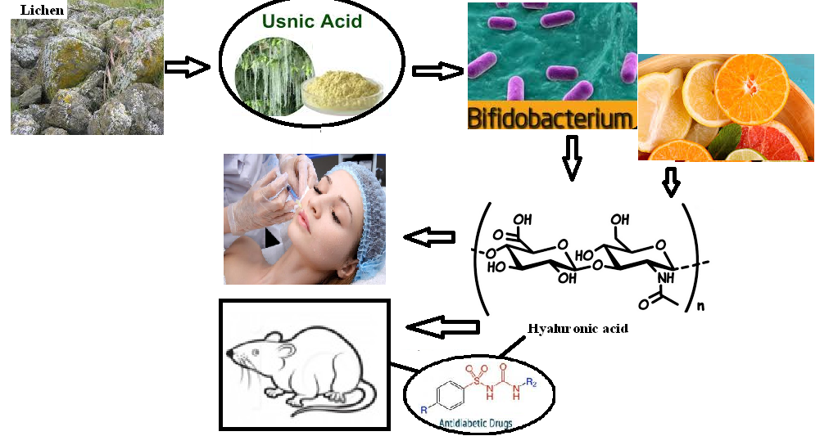

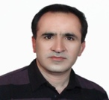

Biography
Akbar Esmaeili has completed his Ph.D at the age of 47 years from Islamic Azad University, Tehran, Iran. He is the Prof. Department Chemical Engineering North Tehran Branch, Islamic Azad University. He has published more than 100 papers in reputed journals, more 13 books, referee for more 100 paper’s and serving as three editorial board member of repute.

Email:akbaresmaeili@yahoo.com
Phone: +989121484813

Notes/Comments:

