Optimization and preparation of Methylcellulose edible film combined with of Ferulago angulata essential oil (FEO) nanocapsules for food packaging applications
Akbar Esmaeili.Ph.D. Department of Chemical Engineering, North Tehran Branch, Islamic Azad University, PO Box 19585/936, Tehran, Iran
Monireh Ebrahimzadeh Fazel, M.S. Department of Phytochemistry and Essential oils Technology, Faculty of Pharmaceutical Chemistry, Pharmaceutical Sciences Branch, Islamic Azad University, Tehran, Iran.
*Corresponding author. Email: akbaresmaeili@yahoo.com

Abstract

The films based on methylcellulose with biodegradable and antioxidant activity incorporated with nano capsule suspension containing F. angulata essential oil were developed. Oil extraction and identification of F. angulata essential oil compounds was done. Nano capsule suspension containing F. angulata essential oil was prepared by ultrasonic bath. The films were prepared by a casting method in three different ratios. The mechanical properties, colour, light transmission, antioxidant activity and release rate characteristics of the films were studied. The addition of nano capsule suspension to methylcellulose films decreased the thickness, tensile strength but increased the percentage elongation at break (%E) and lightness. High antioxidant activity and a prolonged release of F. angulata essential oil were also reported. Five factors design of Response Surface Methodology were used to optimize the thickness, holding time and anti-oxidant effect of edible film based on methylcellulose incorporated with nano capsule suspension containing F. angulata essential oil. Design of experiments was carried out by the software: Minitab 17 (Sigma package). Optimization of thickness, 2, 2-diphenyl-1-picrylhydrazyl radical scavenging and holding time would yield the best mixture proportions of methylcellulose and nano capsule suspension 30%, 30% and 70%; oil.

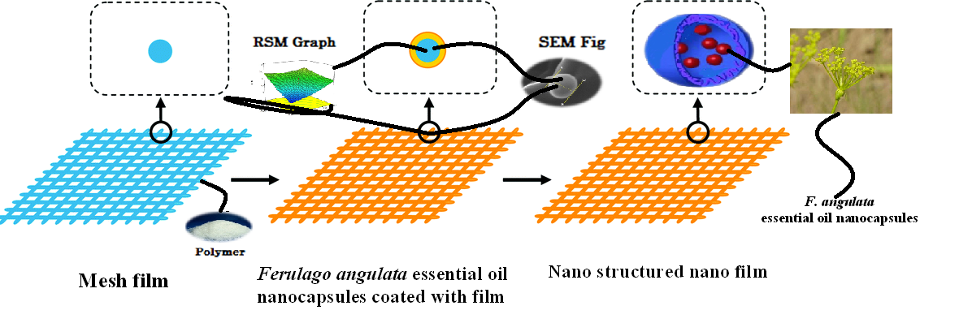
The films based on methylcellulose with biodegradable and antioxidant activity incorporated with nano capsule suspension containing FEO were developed.

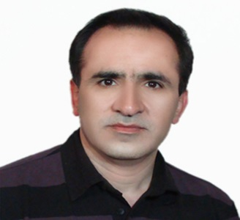

Biography
Akbar Esmaeili has completed his Ph.D at the age of 47 years from Islamic Azad University, Tehran, Iran. He is the Prof. Department Chemical Engineering North Tehran Branch, Islamic Azad University. He has published more than 100 papers in reputed journals, more 13 books, referee for more 100 paper’s and serving as three editorial board member of repute.

Email:akbaresmaeili@yahoo.com
Phone: +989121484813

