Abstract Template

Title: Microbial pectinase: sources, characterization and applications
Nevadita Sharma*¹ Madhu Rathore² Mukesh Sharma³
^{1,2,3} Institute of Biotechnology and Allied Sciences, Training and Research Centre, Sikar, Rajasthan, India
*Corresponding author: E-mail: nevadita@gmail.com

Keywords: Pectin, Pectinase, Pectinolytic bacteria, Microbial pectin

- Abstract

Today pectinases are upcoming industrially important bacterial enzymes. It can be produced by a variety of microorganisms. These enzymes act on pectin, which is the major component of middle lamella in plant cell wall. Pectinolytic enzymes are classiﬁed according to their mode of attack on the galacturonan part of the pectin molecules such as protopectinases, esterase’s and depolymerases. As we know that microbial enzymes work depends up on the type of enzymes application, temperature, concentration, and pH and so on, therefore, pectinase enzyme also differentiated according to their physical and chemical factors too. The biochemical structures of pectinases include members of all the major classes and the structure–function relationship, studies of a few available complexes of pectinases with substrate/ analogs could be considered as prototypes for related family member and the molecular characterization of pectinolytic enzymes is also well documented. Furthermore, it provides a bird’s eye view of the possible application of these enzymes in commercial sector.

- Image

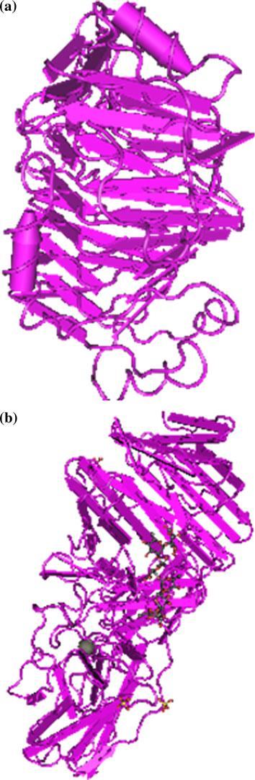

- Reference

- Cho SW, Lee S, Shin W (2001) The X-ray structure of Aspergillus aculeatus polygalacturonase and a modeled structure of the polygalacturonase–octagalacturonate complex. J Mol Biol 311:863–87.

- Federici L, Caprari C, Mattei B, Savino C, Di Matteo A, De Lorenzo G, Cervone F, Tsernoglou D (2001) Structural requirements of endopolygalacturonase for the interaction with PGIP (polygalacturonase-inhibiting protein). Proc Natl Acad Sci USA 98:13425–13430.

- Shimizu T, Nakatsu T, Miyairi K, Okuno T, Kato H (2002) Active-site architecture of endopolygalacturonase I from Stereum purpureum revealed by crystal structures in native and ligand-bound forms at atomic resolution. Biochemistry 41:6651–6659.

- Biography

Currently, I am working as an assistant professor in department of Biotechnology in Seth G.L Bihani S.D. P.G College, Sri Ganganagar, Rajasthan. During my total 5 years tenure I have undertaken various tasks in teaching the theory, practicals, projects and management materials for the undergraduate and master students and successfully gave them the best of my abilities. My Ph. D work done involves the isolation of industrially important extracellular enzymes producing thermophilic bacteria from Bikaner region of Rajasthan. During the work, the isolated organisms showed significant extracellular enzyme producing abilities. Working on this project helped me to gain knowledge on amplification, sequencing of 16S rDNA and phylogeny analysis.

- Presenting author details



Full Name: Dr. Nevadita Sharma
Contact number: +919602523120
Linked In account: https://www.linkedin.com/in/dr-nevadita-sharma-5b032546/
Session name/ number: Synthetic Biology
Category: ( ePoster presentation)
Passport Number: H9657713

