Night natural ventilation and energy saving in high thermal mass historical building in hot dry climate

BENCHEIKH HAMIDA, GC LABORATORY LRGC, AMAR TELDJI UNIVERSITY LAGHOUAT ALGERIA
CHAKALI MERIEM AMAR TELDJI UNIVERSITY LAGHOUAT ALGERIA

Abstract

The thermal comfort and air quality inside buildings spaces is much recommended in Nowadays for human’s health and environment protection, especially if the inside comfort conditions are assured by passive systems means. In hot dry climate such Laghouat city in the south of Algeria, the first consideration in architecture design is given to the building envelope referring to the vernacular architecture in the region. The buildings with high thermal inertia envelope ensure the inside thermal comfort while it is properly closed during day time when the outside air temperature is very high, in hot dry region the night outside air temperature varies between 15 to 20°C, the night natural ventilation through windows properly oriented and dimensioned can lower the inside air temperature during night and evacuate the polluted inside air. The low inside temperature during night leads to a low inside temperature during day time, which has a good effect on energy saving during summer period where air conditioning is needed for more than seven months per year in this region.
The present paper aim was to examine the impact of night natural ventilations in high thermal inertia buildings on energy saving, firstly a field work was carried out by measurements of inside air temperatures in two identical rooms of an old hotel called Marhaba with high thermal inertia envelope built with local materials. In the first room the night natural ventilation allowed when the outside temperature was lower than the inside one by opening windows and the other room was closed around the clock. Secondly a numerical simulation was carried out to evaluate the field measurements results to choose the accurate software for further simulations in order to find the appropriate windows orientation, dimensions and positions can give the high energy saving performances in buildings with high thermal inertia envelope in hot dry climate.

Image
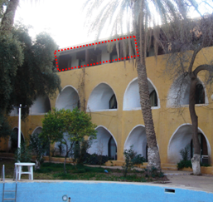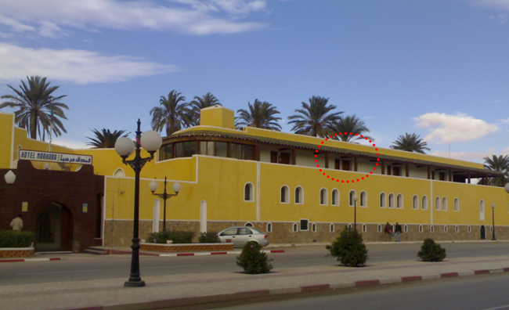
Recent Publications (minimum 5)
1-H. Ben Cheikh, B Belkacem, KM Mouldi (09/01/2014) The effect of alleviating the sand concrete by wood shavings on wall time lag and decrement factor Civil and Environmental Research, Vol.5 2013

2-Hamida Bencheikh, The effect of wind velocity and night natural ventilation on the inside air temperature in passive cooling in arid zones, Proceedings of ICONARCH-II - November 2014-KONYA-TURKEY

3-Hamida bencheikh, Ameur Rachid, Safeddine Djamila, Green cover and urban microclimate in hot an arid environment, Proceedings éditésProceedings of the Third International Conference on Countermeasures to Urban Heat Island / in Proc. 3rd IC²UHI, October 13-15, 2014, Venezia

4-Hamida bencheikh, Douadji younes, Numerical Investigation of a Coupled Passive Cooling System Earthto Air Heat Exchange and Solar Chimney in Hot Arid Zone, Innovative Energy & Research Innov Ener Res 2018, Vol 7(1):188

5-Hamida Ben cheikhet Khlej Samir, Impact of a Retrofitting Project on Thermal Comfort and Energy Efficiency of a Historic School in Miliana, Algeria, international journal of architectural heritage, 2019

Biography
Professor Hamida Bencheikh, held am MPhil from Bath university Uk, PHD from Constantine university, Professor in architecture and environment, lecturer in department of architecture Ammar Telidji university, supervision of PHD student in sustainable architecture, a head of laboratory working group, heat and moister transfer in buildings and new buildings material, wrote three book in this two recent years, passive cooling, urban green cover and cooling,
Email: h.bencheikh@lagh-univ.dz

Notes/Comments:

