Biophilic City and SDG 11: Are We There Yet?
Syuhaida Ismail
Universiti Teknologi Malaysia Kuala Lumpur
Abstract
Biophilic city is a sister term of green city that eventually improvised the concept of the latter. The concept of biophilic city holistically brings humans closer to nature by emotionally affiliating human to other living organisms in positively affecting the human physical and mental wellbeing especially throughout the difficult time of COVID-19 restrictions. In short, biophilic city fulfils the need for urbanisation by generating natural systems and creating an ecosystem for biodiversity towards the achievement of Sustainable Development Goal #11 of sustainable cities and communities. However, the term biophilic city is alien to many, whilst SDG 11, as its name implies, is very much paired with resilient, sustainable and green cities. Hence, this keynote speech aims at exploring the concepts, design elements and indicators of biophilic city and its relations to SDG 11 in benchmarking how far the biophilic city is being adopted towards “making cities inclusive, safe, resilient and sustainable” amidst the COVID-19 crisis. It is expected that this keynote speech will open the eyes on the growing importance of biophilic city and SDG 11 during the COVID-19 pandemic by ensuring a reduction in the virus exposure to human being living in crowded areas.
Biography
Assoc. Prof. Dr. Syuhaida Ismail is an industry-experienced academician with various engineering professional qualifications e.g. the UK Chartered Engineer and ASEAN Associate Engineer. She has contributed as plenary/keynote speaker in conferences and seminars and published more than 250 technical papers/articles/books on Sustainable Cities and Construction, Project Management, Construction Management and recently on the COVID-19 crisis in built environment. She has received more than 50 research/professional awards, where her research products are commercialised into more than 100 Intellectual Property Rights (IPR). She is currently leading Green Cities and Construction Research Group (GCCRG) at Universiti Teknologi Malaysia Kuala Lumpur, who undertakes research and consultation projects as well as organises hands-on workshops/training, global outreach and community engagement programmes on sustainable built environment, civil engineering, construction management and project management.
Recent Publications Related to Keynote Speech Topic
- Khairul Zahreen Mohd. Arof, Syuhaida Ismail, Nadirah Hazwani Najib, Rohayah Che Amat and Nurul Huda Ahmad (2020). Exploring Opportunities of Adopting Biophilic Cities Concept into Mixed-Use Development Project in Malaysia. Journal of IOP Conference Series on Earth and Environmental Science. 409(2020), pp 1-9. ISSN: 1755-1315. Scopus Index. DOI: https://doi.org/10.1088/1755-1315/409/1/012054. Bristol, UK: IOP Publishing Ltd.
- Rohayah Che Amat, Syuhaida Ismail, Mohammad Hussaini Wahab, Nurul Huda Ahmad and Wan Nurul Mardiah Wan Mohd Rani (2020). A Dimension of Biophilia in Urban Design. Journal of IOP Conference Series on Earth and Environmental Science. 409(1), pp 1-9. Article number 012016. ISSN: 1755-1315. Scopus Index. DOI: https://doi.org/10.1088/1755-1315/409/1/012016. Bristol, UK: IOP Publishing Ltd.
- Khairul Zahreen Mohd Arof, Syuhaida Ismail, Subramaniam, C., Shamila Azman, Wan Nurul Mardiah Wan Mohd Rani and Muhammad Farhan Zolkepli (2020). Critical Strategies for Construction Players in the Adoption of Biophilic City Concept in Malaysia. Planning Malaysia Journal. 18(1), pp. 181-192. ISSN: 1675-6215. Scopus Index. DOI: https://doi.org/10.21837/pm.v18i11.719. Kuala Lumpur, Malaysia: Malaysian Institute of Planners.
- Nurul Huda Ahmad, Syuhaida Ismail, Rohayah Che Amat, Mohammad Hussaini Wahab and Wan Nurul Mardhiah Wan Mohd Rani (2019). Preliminary Study on the Wind Flow Simulation over a Biophilic City. Proceedings of the 6th International Conference on Applied Science and Technology (ICAST 2019). 13-14 November 2019. Kyoto, Japan: Academy Research Society of Malaysia.
- Khairul Zahreen Mohd Arof, Syuhaida Ismail, Nadirah Hazwani Najib, Subramaniam, C., Shamila Azman, Abd Latif Saleh and Nurul Huda Ahmad (2020). Critical Causal Factors of Failure (CCFF) in Adopting a Biophilic City Concept in Malaysia. Journal of Critical Reviews. 7(5), pp. 87-91. ISSN: 2394-5125. Scopus Index. DOI: https://doi.org/10.31838/jcr.07.05.14. India: Innovare Academic Sciences Pvt. Ltd.
- Khairul Zahreen Mohd. Arof, Syuhaida Ismail and Abd Latif Saleh (2019). The Importance of Contractor's Performance Appraisal System for Biophilic City Development in Malaysia. IOP Conference Series: Materials Science and Engineering, 849(1), pp. 1-6, ISSN: 1757-8981. DOI: 10.1088/1757-899X/849/1/012011. Scopus Index. United Kingdom: IOP Publishing.

Speaker’s photo
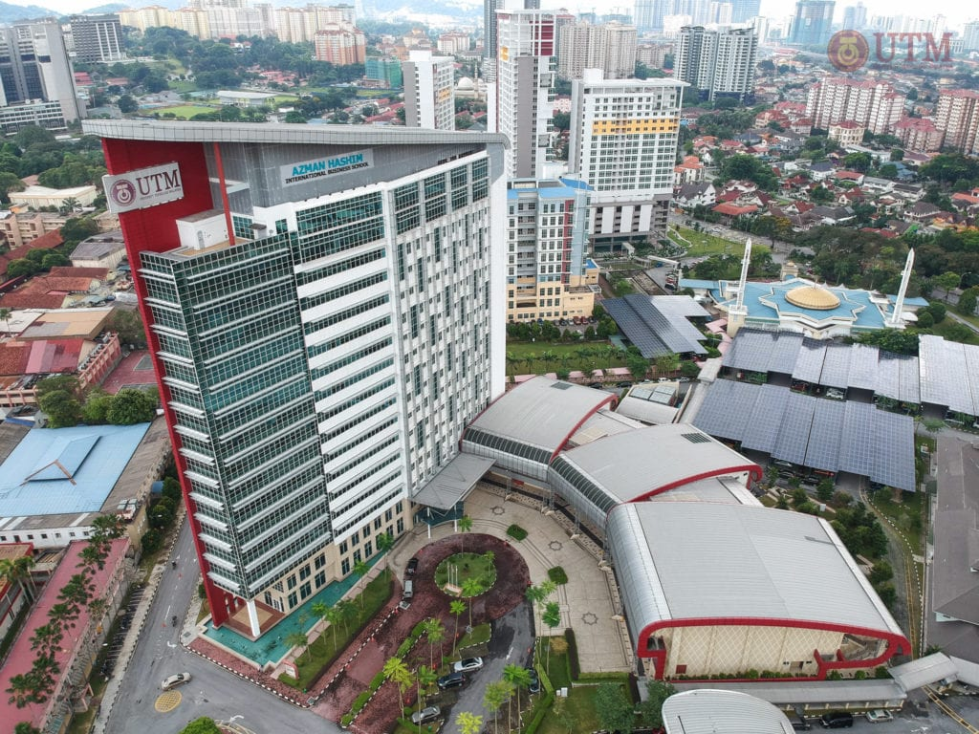

University’s photo

Biophilic city and SDG 11: Are We There Yet?
Syuhaida Ismail, Universiti Teknologi Malaysia Kuala Lumpur, MALAYSIA

Abstract (300 word limit)

Biophilic city is a sister term of green city that eventually improvised the concept of the latter. The concept of biophilic city holistically brings humans closer to nature by emotionally affiliating human to other living organisms in positively affecting the human physical and mental wellbeing especially throughout the difficult time of COVID-19 restrictions. In short, biophilic city fulfils the need for urbanisation by generating natural systems and creating an ecosystem for biodiversity towards the achievement of Sustainable Development Goal #11 of sustainable cities and communities. However, the term biophilic city is alien to many, whilst SDG 11, as its name implies, is very much paired with resilient, sustainable and green cities. Hence, this keynote speech aims at exploring the concepts, design elements and indicators of biophilic city and its relations to SDG 11 in benchmarking how far the biophilic city is being adopted towards “making cities inclusive, safe, resilient and sustainable” amidst the COVID-19 crisis. It is expected that this keynote speech will open the eyes on the growing importance of biophilic city and SDG 11 during the COVID-19 pandemic by ensuring a reduction in the virus exposure to human being living in crowded areas.

Recent Publications (minimum 5)
- Khairul Zahreen Mohd. Arof, Syuhaida Ismail, Nadirah Hazwani Najib, Rohayah Che Amat and Nurul Huda Ahmad (2020). Exploring Opportunities of Adopting Biophilic Cities Concept into Mixed-Use Development Project in Malaysia. Journal of IOP Conference Series on Earth and Environmental Science. 409(2020), pp 1-9. ISSN: 1755-1315. Scopus Index. DOI: https://doi.org/10.1088/1755-1315/409/1/012054. Bristol, UK: IOP Publishing Ltd.
- Rohayah Che Amat, Syuhaida Ismail, Mohammad Hussaini Wahab, Nurul Huda Ahmad and Wan Nurul Mardiah Wan Mohd Rani (2020). A Dimension of Biophilia in Urban Design. Journal of IOP Conference Series on Earth and Environmental Science. 409(1), pp 1-9. Article number 012016. ISSN: 1755-1315. Scopus Index. DOI: https://doi.org/10.1088/1755-1315/409/1/012016. Bristol, UK: IOP Publishing Ltd.
- Khairul Zahreen Mohd Arof, Syuhaida Ismail, Subramaniam, C., Shamila Azman, Wan Nurul Mardiah Wan Mohd Rani and Muhammad Farhan Zolkepli (2020). Critical Strategies for Construction Players in the Adoption of Biophilic City Concept in Malaysia. Planning Malaysia Journal. 18(1), pp. 181-192. ISSN: 1675-6215. Scopus Index. DOI: https://doi.org/10.21837/pm.v18i11.719. Kuala Lumpur, Malaysia: Malaysian Institute of Planners.
- Nurul Huda Ahmad, Syuhaida Ismail, Rohayah Che Amat, Mohammad Hussaini Wahab and Wan Nurul Mardhiah Wan Mohd Rani (2019). Preliminary Study on the Wind Flow Simulation over a Biophilic City. Proceedings of the 6th International Conference on Applied Science and Technology (ICAST 2019). 13-14 November 2019. Kyoto, Japan: Academy Research Society of Malaysia.
- Khairul Zahreen Mohd Arof, Syuhaida Ismail, Nadirah Hazwani Najib, Subramaniam, C., Shamila Azman, Abd Latif Saleh and Nurul Huda Ahmad (2020). Critical Causal Factors of Failure (CCFF) in Adopting a Biophilic City Concept in Malaysia. Journal of Critical Reviews. 7(5), pp. 87-91. ISSN: 2394-5125. Scopus Index. DOI: https://doi.org/10.31838/jcr.07.05.14. India: Innovare Academic Sciences Pvt. Ltd.
- Khairul Zahreen Mohd. Arof, Syuhaida Ismail and Abd Latif Saleh (2019). The Importance of Contractor's Performance Appraisal System for Biophilic City Development in Malaysia. IOP Conference Series: Materials Science and Engineering, 849(1), pp. 1-6, ISSN: 1757-8981. DOI: 10.1088/1757-899X/849/1/012011. Scopus Index. United Kingdom: IOP Publishing.


Biography (150 word limit)
Assoc. Prof. Dr. Syuhaida Ismail is an industry-experienced academician with various engineering professional qualifications e.g. the UK Chartered Engineer and ASEAN Associate Engineer. She has contributed as plenary/keynote speaker in conferences and seminars and published more than 250 technical papers/articles/books on Sustainable Cities and Construction, Project Management, Construction Management and recently on the COVID-19 crisis in built environment. She has received more than 50 research/professional awards, where her research products are commercialised into more than 100 Intellectual Property Rights (IPR). She is currently leading Green Cities and Construction Research Group (GCCRG) at Universiti Teknologi Malaysia Kuala Lumpur, who undertakes research and consultation projects as well as organises hands-on workshops/training, global outreach and community engagement programmes on sustainable built environment, civil engineering, construction management and project management.
Email: syuhaida.kl@utm.my

Notes/Comments:

